FIRST LUTHERAN CHURCH
Northwood, Iowa
641-324-2984
www.flcnorthwood.org
THAT ALL MAY KNOW THE LOVE OF GOD IN JESUS CHRIST
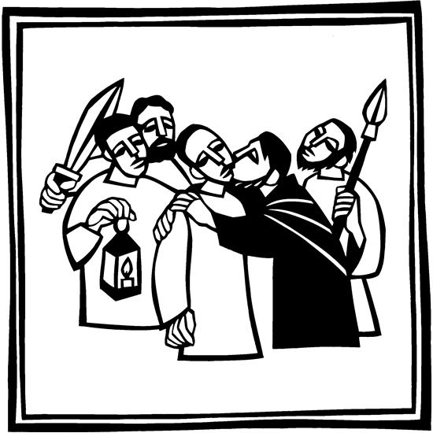
Good Friday
April 15th, 2022
6:00pm
Good Friday
April 15th, 2022
Enter in Silence
Special Music: “Via Dolorosa” Pastor Becky
Prayer of the Day
Almighty God, look with loving mercy on your family, for whom our Lord Jesus Christ was willing to be betrayed, to be given over to the hands of sinners, and to suffe r death on the cross; who now lives and reigns with you and the Holy Spirit, one God, forever and ever. Amen.
Hymn of the Day “In the Cross of Christ I Glory” ELW 324
1 In the cross of Christ I glory,
tow'ring o'er the wrecks of time.
All the light of sacred story
gathers round its head sublime.
2 When the woes of life o'ertake me,
hopes deceive, and fears annoy,
never shall the cross forsake me;
lo, it glows with peace and joy.
3 When the sun of bliss is beaming
light and love upon my way,
from the cross the radiance streaming
adds more luster to the day.
4 Bane and blessing, pain and pleasure,
by the cross are sanctified;
peace is there that knows no measure,
joys that through all time abide.

The Passion According to St. John

John 18:1-11
First candle may be extinguished.
Hymn: “Go to Dark Gethsemane” vs. 1 ELW 347
1 Go to dark Gethsemane,
all who feel the tempter's pow'r;
your Redeemer's conflict see.
Watch with him one bitter hour;
turn not from his griefs away;
learn from Jesus Christ to pray.
John 18:12-27
Second candle may be extinguished.
Hymn: “O Sacred Head, now Wounded” vs. 1-2 ELW 351
1 O sacred head, now wounded,
with grief and shame weighed down,
now scornfully surrounded
with thorns, thine only crown;
O sacred head, what glory,
what bliss till now was thine!
Yet, though despised and gory,
I joy to call thee mine.
2 How pale thou art with anguish,
with sore abuse and scorn;
how does thy face now languish,
which once was bright as morn!
Thy grief and bitter passion
were all for sinners' gain;
mine, mine was the transgression,
but thine the deadly pain.
John 18:28-40
Third candle may be extinguished.

Hymn: “O Sacred Head, now Wounded” vs. 3-4 ELW 351
3 What language shall I borrow
to thank thee, dearest friend,
for this thy dying sorrow,
thy pity without end?
Oh, make me thine forever,
and should I fainting be,
Lord, let me never, never
outlive my love to thee.
4 Lord, be my consolation;
shield me when I must die;
remind me of thy passion
when my last hour draws nigh.
These eyes, new faith receiving,
from thee shall never move;
for all who die believing
die safely in thy love.
John 19:1-7
Fourth candle may be extinguished.
Hymn: “Ah, Holy Jesus” vs. 1-2 ELW 349
1 Ah, holy Jesus, how hast thou offended
that we to judge thee have in hate pretended?
By foes derided, by thine own rejected,
O most afflicted.
2 Who was the guilty? Who brought this upon thee?
Alas, my treason, Jesus, hath undone thee.
'Twas I, Lord Jesus, I it was denied thee;
I crucified thee.
John 19:8-16a
Fifth candle may be extinguished

Hymn: “Ah, Holy Jesus” vs. 3-5 ELW 349
3 Lo, the Good Shepherd for the sheep is offered;
the slave hath sinned, and the Son hath suffered;
for our atonement, while we nothing heeded,
God interceded.
4 For me, kind Jesus, was thine incarnation,
thy mortal sorrow, and thy life's oblation;
thy death of anguish and thy bitter passion,
for my salvation.
5 Therefore, kind Jesus, since I cannot pay thee,
I do adore thee, and will ever pray thee;
think on thy pity and thy love unswerving,
not my deserving.
John 19:16b-22
Sixth candle may be extinguished.
Hymn: “Go to Dark Gethsemane” vs. 2 ELW 347
2 Follow to the judgment hall,
view the Lord of life arraigned;
oh, the wormwood and the gall!
Oh, the pangs his soul sustained!
Shun not suff'ring, shame, or loss;
learn from him to bear the cross.

John 19:23-30
Seventh candle may be extinguished.
Hymn: “Go to Dark Gethsemane” vs. 3 ELW 347
3 Calv'ry's mournful mountain climb;
there, adoring at his feet,
mark that miracle of time,
Mission Project for April
Dayspring Children’s Village

God's own sacrifice complete.
"It is finished!" hear him cry;
learn from Jesus Christ to die.

Bidding Prayer
Let us pray, brothers and sisters, for the holy church throughout the world.
Lord’s Prayer p. 145
John 19:31-42
Eighth candle may be extinguished.

Song: “Were You There” by Quartet

Leave in Silence
Your offering may be left in the plates by the door.
Copyright © 2022 Augsburg Fortress. All rights reserved. Reprinted by permission under Augsburg Fortress Liturgies Annual License #SB154893.

Copyright © 2022 Augsburg Fortress. All rights reserved. Reprinted by permission under Augsburg Fortress Liturgies Annual License #SAS020622. Used by permission.

Organist/Pianist/Vocalist: Leila Gangstad & Loraine Mix Special Music: Senior Choir

Ushers: The Johnson family
Lay Reader:
Sound/Video: Eli Mix, Mark Willand
Communion Set-up: Valerie Abrams & Gina Solberg

