**FIRST LUTHERAN CHURCH  
Northwood, Iowa  
641-324-2984  
www.flcnorthwood.org**

*THAT ALL MAY KNOW THE LOVE OF GOD IN JESUS CHRIST*

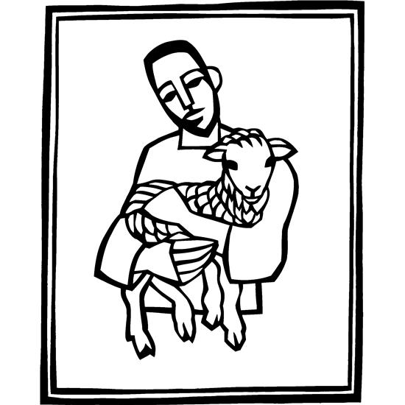

**4th Sunday of Easter**

**May 8th, 2022  
9:00 am**

**Pastor Becky Sogge**

**Organist/Pianist:** Leila Gangstad

**Acolyte:**

**Lay Reader:**

**Special Music:** Leila Gangstad

**Sound/Video:** Hayden Moore, Mark Willand

**Counters:** Russ & Delores Knudson, Steph Perkins

**Greeter:** The Ballantyne Family

**Ushers:** The Ballantyne Family

### Prelude - Leila Gangstad

### Welcome – Announcements

**Thanksgiving for Baptism**

Alleluia! Christ is risen. **Christ is risen indeed. Alleluia!**

In the waters of baptism, we have passed over from death to life with Jesus Christ, and we are a new creation. For this saving mystery, and for this water, let us bless God, who was, who is, and who is to come.

We thank you, God, for your river of life, flowing freely from your throne: through the earth, through the city, through every living thing. You rescued Noah and his family from the flood; You opened wide the sea for the Israelites. Now in these waters you flood us with mercy, and our sin is drowned forever. You open the gate of righteousness

and we pass safely through. In Jesus Christ, you calm and trouble the waters. You nourish us and enclose us in safety. You call us forth and send us out. In lush and barren places, you are with us. You have become our salvation. Now breathe upon this water and awaken your church once more. Claim us again as your beloved and holy people. Quench our thirst; cleanse our hearts; wipe away every tear. To you, our Beginning and our End, our Shepherd and Lamb, be honor, glory, praise, and thanksgiving, now and forever. **Amen.**

**Opening Hymn** *Christ the Lord is Risen Today, Alleluia!* ELW 369

**Greeting p. 138**

### Prayer of the Day

**O God of peace, you brought again from the dead our Lord Jesus Christ, the great shepherd of the sheep. By the blood of your eternal covenant, make us complete in everything good that we may do your will, and work among us all that is well-pleasing in your sight, through Jesus Christ, our Savior and Lord, who lives and reigns with you and the Holy Spirit, one God, now and forever. Amen.**

**Special Music** *-*Leila Gangstad

### First Reading: Acts 9:36-43

36Now in Joppa there was a disciple whose name was Tabitha, which in Greek is Dorcas. She was devoted to good works and acts of charity. 37At that time she became ill and died. When they had washed her, they laid her in a room upstairs. 38Since Lydda was near Joppa, the disciples, who heard that Peter was there, sent two men to him with the request, “Please come to us without delay.” 39So Peter got up and went with them; and when he arrived, they took him to the room upstairs. All the widows stood beside him, weeping and showing tunics and other clothing that Dorcas had made while she was with them. 40Peter put all of them outside, and then he knelt down and prayed. He turned to the body and said, “Tabitha, get up.” Then she opened her eyes, and seeing Peter, she sat up. 41He gave her his hand and helped her up. Then calling the saints and widows, he showed her to be alive. 42This became known throughout Joppa, and many believed in the Lord. 43Meanwhile he stayed in Joppa for some time with a certain Simon, a tanner. Word of God, word of life. **Thanks be to God.**

### Psalm 23

The Lord is my shepherd; I shall not be in want.

**The Lord makes me lie down in green pastures** **and leads me beside still waters.**

You restore my soul, O Lord, and guide me along right pathways for your name’s sake.

**Though I walk through the valley of the shadow of death, I shall fear no evil;** **for you are with me; your rod and your staff, they | comfort me.**

You prepare a table before me in the presence of my enemies; you anoint my head with oil, and my cup is running over.

**Surely goodness and mercy shall follow me all the days of my life,** **and I will dwell in the house of the Lord forever.**

### Second Reading: Revelation 7:9-17

9After this I looked, and there was a great multitude that no one could count, from every nation, from all tribes and peoples and languages, standing before the throne and before the Lamb, robed in white, with palm branches in their hands. 10They cried out in a loud voice, saying,   
 “Salvation belongs to our God who is seated on the throne, and to the Lamb!” 11And all the angels stood around the throne and around the elders and the four living creatures, and they fell on their faces before the throne and worshiped God, 12singing, “Amen! Blessing and glory and wisdom and thanksgiving and honor and power and might be to our God forever and ever! Amen.”  
 13Then one of the elders addressed me, saying, “Who are these, robed in white, and where have they come from?” 14I said to him, “Sir, you are the one that knows.” Then he said to me, “These are they who have come out of the great ordeal; they have washed their robes and made them white in the blood of the Lamb.  
 15For this reason they are before the throne of God, and worship him day and night within his temple, and the one who is seated on the throne will shelter them. 16They will hunger no more, and thirst no more; the sun will not strike them, nor any scorching heat; 17for the Lamb at the center of the throne will be their shepherd, and he will guide them to springs of the water of life, and God will wipe away every tear from their eyes.”   
Word of God, word of life. **Thanks be to God.**

The holy gospel according to John. **Glory to you, O Lord.**

### Gospel: John 10:22-30

22At that time the festival of the Dedication took place in Jerusalem. It was winter, 23and Jesus was walking in the temple, in the portico of Solomon. 24So the Jews gathered around him and said to him, “How long will you keep us in suspense? If you are the Messiah, tell us plainly.” 25Jesus answered, “I have told you, and you do not believe. The works that I do in my Father’s name testify to me; 26but you do not believe, because you do not belong to my sheep. 27My sheep hear my voice. I know them, and they follow me. 28I give them eternal life, and they will never perish. No one will snatch them out of my hand. 29What my Father has given me is greater than all else, and no one can snatch it out of the Father’s hand. 30The Father and I are one.”

The gospel of the Lord. **Praise to you, O Christ.**

**Children’s Sermon**

### Sermon *Pastor Becky Sogge*

### Hymn of the Day *The King of Love, vs.1,2,4 & 6* ELW 502

### Prayers of Intercession

### God, in your mercy, hear our prayer.

### Offering

|  |  |  |  |
| --- | --- | --- | --- |
| **Sunday Attendance and Giving** | | | |
| **Date** | **Attendance** | | **Giving** |
| May 1 | 80 | | $3,121.00 |
| April 24 | 62 | | $790.00 |
| April 17 | 260 | $5,178.00 | |
| April 10 | 181 | $2,598.26 | |

### *Received in the pews or electronically through Vanco*

### Lord’s Prayer p. 145

### Blessing

God, the Author of life, Christ, the living Cornerstone, and the life-giving Spirit of adoption, bless you now and forever.

**Closing Hymn** *Have No Fear, Little Flock*ELW 764

**Dismissal**

Alleluia! Christ is risen. **Christ is risen indeed. Alleluia!**

Go in peace. Tell what God has done. **Thanks be to God.**

### Postlude - Leila Gangstad

Copyright © 2020 Augsburg Fortress. All rights reserved. Reprinted by permission under Augsburg Fortress Liturgies Annual License #SAS020622. Used by permission.

Announcements

**Join Us Next Sunday, May 15th** as we celebrate the graduating Seniors who are members of First Lutheran Church.

**Next Sunday,** May 15th will be the last day of Sunday School.

**Mission Project for May**

**Lutheran Retirement Home Auxiliary**

|  |  |
| --- | --- |
| **INSPIRE Attendance** | |
| **Date** | **Attendance** |
| May 4 | 63 |
| April 20 | 76 |
| April 6 | 86 |
| March 30 | 101 |

|  |  |  |
| --- | --- | --- |
| **Weekly Calendar** | | |
| Sunday, May 8 | 9:00 am | Worship Service- N.O. |
|  | 10:00 am | Council Meeting |
|  | 10:10 am | Sunday School |
|  | 6:30 pm | J.H. Youth |
| Tuesday, May 10 | 11:00 am | Staff Meeting |
|  | 7:00 pm | AA-Al-Anon |
| Wednesday, May 11 | 7:00 pm | Choir |
|  | 7:00 pm | SH. Youth |
| Thursday, May 12 | 8:30 am | Quilting |
|  | 9:00 am | Prayer Group |
|  | 6:30 pm | Taekwondo |
|  | 7:00 pm | Pub Theology |
| Sunday, May 15 | 9:00 am | Worship Service- H.C. |
|  | 10:10 am | Sunday School |
|  | 3:00 pm | LRH Service |
|  | 6:30 pm | J.H. Youth |