Weekly Calendar
Sunday, September 19 |  | 9:00 am | Worship Service with H.C.*
 | 10:00 am |  | Organ Meeting
 | 10:10 am |  | Rally Sunday
 |  | 6:30 pm | JH. Youth
Monday, September 20 |  | 6:30 pm | Bell Choir
Tuesday, September 21 |  | 9:30 am | Bible Study
 | 11:00 am |  | Staff Meeting
 |  | 7:30 pm | AA –Al-Anon
Wednesday, September 22 |  | 5:45 pm | Parent/Student Confirmation
 |  | 7:00 pm | Choir Practice
 |  | 7:00 pm | SH. Youth
Thursday, September 23 |  | 8:30 am | Quilting
 |  | 9:00 am | Prayer Group
 |  | 6:30 pm | Taekwondo
 |  | 7:00 pm | Pub Theology at Brewery
Saturday, September 25 |  |  | Installation of Bishop Jones
Sunday, September 26 |  | 9:00 am | Worship Service with N.O.*
 | 10:00 am |  | Special Congregational Mtng
 | 10:10 am |  | Sunday School
 |  | 6:30 pm | JH. Youth

FIRST LUTHERAN CHURCH
Northwood, Iowa
641-324-2984
www.flcnorthwood.org
THAT ALL MAY KNOW THE LOVE OF GOD IN JESUS CHRIST
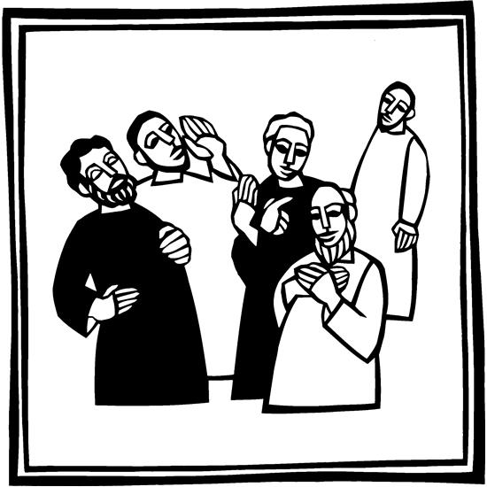
17th Sunday after Pentecost

September 19th, 2021
9:00am

Pastor Becky Sogge

Organist/Pianist: Loraine Mix

Lay reader: Jan Thompson

Special Music: Senior Choir
Sound/Video: Andrew Breitsprecher, Mark Willand
Counters: Lee & Becky Okerlund, Steph Perkins
Altar Guild: LYDIA Circle

Prelude -Loraine Mix

Welcome – Announcements

Confession and Forgiveness
Blessed be the holy Trinity, one God, whose teaching is life, whose presence is sure, and whose love is endless. Amen.
Let us confess our sins to the one who welcomes us with an open heart.
Silence is kept for reflection.
God our comforter: like lost sheep, we have gone astray. We gaze upon abundance and see scarcity. We turn our faces away from injustice and oppression. We exploit the earth with our apathy and greed. Free us from our sin, gracious God. Listen when we call out to you for help. Lead us by your love to love our neighbors as ourselves. Amen.
All have sinned and fall short of the glory of God. By the gift of grace in Christ Jesus, God makes you righteous. Receive with glad hearts the forgiveness of all your sins. Amen
Opening Hymn “All are Welcome” ELW 641
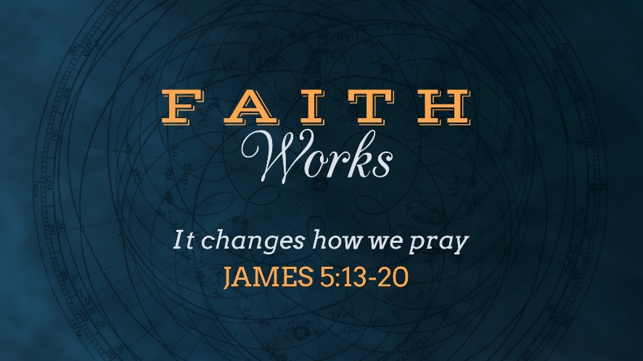
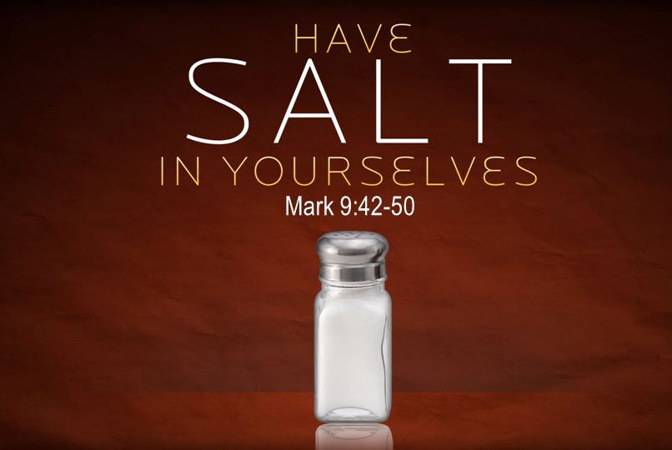
Bible Study on Tuesday: The readings for next Sunday
James 5:13-20: How do you care for the dizzying array of human problems and needs in your congregation and community?
Mark 9:38-50: What have you learned from Jesus about being at peace with others, especially those who set us on edge?
From workingpreacher.org

Announcements
Congratulations to Gene and Sarah Quam on the baptism of their daughter, Sofie Ann.
Congratulations to Jon and Donna Navratil on the baptism of their daughters, Aurora JoAnn and Solara June. Their sponsors are Julie & Brian Schutz, Jeremy Navratil and Carol Lukes.
If you did not receive the congregational letter regarding the special meeting ether in the mail or through an email, please take a copy from the welcome table.
Bell Choir is starting soon and we are looking for new members to play with us. If interested, contact Russ Knudson at 324-1237 or rdknudson1249@gmail.com.
The altar flowers are in celebration of Michael and Riley Gordon’s wedding.
“The Gifts to the Church” committee has to pictures that they are giving away if anyone is interested in them please contact the office or Janelle Johnson.

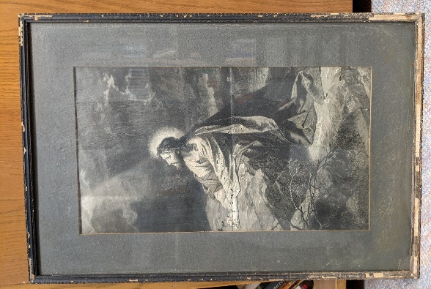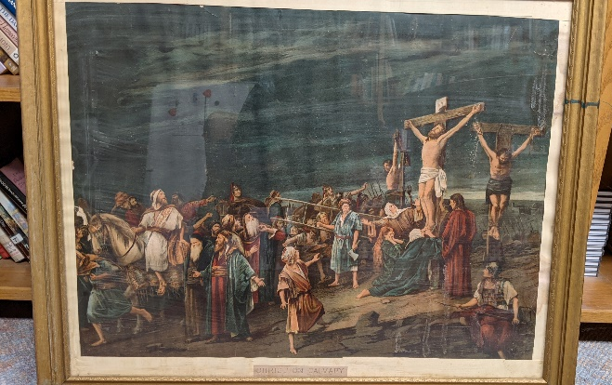

Greeting p. 138

Kyrie p. 138

This is the Feast p. 140

Prayer of the Day
O God, our teacher and guide, you draw us to yourself and welcome us as beloved children. Help us to lay aside all envy and selfish ambition, that we may walk in your ways of wisdom and understanding as servants of your Son, Jesus Christ, our Savior and Lord. Amen.
Special Music “Cannon of Praise” -Senior Choir

First Reading: Jeremiah 11:18-20
Word of God, word of life. Thanks be to God.

Psalm 54
Save me, O God, by your name; in your might, defend my cause.
Hear my prayer, O God; give ear to the words of my mouth.
For strangers have risen up against me, and the ruthless have sought my life, those who have no regard for God.
Behold, God is my helper; it is the Lord who sustains my life.
Render evil to those who spy on me; in your faithfulness, destroy them.
I will offer you a freewill sacrifice and praise your name, O Lord, for it is good.
For you have rescued me from every trouble, and my eye looks down on my enemies.

Second Reading: James 3:13-4:3, 7-8a
Word of God, word of life. Thanks be to God.

Gospel
(Before) The holy gospel according to Mark 9:30-37
Glory to you, O Lord.
(After) The gospel of the Lord. Praise to you, O Christ.

Children’s Sermon

Sermon Pastor Becky Sogge

Hymn of the Day “Jesus Loves Me!” ELW 595

Baptism Sofie Ann Quam

Prayers of Intercession
Lord, in your mercy, hear our prayer.
Peace

Offering is received in the plates at the entrance of the sanctuary or electronically through Give Plus+
Offering Prayer
Great Thanksgiving p. 144

Lord’s Prayer p. 145

Lamb of God p. 146
Prayer after Communion
Invitation to Communion
All who hunger and thirst, come. The table is ready.
Communion Blessing and Prayer
Blessing
People of God, you are Christ’s body, bringing new life to a suffering world. The holy Trinity, one God, bless you now and forever. Amen.
Closing Hymn “Lord, Dismiss Us with Your Blessing” ELW 545

Dismissal
Go in peace. The living Word dwells in you.

That all may know the love of God in Jesus Christ.
Thanks be to God.
Postlude -Loraine Mix
Copyright © 2020 Augsburg Fortress. All rights reserved. Reprinted by permission under Augsburg Fortress Liturgies Annual License #SAS020622. Used by permission.
Weekly Attendance and Giving
Date | Attendance | Giving
September 12 | 62 | 718.00
September 5 |  | $1,558.00
August 29 | 37 | $225.00
August 22 | 41 | $1,451.00

Mission Project for September
Bremwood Youth Home

