FIRST LUTHERAN CHURCH
Northwood, Iowa
641-324-2984
www.flcnorthwood.org
THAT ALL MAY KNOW THE LOVE OF GOD IN JESUS CHRIST
18th Sunday after Pentecost

September 26th, 2021
9:00am

Pastor Becky Sogge

Acolyte: Weston Willand

Organist/Pianist: Leila Gangstad

Lay reader: Rich Selvig

Special Music: Nikkole Koenig and Leila Gangstad
Sound/Video: Hayden Moore, Mark Willand
Counters: Randy & Laure Buehrer, Steph Perkins
Altar Guild: LYDIA Circle

Prelude -Leila Gangstad

Welcome – Announcements

Confession and Forgiveness
Blessed be the holy Trinity, one God, the God of manna, the God of miracles, the God of mercy. Amen.
Drawn to Christ and seeking God’s abundance, let us confess our sin.
Silence is kept for reflection.
God, our provider, help us. It is hard to believe there is enough to share. We question your ways when they differ from the ways of the world in which we live. We turn to our own understanding rather than trusting in you. We take offense at your teachings and your ways. Turn us again to you. Where else can we turn? Share with us the words of eternal life and feed us for life in the world. Amen.
Beloved people of God: in Jesus, the manna from heaven, you are fed and nourished. By Jesus, the worker of miracles, there is always more than enough. Through Jesus, the bread of life, you are shown God’s mercy: you are forgiven and loved into abundant life. Amen.
Opening Hymn “Come Thou Fount of Every Blessing” ELW 807

Greeting p. 138

Prayer of the Day
Generous God, your Son gave his life that we might come to peace with you. Give us a share of your Spirit, and in all we do empower us to bear the name of Jesus Christ, our Savior and Lord. Amen.
Special Music : “Be Still and Know”
by Steven Curtis Chapman, arr. by Tom Fettke

First Reading: Numbers 11:4-6, 10-16, 24-29
Word of God, word of life. Thanks be to God.

Psalm 19:7-14

The teaching of the Lord is perfect and revives the soul; the testimony of the Lord is sure and gives wisdom to the simple.

The statutes of the Lord are just and rejoice the heart; the commandment of the Lord is clear and gives light to the eyes.

The fear of the Lord is clean and endures forever; the judgments of the Lord are true and righteous altogether.

More to be desired are they than gold, more than much fine gold, sweeter far than honey, than honey in the comb.

By them also is your servant enlightened, and in keeping them there is great reward.

Who can detect one’s own offenses? Cleanse me from my secret faults.

Above all, keep your servant from presumptuous sins; let them not get dominion over me; then shall I be whole and sound, and innocent of a great offense.

Let the words of my mouth and the meditation of my heart be acceptable in your sight, O Lord, my strength, and my redeemer.

Second Reading: James 5:13-20
Word of God, word of life. Thanks be to God.

Gospel: Mark 9:38-50
(Before) The holy gospel according to Mark.
Glory to you, O Lord.
(After) The gospel of the Lord.
Praise to you, O Christ.

Children’s Sermon

Sermon Pastor Becky Sogge

Hymn of the Day “Christ, Be Our Light” ELW 715

Prayers of Intercession
Lord, in your mercy, hear our prayer.

Offering is received in the plates at the entrance of the sanctuary or electronically through Give Plus+
Offering Prayer

Lord’s Prayer
Our Father, who art in heaven, hallowed be thy name,
Thy kingdom come, thy will be done,
on earth as it is in heaven.
Give us this day our daily bread;
and forgive us our trespasses,
as we forgive those who trespass against us;
and lead us not into temptation, but deliver us from evil.
For thine is the kingdom, and the power, and the glory,
forever and ever. Amen.
Blessing
People of God, you are Christ’s body, bringing new life to a suffering world. The holy Trinity, one God, bless you now and forever. Amen.
Closing Hymn “Blest Be the Tie that Binds” ELW 656

Dismissal
Go in peace. The living Word dwells in you.

That all may know the love of God in Jesus Christ.
Thanks be to God.
Postlude -Leila Gangstad
Copyright © 2020 Augsburg Fortress. All rights reserved. Reprinted by permission under Augsburg Fortress Liturgies Annual License #SAS020622. Used by permission.

Mission Project for September
Bremwood Youth Home

Weekly Attendance and Giving
Date | Attendance | Giving
September 19 | 85 | $731.00
September 12 | 62 | $718.00
September 5 | 31 | $1,558.00
August 29 | 37 | $225.00

Announcements
Missing! Have you seen the glass bowl that is used in the baptismal font? If you know what happened to it, please contact the office.
(If it’s broken, that is okay, we would just like to know so we don’t keep looking for it.)
Bell Choir meets on Monday’s at 6:30pm and there is a spot for you! If interested, contact Russ Knudson at rdknudson1249@gmail.com.
The altar flowers are in celebration of Michael and Riley Gordon’s wedding.
“The Gifts to the Church” committee has to pictures that they are giving away if anyone is interested in them please contact the office or Janelle Johnson.

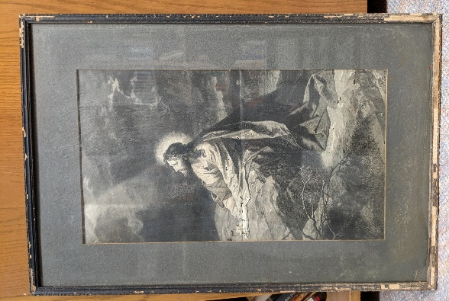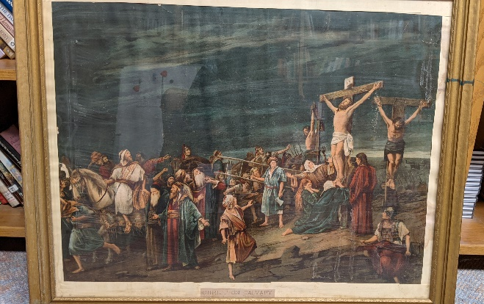

Weekly Calendar
Sunday, September 26 |  |  | 9:00 am | Worship Service with N.O.*
 |  | 10:00 am |  | Special Congregational Mtng
 |  | 10:10 am |  | Sunday School
 |  |  | 6:30 pm | JH. Youth
Monday, September 27 |  |  | 6:30 pm | Bell Choir
Tuesday, September 28 |  |  | 9:30 am | Bible Study
 |  | 11:00 am |  | Staff Meeting
 |  |  | 7:30 pm | AA –Al-Anon
Wednesday, September 29 |  |  | 5:45 pm | Confirmation
 |  |  | 7:00 pm | Choir Practice
 |  |  | 7:00 pm | SH. Youth
Thursday, September 30 |  |  | 8:30 am | Quilting
 |  |  | 9:00 am | Prayer Group
 |  |  | 6:30 pm | Taekwondo
Sunday, October 3 |  |  | 9:00 am | Worship Service with H.C.*
 | 10:10 am |  |  | Sunday School
 |  |  | 6:30 pm | JH. Youth

