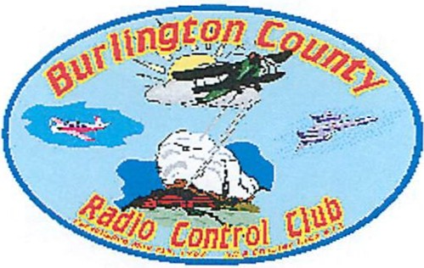

Burlington County Radio Control Club
Membership Application

Name: _____________________Date:__________
Address:_________________________________
City: ________________ State: ____Zip:________
Phone No:___________ AMA Number_________
E-mail address:___________________________
Birth Date:__________

If you are not a member of the “Academy of Model Aeronautics”,
Go to https://www.modelaircraft.org/joinrenew.aspx

Current Club Annual Membership Fee is: $ 100.00 With No Initiation Fee.
$ 2.00 Junior

Mail all applications to:

Anthony Rossi
23 Hughes Road
Somerset, NJ 08873

Make checks payable to: “BCRCC”. Please include proof of current AMA
Or send PayPal payment to:

p510851@gmail.com

Use friend or family
so the club doesn’t get charged and leave a note with your name

Club use only
Received by: _______________________Date:______________

