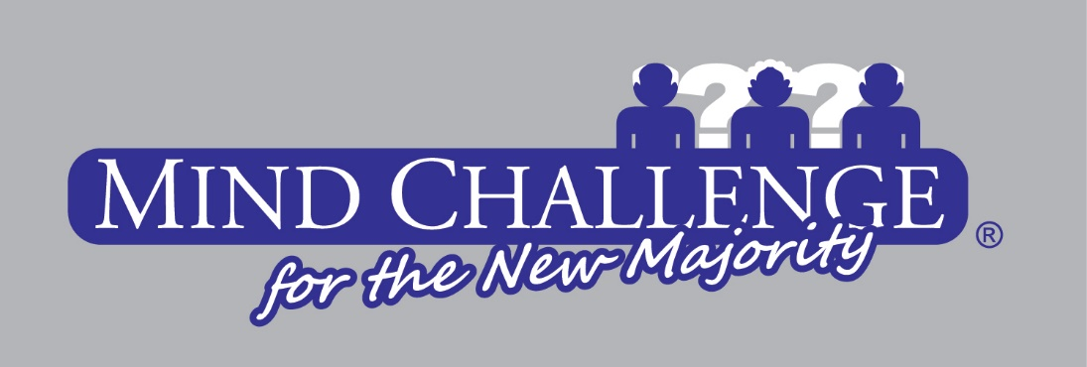
2026 MIND CHALLENGE WAIVER AND RELEASE OF LIABILITY
In consideration of my voluntary desire to participate in the 2026 Mind Challenge:
The undersigned does hereby waive, release, save, hold harmless and indemnify Score Communications,
Get Lucky Trivia, the 2026 Mind Challenge cities and the 2026 Mind Challenge sponsors.
(“The Releasees”), their organizers, officers, employees, agents, and sponsors for all claims or
damage for personal injury or sickness to me or loss of property which may be caused by any act or
failure to act on the part of “The Releasees” for the 2026 Mind Challenge. The undersigned further
assumes the risk of any conditions including but not limited to travel to and from 2026 Mind Challenge
events to which they may be exposed during the course of such activities, and waives any and all notice
thereof.
This Waiver and Release shall remain in effect for the duration of my participation in the 2026 Mind
Challenge during these initial and subsequent events of participation. It is also subject and be governed
by for all purposes by Ohio law, without regard to any conflict of law principles.

ACCEPTED AND AGREED: DATE:

____________________ ___________

SCORE COMMUNICATIONS DATE:

______________________ __________

