Live in Workers and EVV

DHS does not require EVV use for live-in workers, but a worker’s live-in status must be verified at enrollment and annually. LKi must have a live in worker form and documentation of residency on file for purposes of audit by the state. LKi has chosen the month of March for the annual collection of the live in worker documentation. A form will be sent out to all live in workers the first half of the month.

For the purposes of EVV, a live-in worker is a worker who meets one of the following requirements:
• The worker permanently resides in the same residence as the member or participant receiving services.
• The worker permanently resides in a two-residence dwelling (such as a duplex) where the member or participant receiving services lives in the other half of the dwelling and is a relative of the member or participant receiving services.
Permanent residency is determined by the worker being able to produce documentation that shows the worker’s name and current residential address and matches what we have on file. The worker may use one document from Column A or two types of documents from Column B.
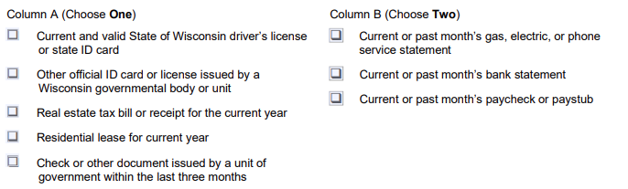

Spring is when you feel like whistling even with a shoe full of slush! – Doug Larson

-----------------------Your LKiChoice Contacts: -----------------------
Beth Adrian-Peters
EVV Specialist
(608) 326-0434 ext. 284, FAX (844) 634-7225
E-mail: Beth.Adrian-Peters@LKiChoice.com

