CASE PRESENTATION
CLINICAL HISTORY
- 24 Y/F presented with renal dysfunction for 10 days
- Fever and vomiting for 10 days
- History of herbal medicine intake for infertility 10 days back (medicines were consumed for a period of 10 days)
- Known case of hypothyroidism on treatment for 6 years
- Known case of PCOD
- Not a diabetic or hypertensive
INVESTIGATIONS
- Hemoglobin – 6 g/dl
- Serum Creatinine – 10 mg/dl
- Urine microscopy – No RBCs
- Serum Bilirubin – normal
- Peripheral smear – Normocytic normochromic, Corrected Reticulocyte count – 1
CLINICAL DIAGNOSIS: Acute Renal Failure
CLINICAL COURSE: Patient underwent dialysis and was also transfused with 4 units of Packed RBCs.
KIDNEY BIOPSY:
HE (100X)

HE (100X)
HE (200X)
PAS (100X)
PERLS PRUSSIAN BLUE (100X)

PERLS PRUSSIAN BLUE (100X)
Immunofluorescence:
IgG, IgA, IgM, C3, C1q, Kappa and Lambda - Negative
Kidney biopsy report:
Glomeruli appeared histologically unremarkable. There was no evidence of mesangial hyper cellularity or crescents. There was marked Acute Tubular Necrosis with hemosiderin deposition in the tubules, which was highlighted by Perls Prussian Blue stain. Occasional tubules showed neutrophilic cast. Tubular atrophy is not evident. Interstitium showed edema and mild inflammatory infiltrate comprising of neutrophils and lymphocytes. Minimal interstitial fibrosis present.Blood vessels appeared unremarkable.

ANSWER THE QUESTIONS:
- What is the diagnosis?

- What are the additional investigations recommended for confirming the diagnosis?

Answers:
- What is the diagnosis?

Acute tubular necrosis suggests Paroxysmal Nocturnal Hemoglobinuria (PNH)

- What are the additional investigations recommended for confirming the diagnosis?

- Tests to exclude other causes of hemolytic anemia: Peripheral smear, Direct Coomb’s Test
- Ham’s acidified serum test: RBCs are lysed in an acidic pH in presence of complement
- Flowcytometry: for detecting an quantifying PNH clones (CD55 & CD59 negative) in the RBC and WBC population

CLINICAL COURSE:
Suspicion of PNH was then confirmed by Bone marrow examination and Flow cytometry at JIPMER. Bone marrow examination showed erythroid hyperplasia.

FLOWCYTOMETRY IMAGES OF PERPHERAL BLOOD:
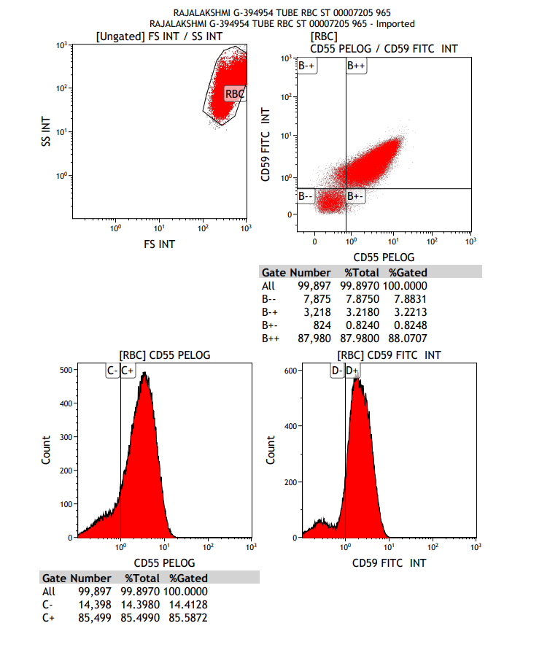

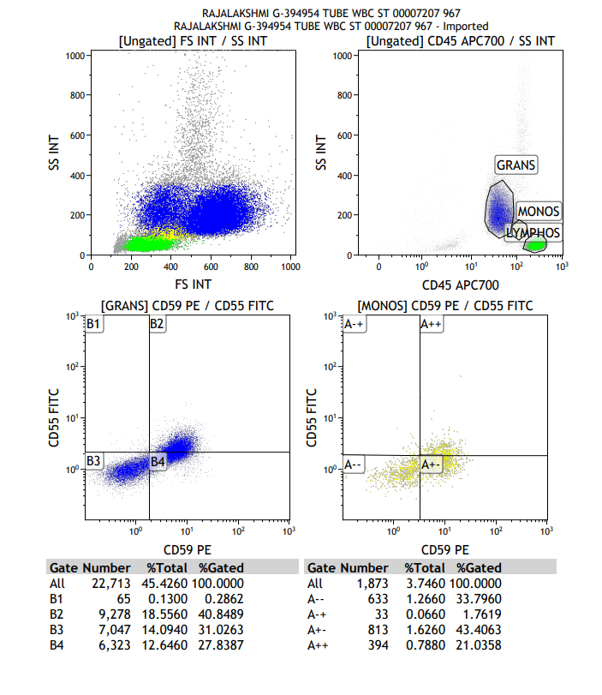
Flowcytometry Report:
PNH clone is detected in RBC – 8.2%
WBC: Granulocytes – 31.02% & Monocytes – 34%
Discordance in clone size of RBC & WBC is attributed to hemolysis/transfusion

DISCUSSION
PNH (Paroxysmal Nocturnal Hemoglobinuria) is a rare acquired clonal disorder. This disease is caused by a mutation of PIG-A gene on Chromosome X, resulting in a partial or complete deficiency of GPI- anchored membrane proteins on hematopoietic stem cells and their cellular progenies. CD55 (Decay Accelerating Factor) and CD59 (Membrane Inhibitor of Reactive Lysis) are the two important complement regulatory proteins belonging to GPI-anchoring protein (GPI-AP) family. Deficiency of these proteins renders the RBCs abnormally sensitive to lysis via alternative complement pathway activation.
Common clinical presentations are usually attributed to hemolysis, bone marrow failure or thrombosis. Renal involvement is not clinically apparent. But in those cases presenting with significant renal disease, usual manifestation is acute renal failure and rarely a chronic kidney disease. However, the association between PNH and renal failure is considered disputable. A few authors have attributed presence of concomitant renal disease or transfusion reaction as causes of renal failure in PNH.
Hemosiderin deposition in renal tubular epithelial cells is the most consistent histopathological feature reported in kidney biopsies done in PNH patients, irrespective of their renal function. Additional findings described include urate crystals, cellular casts/debris in tubules and acute interstitial necrosis. Microinfarcts can occur due to venous sludging. Interstitial fibrosis can also happen and can lead to progressive and irreversible renal dysfunction.
A similar hemosiderin deposition in renal epithelial cells is also seen in many other hemolysis associated conditions including Autoimmune Hemolytic Anemia, mismatched blood transfusion and infections like malaria. An absence of schistocytes, nRBCs or reticulocytosis in peripheral smear and normal serum Bilirubin levels of this patient excluded the possibility of an acute event of hemolysis, thereby eliminating above mentioned possibilities. However, PNH is known to cause chronic intravascular hemolysis without a proportional reticulocytosis and often patients with subclinical PNH may not have clinical or even laboratory evidence of hemolysis.
When there is intravascular hemolysis, hemoglobin is broken down into alpha-beta dimers and that, if unbound to haptoglobin, are filtered by glomerulus and results in hemoglobinuria. Renal tubular epithelial cells absorbthese hemoglobin dimers, which are later degraded, releasing free chelatable iron. It is suspected to be the mediator of free radical injury to renal tubular epithelial cells. Free chelatable iron is stored in tubular epithelial cells as hemosiderin. Under normal circumstances, hemosiderin is only mildly nephrotoxic. But the presence of low blood volume and aciduria can induce hemoglobinuria associated acute renal failure.
Acute Renal Failure in PNH is mostly associated with sudden and severe intravascular hemolysis and this is usually reversible. In the absence of an acute severe hemolysis in this case, acute tubular necrosis may be attributed to multiple other coexisting conditions in this patient. Vomiting causing dehydration, this by itself and also by enhancing the nephrotoxicity of hemosiderin or the intake of herbal medicine may cause Acute Renal Failure. Role of PNH in this case can be perceived as either a persuader or an innocent bystander, a possibility of former being higher than later. It can still be the sole contributor to Acute Renal Failure in this case; a situation rarely encountered in clinical practice and needs further studies to confirm the same.

CONCLUSION
The presence of hemosiderin deposition in renal tubular epithelial cells in the absence of other clinical or laboratory evidence of acute hemolysis should raise the suspicion of possibilities of conditions associated with chronic hemolysis like PNH. Acute Renal failure in PNH patients without acute hemolysis is an area which needs further exploration.

REFERENCES
- Clark DA, Butler SA, Braren V, Hartmann RC, Jenkins DE Jr. The kidneys in paroxysmal nocturnal hemoglobinuria. Blood. 1981 Jan;57(1):83-9
- Puri V, Gandhi A, Sharma S. Renal Biopsy in Paroxysmal Nocturnal Hemoglobinuria: An Insight into the Spectrum of Morphologic Changes. Indian J Nephrol. 2017 Jul-Aug;27(4):284-288. doi: 10.4103/0971-4065.202833
- Qi K, Zhang XG, Liu SW, Yin Z, Chen XM, Wu D. Reversible acute kidney injury caused by paroxysmal nocturnal hemoglobinuria. Am J Med Sci. 2011 Jan;341(1):68-70. doi: 10.1097/MAJ.0b013e3181f515b9
- Nair RK, Khaira A, Sharma A, Mahajan S, Dinda AK. Spectrum of renal involvement in paroxysmal nocturnal hemoglobinuria: report of three cases and a brief review of the literature. IntUrolNephrol. 2008;40(2):471-5. doi: 10.1007/s11255-008-9356-5.

