**Diagnosis – Collagenofibrotic glomerulopathy**

**Discussion**

Collagenofibrotic Glomerulopathy (CG) is a rare condition characterized by deposition of type III collagen fibres in the mesangial and sub-endothelial space of the glomerulus. Fewer than 100 cases have been described in the literature under several names, including primary glomerular fibrosis, collagen III glomerulopathy, and collagenofibrotic glomerulopathy. Publication of articles related to this entity began in the late 70's, the first report being from a team of Japanese doctors who considered this disease to be either a variation of Nail-Patella Syndrome or a different entity. The patients ranged in age from 2-66 years, with no sex predilection. The most common clinical presentation is proteinuria with or without associated nephrotic syndrome, with minor alterations in renal function. CG is relatively common in the Asian continent.

The etiopathogenesis of this glomerulopathy remains unclear. Clustering of the cases from Japan, points to an environmental or ethnic factor in causation of the disease. Occurrence of the disease in siblings points to genetic etiology. Although the pathogenesis of this disease is still unknown, there are two major theories about the origin of spiralled and frayed collagen. One concept is that the abnormal collagen is produced in house by the mesangium; alternatively, type III collagen is derived from other organs and accumulates in the mesangium. Although it is reported that mesangial cells are capable of synthesizing type III collagen by using in situ hybridization techniques, the primary production site of abnormal collagen does not seem to be kidney in collagenofibrotic glomerulopathy.

Histopathologically, the light microscopy shows lobular bland appearing glomeruli due to global expansion of the mesangium with no substantial mesangial hypercellularity and peripheral capillary wall thickening. The mesangial expansion is due to the accumulation of amorphous weakly PAS-positive material mimicking amyloid deposits, however Congo red and thioflavine stains are completely negative.On Masson Trichrome stain, the deposited material reveals blue staining. The capillary lumina are narrowed but not occluded. The peripheral capillary wall show thickening and focal reduplication, however PAS and methenamine silver stain clearly highlights that the capillary wall are thin and thickening is due to sub-endothelial deposition of pale amorphous material. Usually no endocapillaryor extracapillary proliferation is seen in CG. In advanced stage, capillary lumens are narrowed by the expanded mesangium and thickened capillary walls and glomeruli show a nodular appearance suggestive of diabetic nephropathy and light chain deposition disease. However, unlike these two entities the nodular lesions are weakly PAS positive or PAS negative in CG. Patchy tubular atrophy and interstitial fibrosis may be present, and these changes are proportional to the degree of global glomerulosclerosis. Arteriolar hyalinosis and thickening of the walls of arteries sometimes are seen, probably secondary to hypertension.

Staining for immunoglobulins and complement components usually is negative. Focal and segmental trapping for immunoglobulin M and complement C3 may be found in glomeruli, corresponding to the sub-endothelial hyaline deposits seen on light microscopy, which probably represent insudated plasma proteins and are not indicative of immune complex mediated process.

Electron microscopy is essential to establish a definitive diagnosis. The pathologic findings are rather peculiar and should be recognized with certainty when identified in the routine ultra structural evaluation of a renal biopsy specimen. The electron microscopy of CG is characterized by massive accumulations of banded collagen in glomerular mesangial and sub endothelial zones. Banded collagen (e.g. type I and type III) occurs focally and in small amounts with many forms of glomerular injury, but is usually, but not always, inconspicuous ultra structurally, even with advanced glomerular sclerosis. Most matrix expansion in the sclerosis of injured glomeruli is caused by increased non-banded type IV collagen. Abnormal accumulation of banded collagen is an ultra structural pathologic hallmark of nail-patella syndrome glomerulopathy; however, in this disease, the profiles of banded collagen occur predominantly within the lamina densa of glomerular basement membranes; whereas, in collagenofibrotic glomerulopathy, the abnormal collagen bundles are predominantly in the sub endothelial zone and mesangium. At high magnification, the fibrils appear curved, frayed, and worm- and comma-shaped when sectioned transversely, and they show a distinct periodicity from 43 to 65 nm. The fibrils typically arrange in irregular bundles when cut longitudinally. Because of the typical periodicity of banded collagen, as well as the shape, size and organization of the bundles, the atypical type III collagen fibrils in CG can be clearly differentiated from the fibres of regular type III collagen (which usually look like straight lines when cut lengthwise) and other types of organized glomerular deposits, e.g. the deposits of amyloid, fibrillary glomerulonephritis and immunotactoid glomerulopathy. However, the banded morphology of collagen fibrils can be identified with routine staining for electron microscopy, but it is visualized more clearly by special staining with tannic acid– lead or phospho-tungstic acid. Discrete electron-dense immune complex–type deposits usually are not present, although sub endothelial dense deposits can be seen infrequently. Variable degree of epithelial foot process effacement is usually seen.

Demonstration of collagen III in the expanded mesangial areas is imperative to confirm the diagnosis. Collagen III immunohistochemistry shows either focal, segmental, or diffuse and generalized mesangial staining, primarily depending on the stage of the disease process. Immunostaining for other collagen types typically is negative; however, there were a few cases in which both types III and I or III and V could be detected.

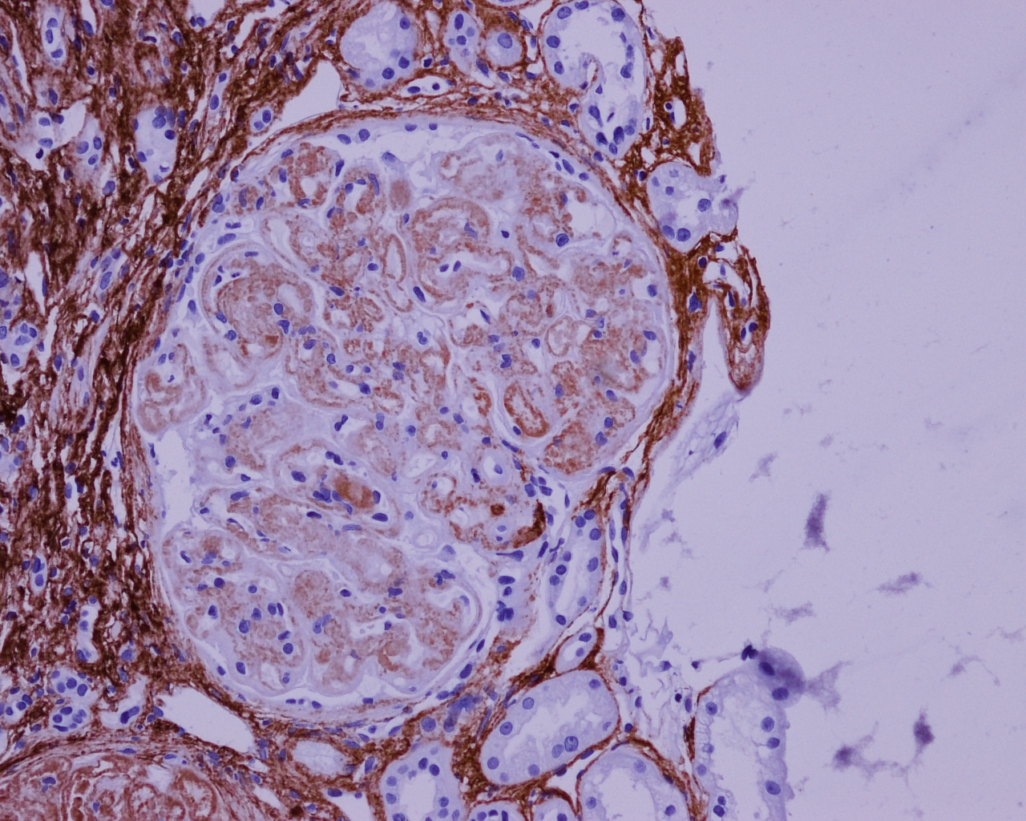

**Collagen type 3 immunohistochemistry**

**Answers to MCQ**

**Question 1. What is the pattern of glomerular injury ?**

-Membranoproliferative pattern of glomerular injury

**Question 2. What is the name of this glomerular lesion ?**

Collagenofibrotic glomerulopathy

**Question 3. Which immunohistochemical stain is useful in confirming this glomerular pathology ?**

Collagen 3 immunohistochemistry

**Question 4. Is this disease common in Asian countries ? (Yes/No)**

Yes

**References :**

1.Alchi B, Nishi S, Narita I, Gejyo F. Collagenofibrotic Glomerulopathy: Clinicopathologic overview of a rare glomerular disease. Am J Kidney Dis. 2007;49:499-506.

2.Duggal R, Nada R, Rayat CS, Rane SU, Sakhuja V, Joshi K. Collagenofibrotic Glomerulopathy – a review. [Clin Kidney J.](https://www.ncbi.nlm.nih.gov/pmc/articles/PMC4400455/) 2012 Feb; 5(1): 7–12.