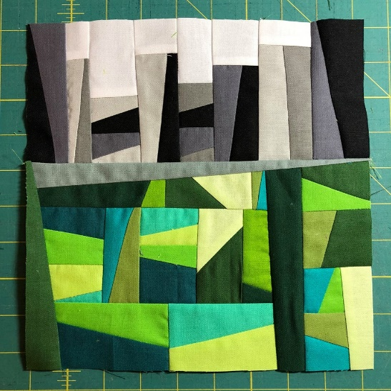

**Canadian Modern Quilt Guilds – Block Lotto Challenge**

**Wedges as Topography**

**General Lotto Rules:**

1. Make one quilt block (or more) following the pattern and color scheme outlined in the post.  Please see this link for video details;

https://www.youtube.com/watch?v=RtM9VBfutF4&feature=youtu.be

For every block you make and bring to the November meeting, you will get one entry in the lotto.  If you are unable to attend the meeting, but really want to participate in the lotto, mail or drop them off prior to the meeting to: WMQG,146 Kinlock Lane, Wpg MB, R3T 1B6.  Make sure to attach a name to your block!

2. The winner gets **all the blocks** to make a quilted project from them (guild reserves the right to vote on splitting up the blocks between more than one winner if there are enough entries).  If you win, the blocks become yours and you can use them in any way you choose. You may only win one group per lotto.

3. We would like to see your finished project, either in person or pictures, within a year of winning the blocks.

4. Have fun!  Keep in mind that (most likely) someone else will be taking home your block to incorporate into a larger piece and things must fit together (literally, …so keeping your block true to size is probably the most important thing), but you should also make it yours and enjoy the process!  
  
5.  Remember, you must be a member of Winnipeg Modern Quilt Guild to participate.

Please hashtag your pictures on Instagram

**#cdnmqgblocklotto2018**

**#wedgesastopography**

**#winnipegmqg**