Price List

**Pool Swim**

Sessions include a trained hyrotherapist in the pool with your companion at all times. We can book two companions from the same family which will require two hydrotherapist’s in the pool. Life vest hire, toys and or treats for motivation are included in the price. We will replace your collar with one of ours when you arrive so you have a dry collar to go home with.

All bookings are exclusive to your companion and family and your companion will not be swimming with other clients. Session notes and records are kept for all swims.

At the end of the session you are welcome to use our shower wash off area and shampoo and dry off your companion with our complementary extensive range of Australian made Pro groom and Aloveen Shampoos and Conditioners. A heated blow dryer is available.

Initial session- Including assessment of your companion’s condition, completion of administration paperwork, gait assessment, discussion of goals and outcomes, treatment plan and a pool session. Please be aware this may shorten the swim time for the first session depending on the condition of your companion.

Pool Swim

One companion Second companion

From same family

30 minute session $50 $25

Block of 10 sessions $450 ($45 each saving $50) $200 ($20 each saving $50)

**A five minute swim is equal to a 5 km run on land due to the resistance of the water**

**Under Water Treadmill**

All sessions will have a minimum of one trained hydrotherapist with your companion. With rehabilitation clients we will have multiple therapists assigned and often in the treadmill supporting your loved one. All sessions are tailored to the individual.

Price includes the supply of life vests or harnesses, toys or treats for motivation.

We have four portable CCTV cameras that we can locate around the treadmill that project onto a split screen television so that we always get a full view from all angles. These can be recorded and provided to your Vet on request so they can get a complete picture of how the sessions are progressing and it allows your Vet to suggest feedback for best treatment of your companion.

Session notes and records are kept for all treatments.

At the end of the session you are welcome to use our heated shower wash off area and shampoo and dry off your companion with our complementary extensive range of Australian made Pro groom and Aloveen Shampoos and Conditioners. If you require assistance with showering we are more than happy to help.

Sessions

30 minutes $70

Block of 10 sessions $600 ($60 each saving $100)

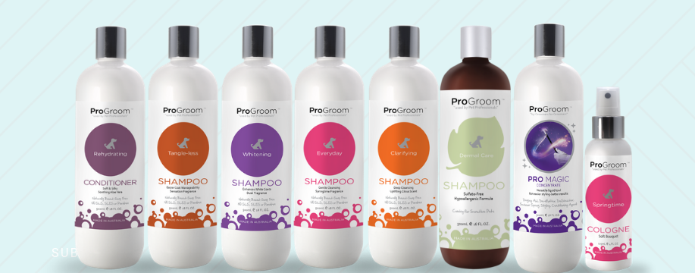

**DIY Wash**

Not having a hydrotherapy session but would like to wash your companion in an indoor environment? We have you covered, book in for a self service wash only using our Pro Groom and Aloveen range and blow dryer if required.

$10 per wash