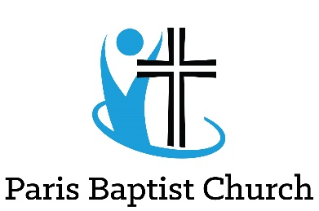

**Registration 5 Day Club**

July 13-17, 2020

From 10:00 -11:00 a.m.

**Child Information (Fill out separate for each child)**

Name:

Last First

Street Address: Apt. #: Postal Code:

City: Gender: Male Female Age:

Grade by September 2020: How did you hear about this program?

Does your child attend church? Yes No Church’s name:

Are there any **physical or behavioural** concerns we should be aware of?

**Parent/Guardian Information:**

Name:

Last First

E-mail:

**General Information:**

1. The Camp Leader reserves the right to dismiss a child who is a hazard to the safety of others, or has appeared to reject the reasonable rules of the program.
2. The Parent/Guardian signing this form has legal custody over the child. All information provided will be kept in strict confidence; respecting the privacy of families.
3. Paris Baptist Church and CEFOntario may use any photograph or video footage my child appears in for promotional purposes. **Yes** **No** **(Please initial) ________**

I have read through the application and accept the conditions of enrolment and cancellation for my child to participate in 5 Day Club at Paris Baptist Church.

Parent Name (Print): Date:

Please email this form to [parisbaptist@rogers.com](mailto:parisbaptist@rogers.com)

**Please include email so we can send you the link for the Zoom Summer Program.**