**Double/Triple Braid Set Up**

**Using a lasher (3/16” fo), an anchor piece (7mm fo), and braiding weavers (fine cane). Your choice of size of braiding materials.**

* Weave lasher until desired location to start the braid, tucking end at start.
* Add weavers as illustrated. Place new braid weaver under the anchor and over the lasher that runs under the anchor piece.
* Place braid weavers with wrong side facing up.
* Wrap lasher over anchor piece, then under anchor between each add on.
* Each level of braid weaver will sit on top of the lasher wrapped under the anchor, with wrong side facing.

**Double & Triple Braid Weave**

* Starting at the bottom with the first braid weavers, (start with ride side or left, but always the same), twist to wrap braid with right side of weaver facing up, cross over all levels and under the anchor base piece (on top of the lasher), twisting to keep right side of reed/cane laying wrong side up on top of the lasher that runs under the anchor piece. (Illustration shows crossing from right to left first, then tucking under the anchor, then left to right, tucking under).
* Wrap lasher over the anchor piece, around, then under it, keeping right side facing up. Repeat with the next level of weavers.

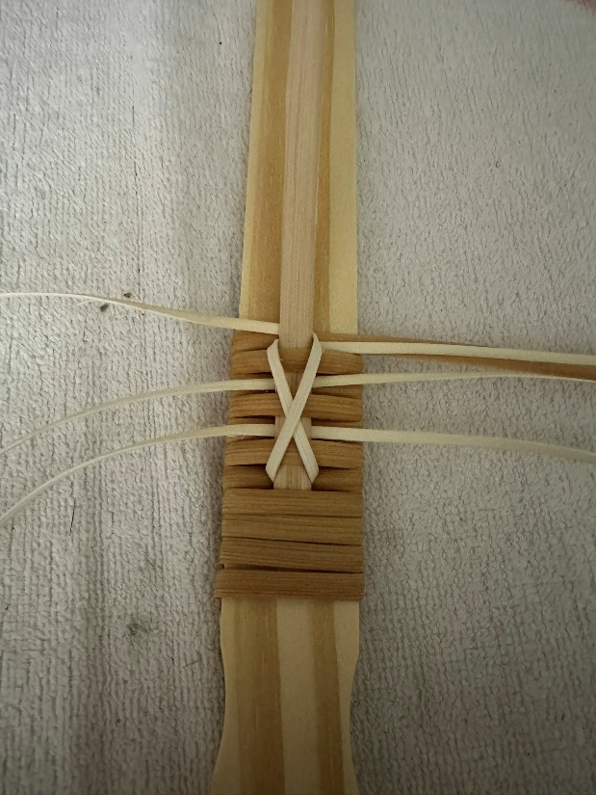

* Continue pattern starting right to left or left to right as desired, but always the same.
* Wrap the lasher over, around, then under, around, between each braid. Snug up. A close-up of a woven basket

  AI-generated content may be incorrect.

**Ending the Braid**

* Weave each set of weavers one at a time, laying flat to the surface, NOT wrapping around the anchor piece, as previously.
* Then wrap lasher over the braid ends and anchor and then again over the braid ends, but under the anchor piece, as illustrated.
* Repeat with each set of braid weavers, starting with the lowest set first.

* Straighten the weavers and snug up.

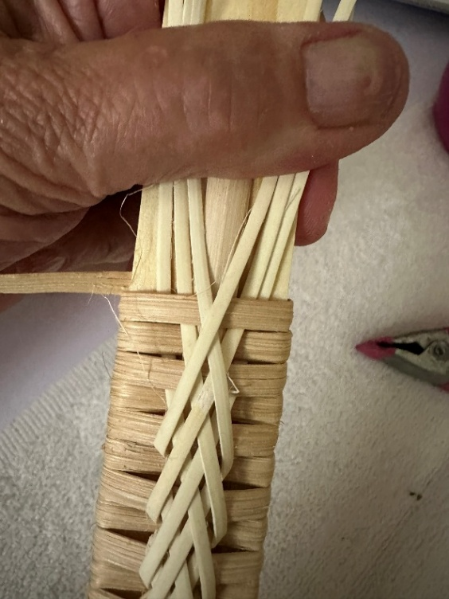

* Continue wrapping the lashing to the end over anchor and weavers.
* Tuck the lasher in the back to secure.
* Trim ends.

**Using 3/16”fo lasher as wrapper and braiding weavers, use a smaller anchor (1/4”ff illustrated).**

* Set up and ending is always the same, ending larger braiding weavers illustrated below.
* Start with braid pieces at the bottom of your braid.

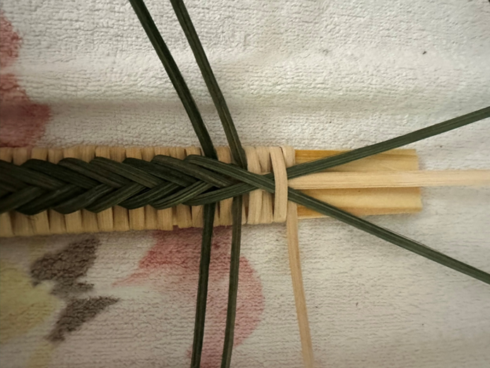

* Wrap the lasher over and under, repeat with each braiding weaver. You can adjust this if you do not like the way it looks at the end. It’s personal preference and looks different with size of braids.

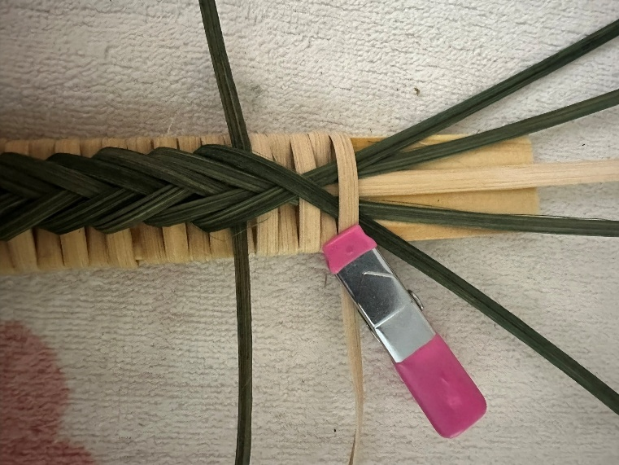

* Wrap the lasher over everything to the end and tuck the end to secure. Trim ends of braid weavers.

**Far left** using 3/16” lasher for wrap and anchor, fine-fine cane for braiding. Size of the braiding weavers and the anchor determine size of the braid.

**Middle** using 3/16” lasher for wrap, 7mm fo for anchor, and fine cane for braiding weaver.

**Far right** using 3/16” fo lasher for wrap and braid weavers, ¼” ff anchor piece.

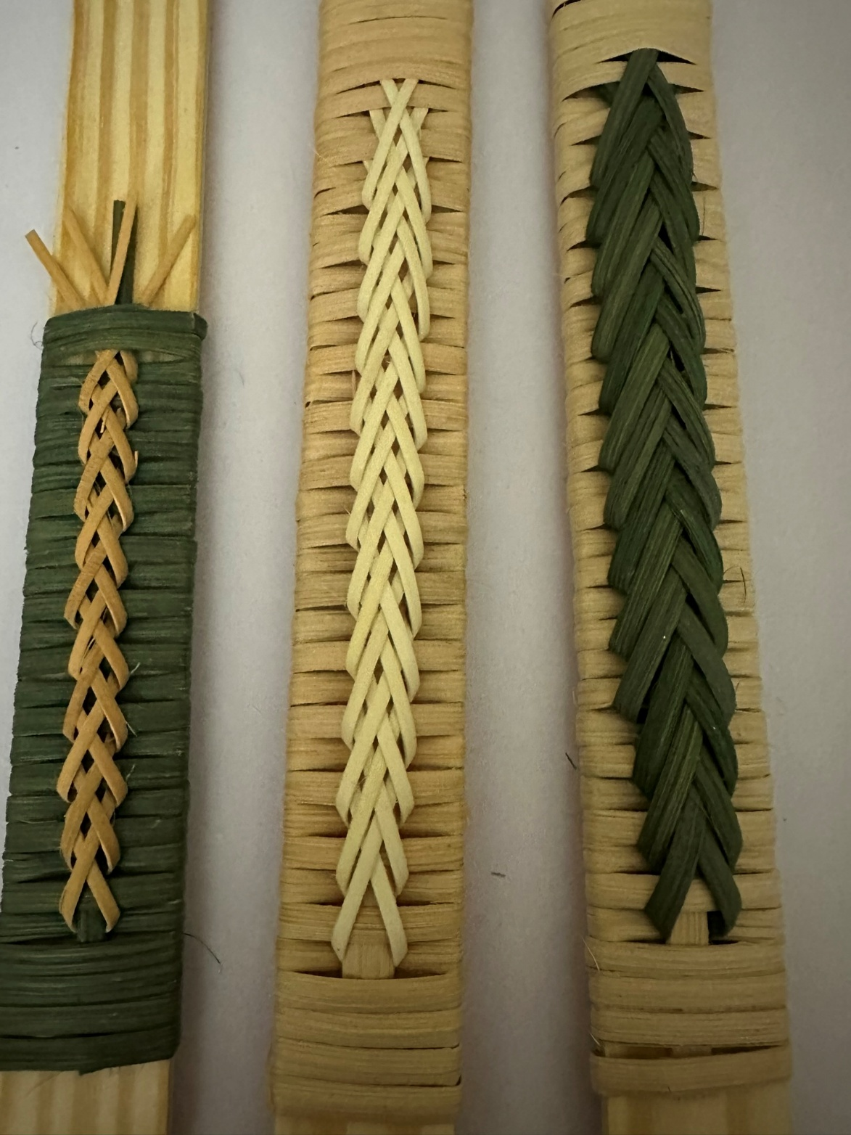

**Paint stick width and length requires:** 9 inches for anchor piece, approximately 9 feet of lashing wrapper, and 2-3 36” lengths of weavers (depending on double vs triple braid).

**Estimate around 1 foot per inch for wrappers.** If your basket handle is narrower and/or shorter, adjust accordingly. If your wrapper will not complete the handle, stop/start new piece underneath the center of the handle to make it less visible.

**Other Cute Ideas**

