Impact of your Emotions on your Health

Date: 4.13.2018

Created by: Edith Sellman

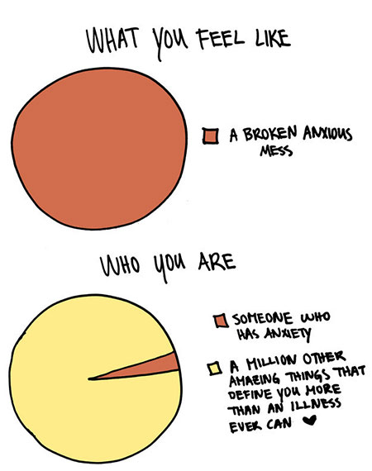

How you might reflect on your own everyday experience for a moment:

Have you noticed how holding a thought can lead to a body reaction? Are there particular stories or thought patterns that you have repeatedly?
- Have you recognized how they connect with feelings of fear, anxiety, or worry?
- Have you ever noticed how your own body is recruited into action by these thought patterns and stories?
- Common expressions demonstrate that many people have observed such mind-body connections:
  - He was bursting with anger
  - She died of a broken heart
  - He worried himself sick
  - She was scared to death
- These are but a few familiar examples of how we acknowledge in everyday language the power impact of thoughts and emotions on health. Medical researchers have made interesting discoveries in recent years about the link between thoughts, emotions and health. (Book: Calming your Anxious Mind, by Jeffrey Brantley, MD)
A-Type Personalities: Redford Williams of Duke University Medical Center is a pioneer in the field of behavioral medicine. His work has led to a much clearer understanding of the connection between hostility and illness, especially the effects of hostility on the human heart.
In the 1960’s cardiologists identified behavioral characteristics that seemed to be present in most of their cardiology patients:
- Constant hurriedness
- Intense competitiveness
- Free-floating hostility.
Worry: Worry is another way thoughts and feelings can affect health. We have seen how worry can be understood as the patterns of thinking driven by feelings of anxiety. Often, the content of the thoughts reflects a person’s attempt to cope with or eliminate the discomfort and ill ease present as part of their experience of anxiety.
- ⅔’s of Americans classify themselves as worriers
- ½ of that group classify themselves as moderate worriers who worry 10-50% of the day;
- The rest of the worrier’s report that they worry 8+ hours a day;
- Worry has been related to health problems. These include cardiac arhythmias, increased blood pressure, asthma in both adults and children.
- Uncertainty is particularly potent and toxic.
- When people are confronted by situations of high uncertainty, and they do not know what will happen next, or how they should act, they can experience destructive feelings of helplessness and frustration. Uncertainty keeps people in a constant state of semi-arousal, unable to relax.
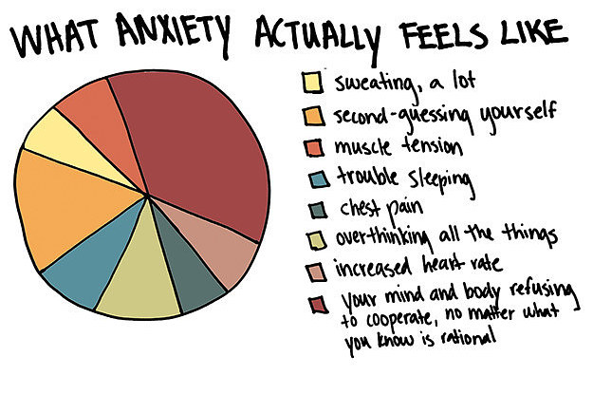
Attitudes and Beliefs: Besides anger and worry, deeply held attitudes and views of self and the world have been demonstrated to have potent effects on health.
- The power of attitude has come under intense scrutiny by health researchers. Of particular importance to your health are thought patterns that shape your sense of personal power and control, your confidence in your ability to handle problems and stress, and your sense of hope and optimism or pessimism about situations you face.
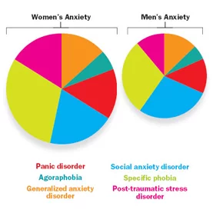
Stress Hardiness: describes the qualities of individuals who managed stress with few or no significant health problems. The three elements of stress hardiness are:
- Commitment: means a deep and abiding interest and involvement in what is happening around you, including yourself, others, work, and a set of important values. In other words, feeling a sense of connection is important.
- Control: means being confident that you have the ability to cushion the hurt or destructiveness of a particular stressful situation. It does not mean that you have to control other people or all aspects of a situation. Control is the refusal to become a victim. It is the ability to focus on what you can control and not be distracted by what you cannot.
- Challenge: means having the ability to greet the stressful situation as an interesting opportunity for growth and excitement. This inevitably means also welcoming and accepting change, which is constant, rather than feeling overwhelmed by it.
Explanatory Style: how do you explain to yourself what is means when something bad happens to you? The results of research in this area indicate, in truth, we are what we think.
- Pessimists: Tend to view themselves and most situations negatively. They tent to blame themselves for all the ‘bad’ events happening to them, and they tend to catastrophize, or inflate every situation into the worst thing imaginable.
- Pessimists have worse health outcomes, and the correlation is so strong that the pessimistic style actually has predictive value. In other words, researchers have been able to predict which members of a study would have negative health outcomes based solely on their style of viewing life events pessimistically.
- Optimists: tend to see the good situations, expect things to go their way, see controllable aspects to situations and focus on those, resist giving up easily, and avoid blaming themselves for what has happened.
- In contrast to pessimists, individuals with an optimistic style have repeatedly been shown in studies to have better health outcomes. It is even suggested that having an optimistic style can actually protect you from getting sick.
When you recognize and understand the attitudes, views, and emotions operating within you, you gain the power to evaluate and change your attitudes.
While this change can take time, and varies from person to person, the message is clear. You can be a healthier person by recognizing and managing the power of your own thoughts and emotions.
How Mindfulness Can Help: Mindfulness is an awareness that is not thinking. It is an awareness that is capable of recognizing thoughts and emotions as they occur and does not identify with them. Mindfulness is friendly, non-judging, allowing, present-moment awareness.

Keep in Mind
- Thoughts are powerful. They can have a helpful or a harmful interaction with the body’s fear system and the experience of anxiety. You can learn to manage the power of your thoughts and their effects on fear.
- You may not be able to stop your thoughts or control your thoughts. But you can learn not to identify with them and not be believe them automatically.

The Value of Mindfulness
- Most of us all walk around as if we’re sleepwalking. We really don’t experience the world fully, because we’re half-asleep, doing things we automatically think we have to do.
- As a human being, you already have what you need to experience the preciousness of each moment. You have the quality you need to open to what scares you instead of hardening into resentment and fear.
- Mindfulness or Mindlessness?
- Holding fixed views and mind-sets can make us blind to things right in front of us, and how we pay a high price for this.
- Mindfulness is based on meditation.
- You can teach yourself the art of attention and awareness by developing and maintaining a stable and dependable mindfulness meditation practice

Smiling and Kindness:
- Kindness is a vital characteristic of mindfulness. Many meditation teachers emphasize the importance of having a friendly or welcoming spirit toward whatever arises when practicing mindfulness.
- The welcoming spirit of kindness or friendliness helps you to be more open to moment by moment experience. It also helps you overcome the deeply rooted habits of judging and aversion that often operate strongly just out of awareness and interfere with your being present and paying attention on purpose.
- The popular meditation teacher, Thich Nhat Hanh, invites his students to smile more when meditating. In his 1987 book “Being Peace”, Hanh tells us that “life is both dreadful and wonderful. To practice meditation is to be in touch with both aspects.
- To meditate well, we have to smile a lot. “This is the only moment that is real. To be here now, and enjoy the present moment, is our most important task.”
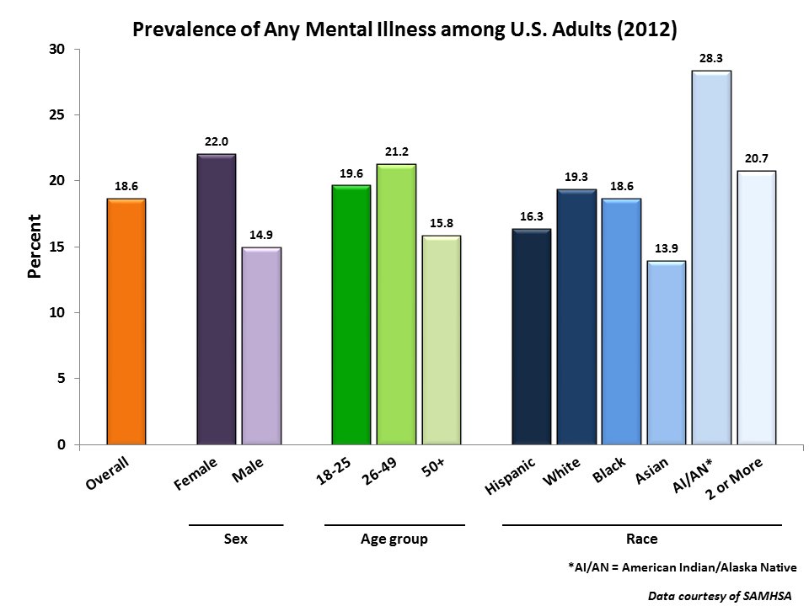

Feeling:
- Because mindfulness practice increases your awareness of and sensitivity to everything, including pain and fear, you should be aware that you may actually feel worse in the beginning.
- However, this is only a stage in the process of healing and transformation. As your meditation practice strengthens, you will learn to relax and stay present even when anxiety, fear, and panic move through the present moment. This is not an act of willpower, but a capacity that you develop through meditation.

What is Meditation:
- Attention: establishing ourselves in the present moment
- Awareness: develop a consciousness that is light, unburdened, sensitive and clear provides an inner environment that is intuitive and still
- Understanding: is born of the direct and immediate perception of our inner and our worlds. It provides the possibility of traveling new pathways in our lives and is part of the tapestry of deepening wisdom
- Compassion: directs our kind, non-judging attention to ourselves and then extends it to every living thing
Thus, meditation can be understood as a process of transformation involving:
- Directing attention in a calm and steady way
- Developing an awareness that is light and clear
- Growing understanding and wisdom about yourself and life
- Having the embedded qualities of kindness and compassion
Concentrative Meditation:
- Narrow focus on a single object either internal or external,
- The object could be your breath or a sound outsight you (a fan)
- It can be a repetition in your mind of a simple phrase or word
- A prayer
- Or external could be a sacred figure, a painting or a burning candle
- If for HEALTH (like lower blood pressure) the object of concentrated attention is typically a breathing sound
- When you mind wonders, return to the object or breath
- This must be done literally thousands of times and is viewed as necessary in order to train the mind
- It is by concentrating attention that the relaxation response is elicited.

Mindfulness Meditation:
- True present-moment awareness is the key to transforming your relationship to anxiety. It allows you to observe your anxious thoughts without judgement,
- Recognize them simply as thoughts arising in the present moment,
- And maintain a calm center that is not defined by fear
The Seven Essential Attitudes:
- Non-judging - compassionate, open-hearted, awareness
- Patience - ability to bear difficulty with calmness and self-control. There is a certain wisdom that supports patience. This wisdom recognizes that things have a life cycle of their own and that the ego is not always calling the tune. As you learn to rest more and more with this truth, your patience will grow stronger.
- Beginner’s mind
- Trust
- Non-striving
- Acceptance and
- Letting go
The ability to bring these attitudes forward in your mindfulness practice will have a great deal to do with your long-term success and ability to calm your anxious mind.
Patience:
- The ability to bear difficulty with calmness and self-control. It requires connections with your calm inner core and also some faith and courage. Patience also requires a degree of kindness and compassion for yourself as you bear the upset of the situation.
- There is a certain wisdom that supports patience. This wisdom recognizes that things have a life cycle of their own and that the ego is not always calling the tune. As you learn to rest more and more with this truth, your patience will grow even stronger.
- To become patient, you must learn to recognize impatience. Notice any tendency to rush through one moment to get to the next.
- Rest in patience in the wisdom that things are the way they are, and you are doing all you can do.
Mindful Eating:
- Practicing mindful eating, you simply stop everything else you are doing and really pay attention.
- Peeling and eating an orange. Hold the orange in your hand like you’ve never seen one before.
- Pick it up, feel it, smell it, look at it.
- Start to peel the orange, smelling it, stay present during the peel and you smell each orange skin peel. Next, peel a slice and move it to your month.
- What do you notice about the taste, smell, feel on your tongue?
- Slowly peel, smell, sense the orange as you put each slice in your mouth.
- As you reflect on each slice, bring your attention to how this orange is the product of conditions of sunlight, earth, water, nutrition, and the care and activity of living things, including human beings.
- It started as a seed, grew into an orange, was picked, packaged, and brought to a market, where you found it and brought it home and into your hand right now.
This natural ability to calm and relax the mind and body is an important element in all meditation practices.
Invitation to Practice Mindfulness in Daily Life:
- As a gentle reminder of growing your mindfulness practice, start to pay more attention to the everyday activities of your life:
- Eat a meal mindfully at least once a day,
- Pick a daily activity to do mindfully (getting dressed, brushing your teeth) slow down enough to notice the experience,
- Pay more attention in the different situations of daily life: as you travel from place to place, in your garden, at sunset, at sunrise, at the gym.
- Don’t worry if you do not have much time. You have all the time in the world.
- Keep in mind, we live in the present moment, yet habits of inattention and absence keep us from living fully and connecting deeply with what is here.

What is CES Treatment?
Cranial electrotherapy stimulation (CES) is a US Food and Drug Administration–approved, prescriptive, noninvasive electromedical treatment that has been shown to decrease anxiety, insomnia, and depression significantly.
Link to ‘Mental Health of America:
http://www.mentalhealthamerica.net/cranial-electrotherapy-stimulation

Studies and clinical experience also suggest benefits for:
- attention deficit hyperactivity disorder (ADHD),
- obsessive-compulsive disorder,
- post-traumatic stress disorder (PTSD),
- cognitive dysfunction,
- traumatic brain injury,
- pain,
- enhancing attention and concentration, and
- decreasing assaultive behavior.
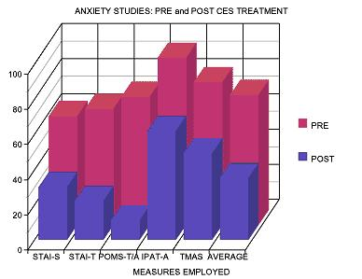

Natural Calm Ingredients (RediCalm):
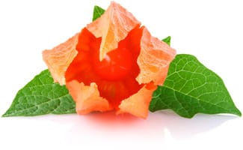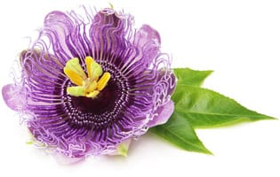
Ashwagandha Passion Flower
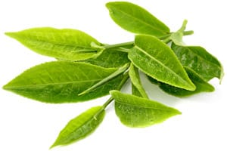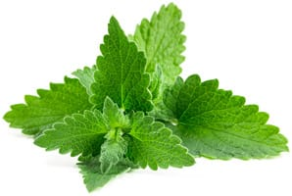
L-Theanine Lemon Balm
Ashwagandha: is an adaptogenic herb popular in Ayurvedic medicine that has shown incredible results for lowering cortisol and balancing thyroid hormones. In India, ashwagandha is known as the “strength of the stallion” since it has traditionally been used to strengthen the immune system after illness.
Passion Flower: Did you know that passionflower was traditionally used by some Native American tribes as a poultice to reduce the inflammation of boils and wounds (Hamel & Chiltoskey, 1975)? In modern times, most people use passionflower mainly for its nervine and sedative properties, but we mustn’t forget that there is much more to this plant than these properties only.
L-Theanine is an amino acid (a building block for proteins) found in green tea. People use theanine for treating anxiety and high blood pressure, for preventing Alzheimer's disease, and for making cancer drugs more effective. Lemon Balm: Lemon balm (Melissa officinalis), a member of the mint family, is considered a calming herb. It was used as far back as the Middle Ages to reduce stress and anxiety, promote sleep, improve appetite, and ease pain and discomfort from indigestion (including gas and bloating, as well as colic).
5-HTP: dietary supplements help raise serotonin levels in the brain. Since serotonin helps regulate mood and behavior, 5-HTP may have a positive effect on sleep, mood, anxiety, appetite, and pain sensation. ... As a supplement, 5-HTP is made from the seeds of an African plant called Griffonia simplicifolia.

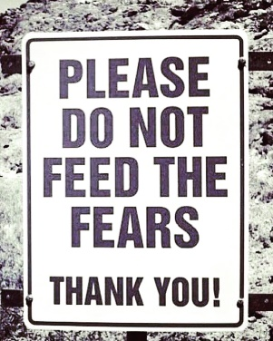

TodayistheFirstDayoftheRestofYourLife

This whitepaper is a summation of “Calming Your Anxious Mind” by Jeffrey Brantley, MD

