10 Reasons Why You Need To Start Eating Raw Cannabis
HEALTH
Have you ever tried a raw cannabis smoothie? There are several surprisingly good reasons why cannabis may be the next new superfood
ANNA WILCOX
Apr 5, 2017
SHARE
TWEET
EMAIL
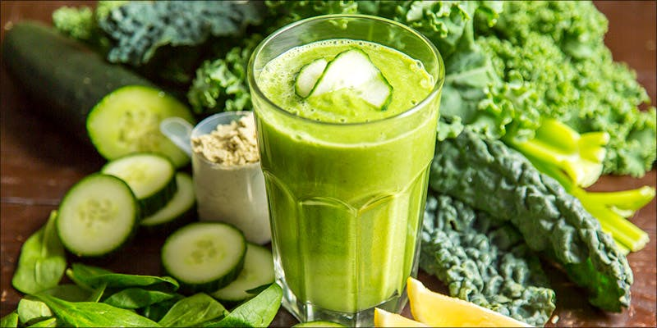
Have you ever tried a raw cannabis smoothie? While it may sound gross to some, there are several surprisingly good reasons why cannabis may be the next new superfood. Raw cannabis is not psychoactive, meaning that it is safe and healthy for people to consume in their diet. It’s also extremely nutrient rich, meaning that makes a big nutritional impact even in small doses. If you’re skeptical, here are 10 reasons why you should eat raw cannabis.

1. Cannabinoid acids
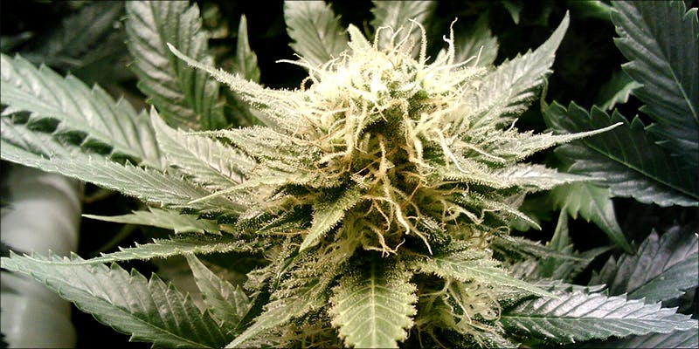
There are 421 distinct chemical compounds in the cannabis plant. Over 100 of them are unique plant molecules called cannabinoids. While recent research suggests that other plants may contain chemicals that have similar functions to cannabis, these specific compounds are unique to both marijuana and hemp plants.
The primary psychoactive in cannabis, tetrahydrocannabinol (THC), is a cannabinoid. However, the cannabis plant itself does not produce an abundance of THC. Rather, the cannabinoid is found on the plant in its raw form as tetrahydrocannabinolic acid (THCA).
It is only through heating and aging that that THCA transforms into THC. While there may be a small amount of aged THC and other active cannabinoids on a cannabis flower, the majority of them will be found as cannabinoid acids. Some speculate that these acids have a wide variety of health benefits.
Preclinical research suggests that THCA potentially has antiproliferative and antispasmodic effects. The acid has also been found to trigger a certain cell receptor called TRPA1, which plays an important role in pain regulation and inflammation related to the nervous system.
The raw, acid form of cannabidiol (CBD), a cannabinoid that is being researched as a potential new treatment for epilepsy, also has shown some potential. Early research has shown that CBDA connects with the same cell receptors as some over the counter anti-inflammatory drugs. CBDA also interacts with the TRPA1 receptor, giving it some pain-fighting potential.

2. Fiber
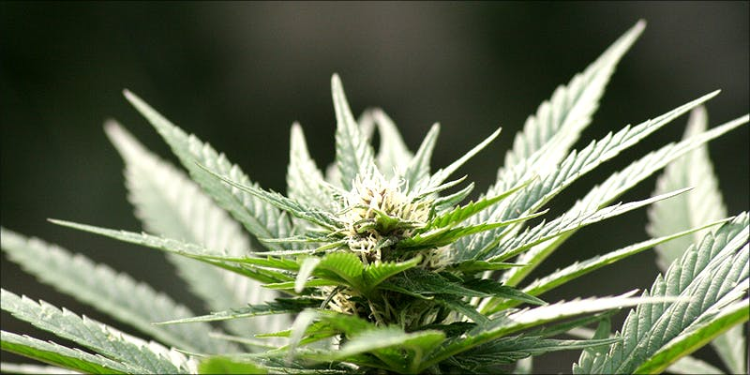
Many people throw cannabis leaves and bud into a juicer. However, there may be some benefit opting for a smoothie or a few cannabis leaves in a salad. Like all leafy greens, cannabis leaves are filled with the fiber needed for a healthy diet.
Consuming high-fiber foods is needed to maintain proper digestion and to cultivate a healthy microbial community in your digestive tract.
Fiber is broken down by microbes that live in the intestines. These microbes are essential for human survival, and recent research shows that caring for this internal ecosystem is vital for proper immune function and mental health. To keep these microorganisms alive and in balance, eating fibrous foods is key.
Some may find that cannabis raw fan leaves are slightly irritating to the stomach. If this is the case, blending the plant in a smoothie is a great way to keep some of the fiber without having to digest the entire plant.
Add cannabis fan leaves into a green smoothie, a homemade pesto, or use a couple of chopped leaves as a garnish for a pasta dish.

3. Vitamins
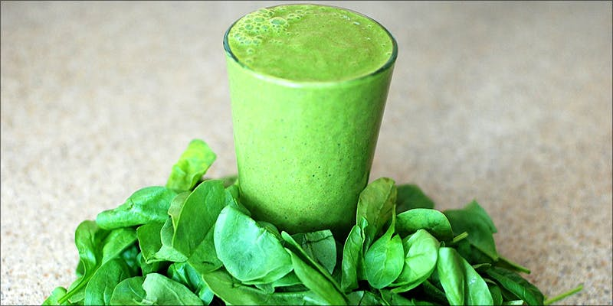
Like other green leafy plants, cannabis fan leaves contain a variety of vitamins and minerals. Leafy greens are filled with nutrients like:
- Folate (essential for DNA repair)
- Iron (essential for moving oxygen through the blood)
- Calcium (essential for strong bones)
- Vitamin C (essential for immune function)
- Vitamin K (essential for blood clotting and calcium absorption)
Cannabis is special and also contains cannabinoid acids. However, all edible dark leafy greens contain compounds that protect against cancer development. All in all, the greater the variety of greens, the better.
To get the most nutritional benefit from the herb, make sure you also include fat in your meal while consuming.

4. Antioxidants
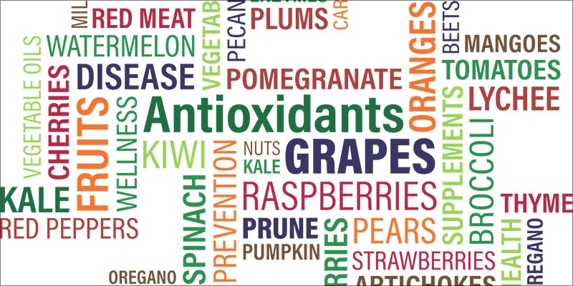
By now, it’s fairly well-known in the cannabis literature that the herb contains a host of antioxidant compounds. Cannabinoids like CBD and THC are considered antioxidants, meaning that they protect the body from damage from stress.
Raw cannabis also contains antioxidants, making it a great way to get a healthy boost of anti-aging nutrients without experiencing a psychoactive high.

5. Anthocyanins
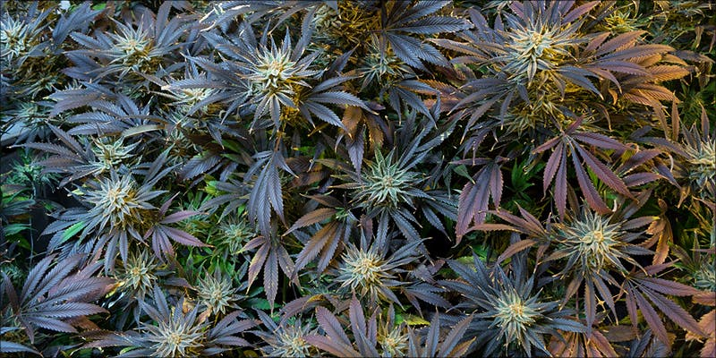
Have some purple cannabis leaves? Eat them! Deep red, purple, and blue coloration in cannabis means that the plant is filled with flavonoid compounds called anthocyanins. Anthocyanins give the rich color to foods like blackberries, black tomatoes, plums, eggplant, and red raspberries.
Research shows that anthocyanins have a protective effect on human health. A 2004 review suggests that these colorful compounds are antioxidants themselves, protecting against DNA damage. They also seem to provide protection aginst hormone-dependent diseases, regulate the immune response, and some may even help improve vision in concentrated doses.

6. Pain relief
As mentioned above, the cannabinoid acids in raw cannabis seem to have some of the same properties as over the counter drugs like ibuprofen and aspirin. Unfortunately, trials and conclusive research on the subject is sorely lacking.
However, many medical cannabis patients with conditions like fibromyalgia and arthritis use raw cannabis juices to aid in pain management.
Already, green juicing is thought to be highly beneficial for those with arthritis. While consuming a diet rich in nutrient-dense plants is essential for the healthy management of any pain condition, the unique acids in the cannabis plant make it an especially promising addition to a green juice or smoothie.

7. No “high”
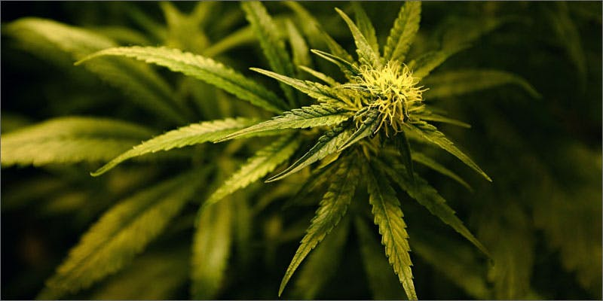
Many dedicated cannabis consumers pick up the herb for its psychoactive potential. Raw cannabis, however, does not cause the “high” associated with the herb.
The cannabis plant contains more acids when it is unheated and fresh, not dried or cured. Once drying and curing begin, more THCA is converted into THC and the plant becomes more psychoactive.
However, raw fan leaves and fresh bud can be consumed by anyone without causing any noticeable change in cognition or functioning. Instead, it’s like eating just about any other flavorful herb. This makes the herb more accessible to a greater amount of people, as there are no psychoactive side effects.

8. Healthy fats
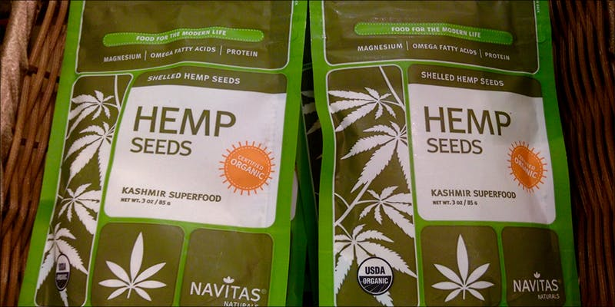
Consuming leaves and bud is not the only way that raw cannabis is nutritious. Raw hemp seeds and cold pressed hemp oil is abundant in essential fatty acids.
Hemp is an excellent source of plant-based omega 3 fatty acids, which are essential for brain health and development. Hemp oil is also high in linoleic acid, which is key to maintaining healthy skin and hair.
Raw hemp seeds are available at health food stores and online. They are excellent to add into a pesto made from fresh cannabis leaves and other valuable herbs. Some early research shows that consuming hemp oil may even ease symptoms of inflammatory conditions like eczema. There is also speculation that dietary hemp oil could be beneficial for arthritis.

9. More terpenes
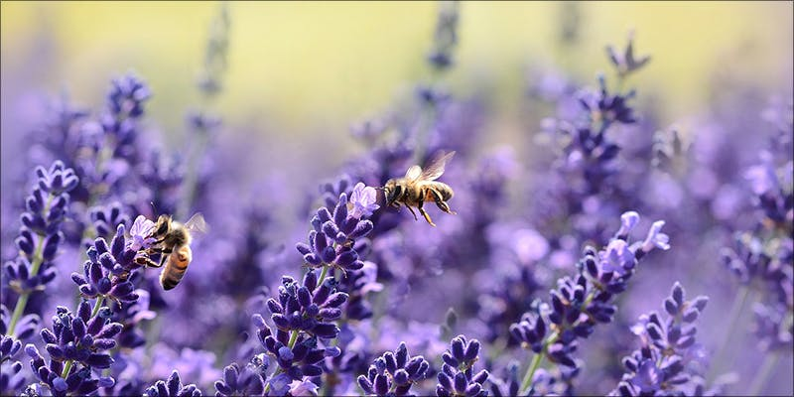
Heat is a peculiar thing. It takes heat to convert cannabinoid acids like THCA into its psychoactive form. However, during the heating process, there’s a high likelihood that you’re also burning off some of the valuable terpenes that add medicinal value to the cannabis plant.
Terpenes are aroma molecules that are found in plant resins. Some terpenes, like linalool, which provides the lavender scent to some cannabis strains, is thought to have sleep-inducing and anti-convulsant properties, providing a sensation of calmness.
Many terpenes and cannabinoids have boiling points within a similar range. Heating up cannabis products above 350 degrees risks evaporating off some of these valuable aroma components. With raw cannabis, this problem is avoided altogether, allowing you to consume as many terpenes and cannabinoid acids as possible.

10. Dosage
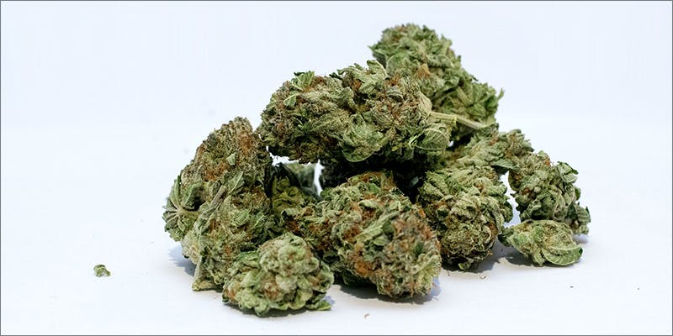
When first experimenting with cannabis for health, finding the right dosage of THC or CBD can be difficult. Consuming too much of either compound can trigger side effects, including headaches and nausea. High doses of THC can also cause sleepiness, paranoia, anxiety, and racing heart.
While a standard dose of THC or CBD is considered to be about 10 milligrams, the dose of cannabis acids inside the raw cannabis plant is much higher. You can consume a significantly larger amount of THCA with none of the psychoactive side effects coupled with just a small dose of THC.
This means that you can consume large amounts of nutrient-packed raw cannabis without any of the unwanted side effects typically associated with the smoked or heated herb.

