**Convenors Roll**

Download the inTennis APP

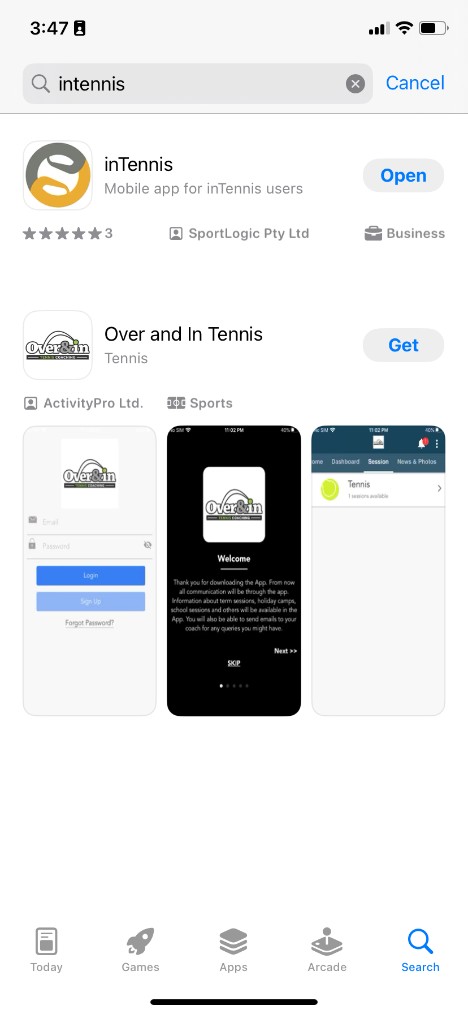

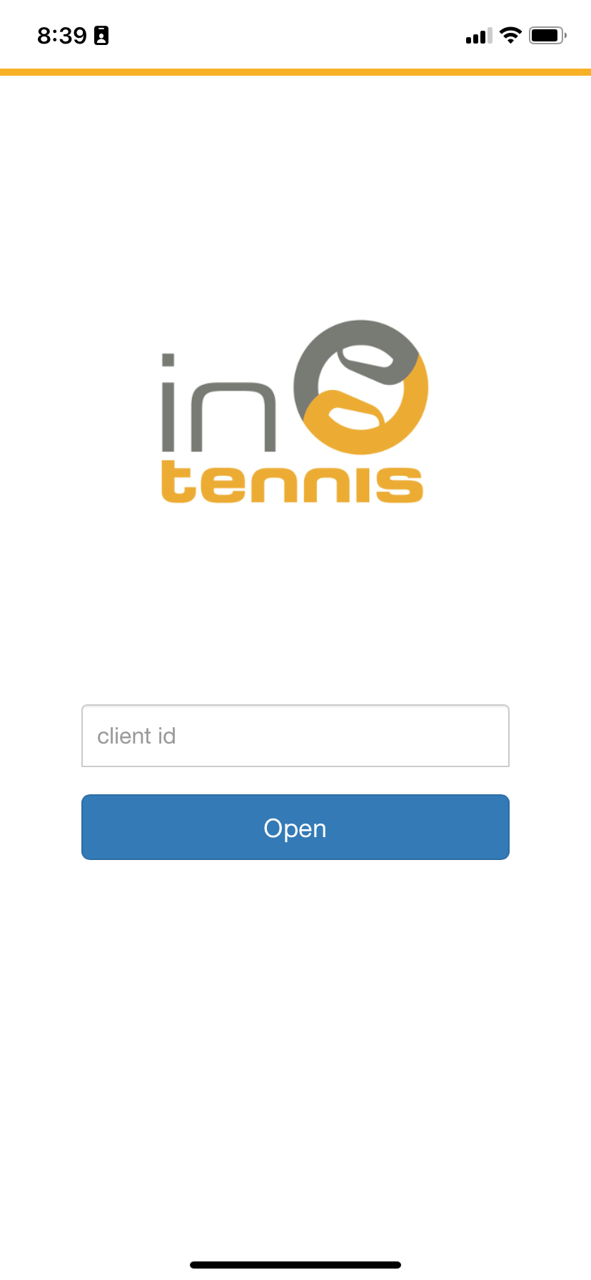

Open the APP and Log on using - thpc

Log in

Username – Thpc

Password – Zap2025?

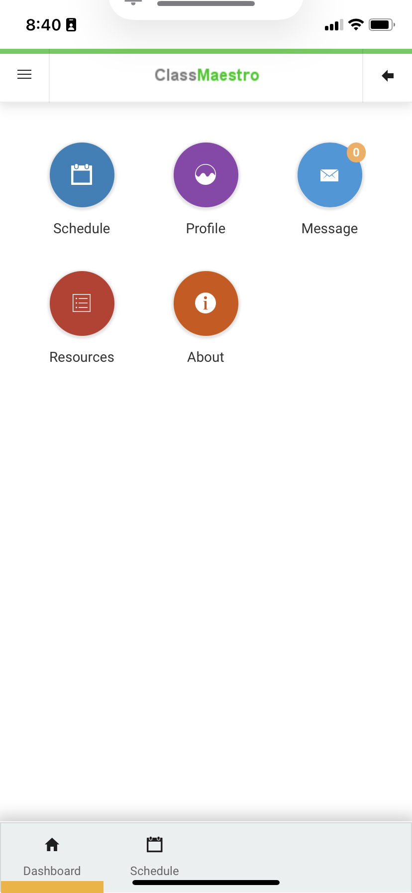

To mark the roll select schedule

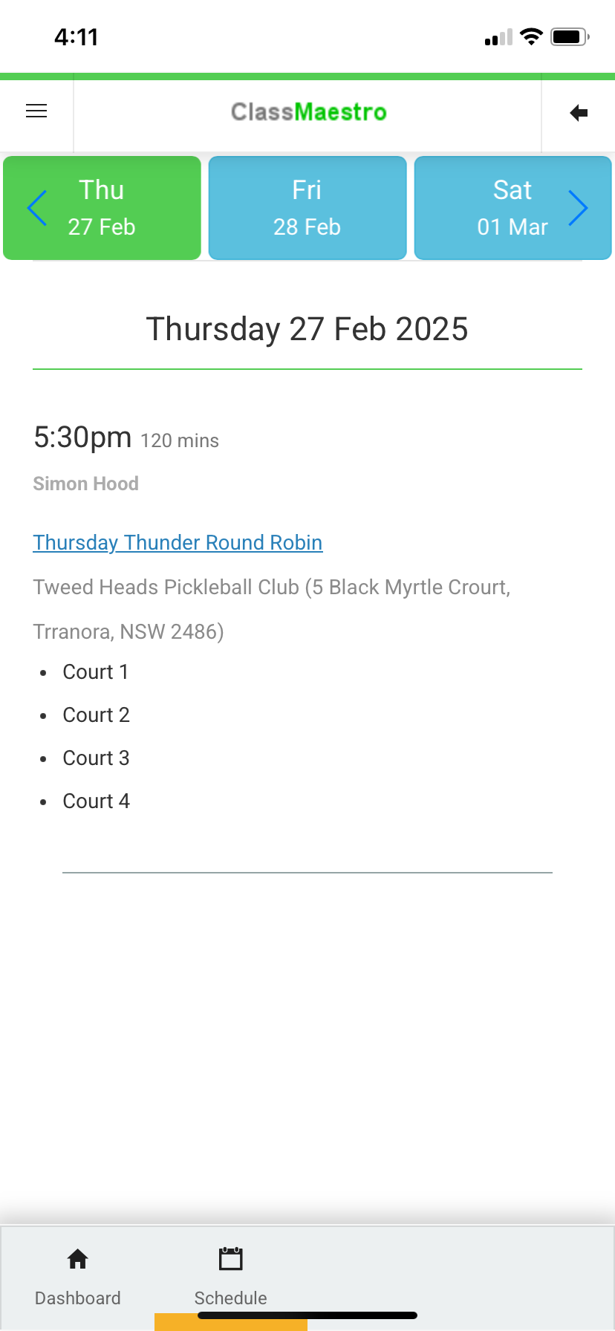

Select the session you are convening

If there is more than one session on the day scroll down to find the one you are convening - Select the blue session name with a line under it and tap it.

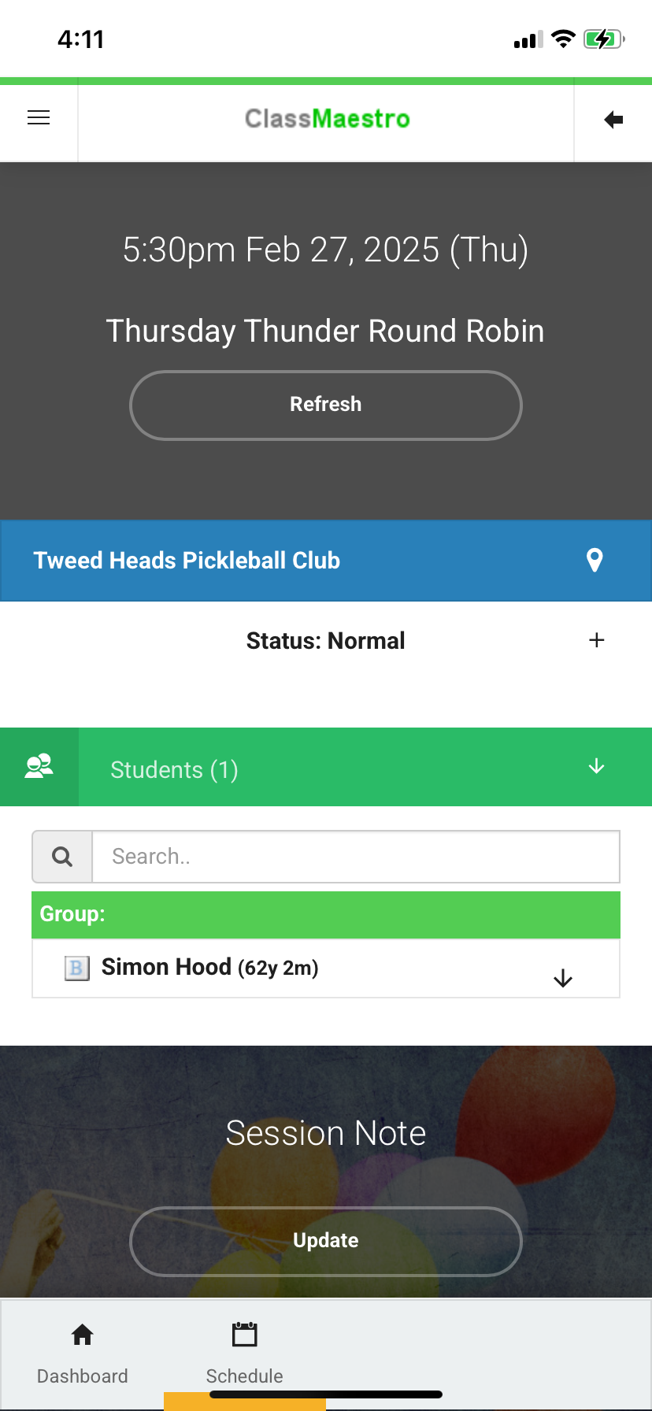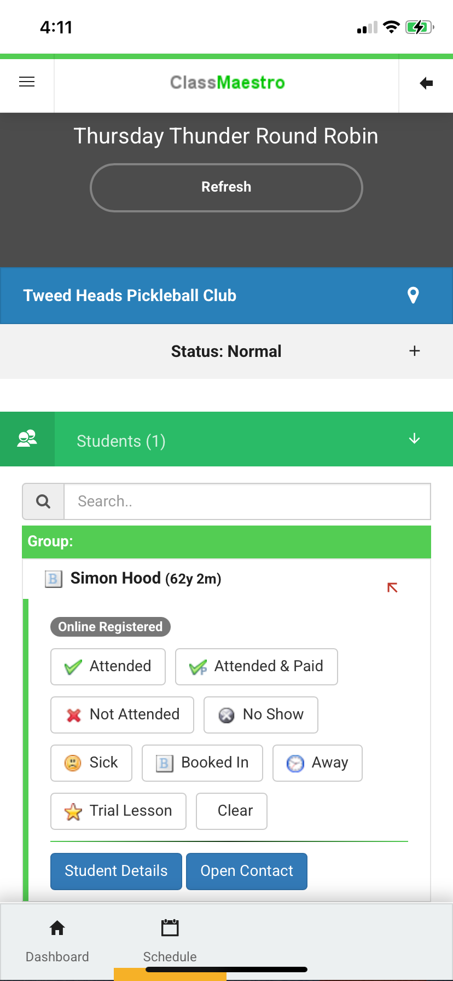

Scroll down, select students and then mark them off.

You can mark them all off at the one time as attended or if the session is cancelled. You can also mark people off individually (eg. They do not attend)

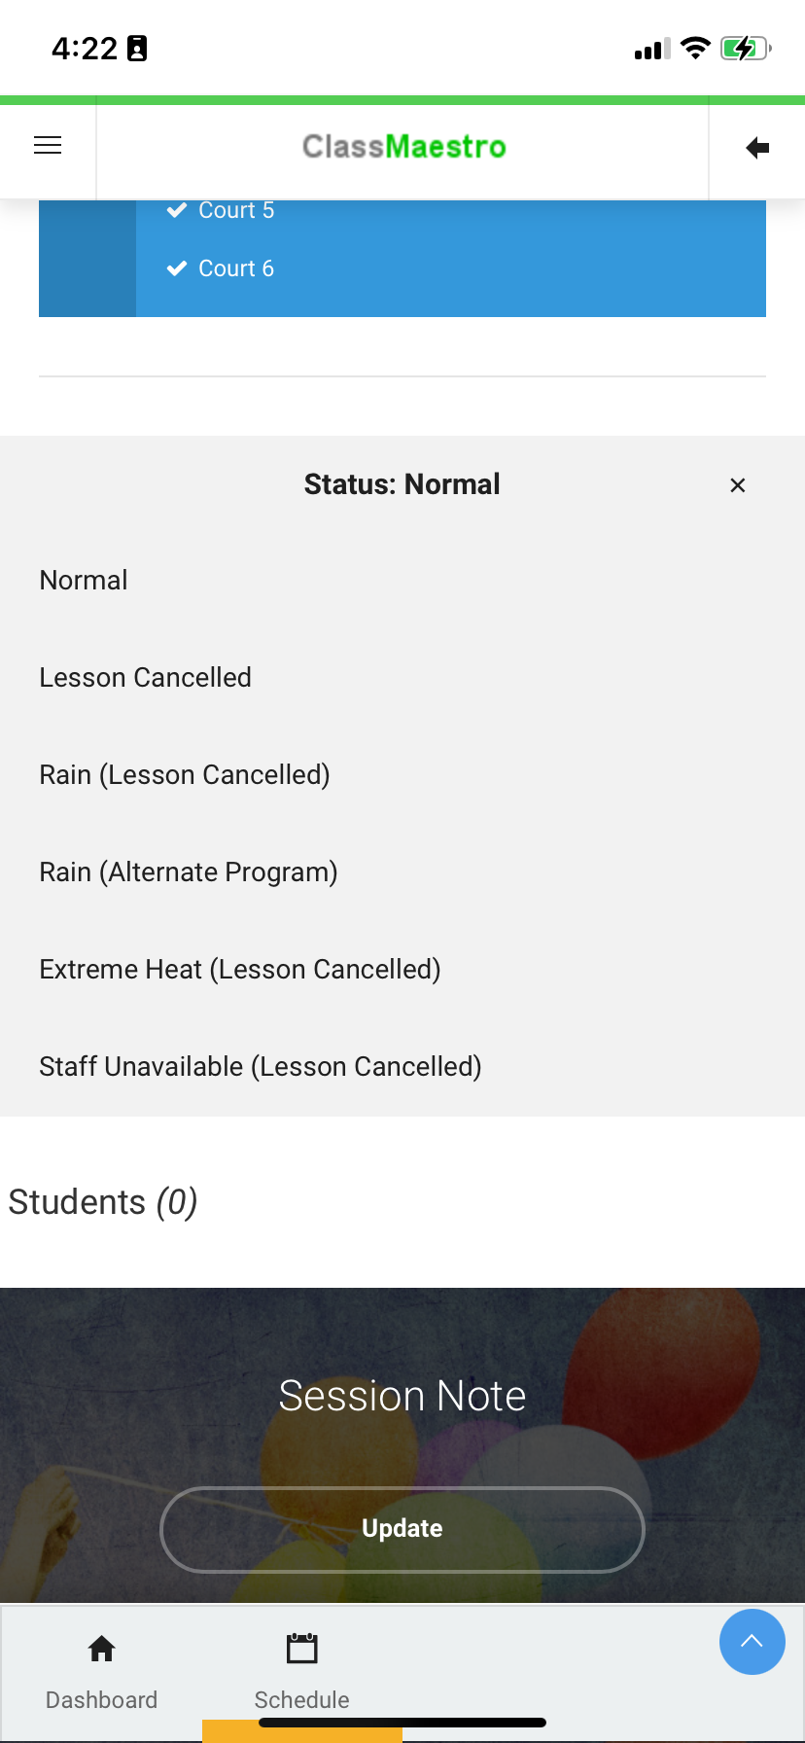

You can cancel the session for rain etc.

Click on the + sign next to Status: Normal

If they are already there it is easy – all you need to do is notify the secretary to give them credits – contact them through email – [secretary@tweedheadspc.org](mailto:secretary@tweedheadspc.org).

If you cancel the session before they arrive, you can SMS them all the attendees to let them know – when you cancel the session on inTennis go to the bottom of the page and First thing is to notify them that the session is cancelled

If you cancel the session, we need to arrange to give people credits.

If so, you will need to contact one of the Administrators and let them know that the session has been cancelled. This can be done via SMS.

Credits will be allocated to people in the back end of the programme.