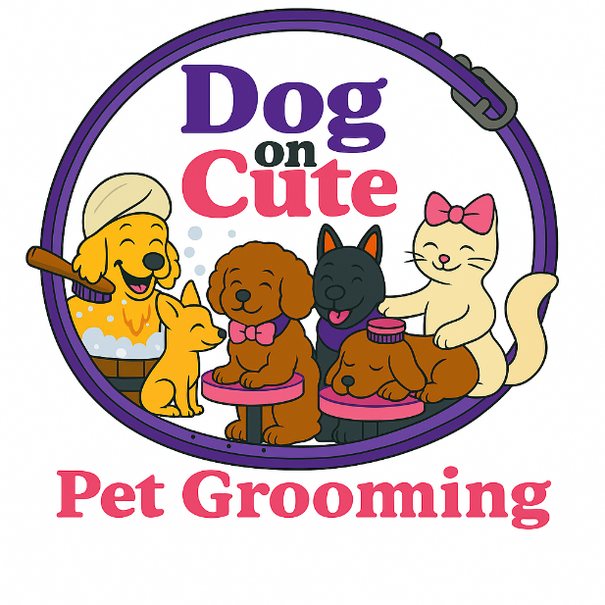
Client Intake Form
✂️ 🎀 🐾 💜
────────────────────────────────────
Client Name:
Address:
Phone Number:
Email:
Emergency Contact Name & Phone:
Owner Signature: ________________________________
Date: ____________________
Pet Profile Form
✂️ 🎀 🐾 💜
────────────────────────────────────
Pet Name:
Breed:
Age:
Sex:
Color:
Weight:
Allergies:
Special Needs:
Owner Signature: ________________________________
Date: ____________________
Grooming Service Agreement
✂️ 🎀 🐾 💜
────────────────────────────────────
• I authorize Dog On Cute to perform grooming services on my pet.
• Grooming may expose underlying health issues.
• I agree to pay all grooming fees.
Owner Signature: ________________________________
Date: ____________________
Grooming Consent & Release Form
✂️ 🎀 🐾 💜
────────────────────────────────────
• I release Dog On Cute from liability for pre-existing conditions.
• I will disclose all behavioral or health concerns.
Owner Signature: ________________________________
Date: ____________________
Medical Emergency Release Form
✂️ 🎀 🐾 💜
────────────────────────────────────
• I authorize emergency treatment if needed.
• I accept responsibility for vet costs.
Owner Signature: ________________________________
Date: ____________________
Vaccination & Health Confirmation Form
✂️ 🎀 🐾 💜
────────────────────────────────────
Vet Name & Phone:
Rabies Expiration:
Distemper Expiration:
Bordetella Expiration:
Owner Signature: ________________________________
Date: ____________________
Matted Coat Release Form
✂️ 🎀 🐾 💜
────────────────────────────────────
• I understand matting increases risk during grooming.
• I authorize shaving/dematting as needed.
Owner Signature: ________________________________
Date: ____________________

Aggressive / Special Handling Pet Release Form
✂️ 🎀 🐾 💜
────────────────────────────────────
• Additional handling fees may apply.
• Behavioral issues must be disclosed.
Owner Signature: ________________________________
Date: ____________________

Photo / Video Consent Form
✂️ 🎀 🐾 💜
────────────────────────────────────
• I consent / do not consent to photos/videos of my pet.
• Images may be used for marketing/social media.
Owner Signature: ________________________________
Date: ____________________

Privacy Notice & Client Information Policy
✂️ 🎀 🐾 💜
────────────────────────────────────
• Dog On Cute does not sell or share personal info.
• Info is used only for safety and service.
Owner Signature: ________________________________
Date: ____________________

