**MAC: GETTING STARTED GUIDE**

**Step 1: Download app (either option below will work)**

**-everything you will need can be accessed from the apps**

* **Download Millsaps Athlete Care app free in Apple store** 
  + **Android coming soon**
* **Add this webapp to your phone or computer desktop:** [**https://webapp.mobileappco.org/m/millsapsathletecare276/**](https://webapp.mobileappco.org/m/millsapsathletecare276/)

**Step 2: Register for the Athena Health Patient Portal**

* **Click “Patient Portal” on the app, NOT “Register”- you already did this.**

**You will do *everything* from your patient portal**

-can be accessed from the MAC app, webapp, MAC website, or portal website

* Schedule appointments
* Request refills
* Send me messages
* Access your visit summaries and records

**Portal Website (only needed if unable to download app):**

24014.portal.athenahealth.com

**Step 3: Schedule an Appointment**

1. Go to Athena Health Patient Portal. It can be accessed from the Millsaps Athlete Care App (WebApp, iOS), portal site, or www.MillsapsAthleteCare.com website.

**Portal site: 24014.portal.athenahealth.com**

1. Login and choose appointment tab.
2. Pick an appointment type (types explained below).
   1. **The first time you make an appointment**: you will only be able to choose **“new patient appointment**.**”** Please choose an appointment. This can be cancelled later. If you plan to cancel you can write “cancel” in the “additional details”- I will see this and assume it is cancelled. You can also manually cancel the appointment. This will allow you access to fill out your medical history. You may then keep your appointment or cancel and schedule for a different time.
3. Click on any available appointment to schedule.

**There are two types of appointments:**

1. **Scheduled:** Schedule these if you wish to be seen at a certain time (limited).
2. **Telehealth:** These are first-come-first-serve appointments.

* The time you sign up for does not matter because I will call you at my

first availability that day.

* If you miss my call, don’t worry, I will continue to call when I’m free.
* No need to call me back, as I likely won’t be able to answer due to

other appointments, but I WILL call you back, multiple times.

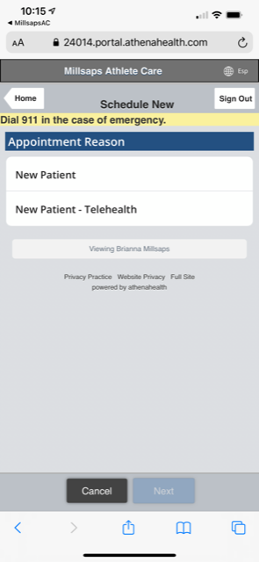

Scheduled (scheduled telemed visit)

Telemed (first come-first serve telemed visit)

**Appointment choices (after initial “new patient” appointment):**

**New patient visits:** These are longer appointments so we can get to know each other. All first visits should be scheduled as new patient visits.

**Sick visits:** These are visits to address illnesses urgently or they can be visits to discuss new non-urgent concerns.

**Follow-up visits:** These are visits to discuss previously addressed concerns.

**Lab visit:** These are quick visits to order labs or go over labs. Abnormal lab discussions will be scheduled as a follow-up visit.

**Annual exam visits:** These are appointments to discuss generalized health and fill out physical forms.

**Step 4: Check-in to appointment**

1. **You will get a text with a link to check-in**. Please do this **ASAP** so you can complete the quick forms. Your first visit will require a couple more in-depth forms, but subsequent appointments will only require updates.
2. Sign patient contract.
3. Fill out medical history (meds, allergies, medical history).
4. Add preferred pharmacy.
   * Filling this out as completely as possible will allow me to make the best medical decisions for you efficiently.
   * I will also be able to set up on-line billing once this is done.

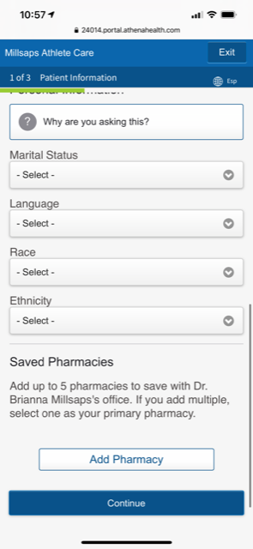

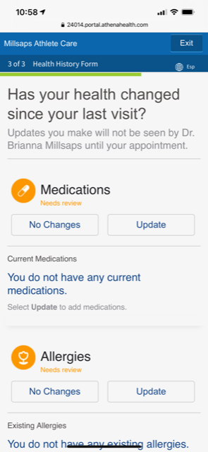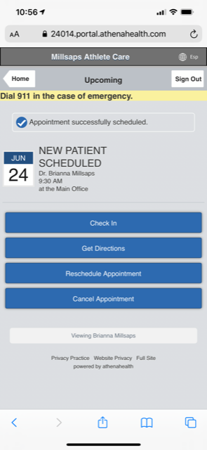

**What to expect after you check-in for an appointment:**

1. You will then log into the telemed room via the link sent to you. I will join you. We can also use facetime or just a phone call if you prefer.
2. If you prefer a phone call or Facetime rather than telemed, please make an appointment and confirm your details. Type “Phone call” or “Facetime” in appointment details.

**How do you pay your bill?**

1. Let me know if you would like to pay monthly, every 3 or 6 months or annually.
2. Three ways to access and pay your bill:
   1. Your Patient Portal under “billing”
   2. A link will be emailed to you.
   3. A link will be texted to you.
3. You can place a credit card on file for automatic billing at the interval of your choice (or single payment if a camper).
   1. Membership dues will be billed at the beginning of the month.
   2. Campers’ payment will be processed at the end of the week/ month, however, you must register on day 1 of camp at registration.
   3. Any extra costs, such as labs will be added to your next bill based on your billing preference.
   4. Accepted: Credit card, venmo, paypal, check. Cash or check accepted at MTF office placed in an envelope labeled MAC.
   5. Checks can be made out to Millsaps Athlete Care LLC mailed to:

867 Bold Springs Road, Cairo, GA 39828.

**Methods of Communication:**

**Phone: 229-363-3955**

**Please use this number for all practice communications (my personal number needs to remain free for my fellowship, family, and emergencies).**

* **Urgent:** (call 911 if emergency)
  + Call: 229-363-3955 and leave a voicemail (do not text).
    - My message service will convert your voicemail to a text message and I will get it immediately on my personal phone.
* **Non-urgent:**
  + Portal message (preferred): Answered daily. I can address concerns while looking at your chart. I can also answer from an app on my phone.
  + Text: 229-363-3955 (completely acceptable)
    - Checked periodically throughout the day-will respond same day
  + E-mail (least preferred):
    - Slight chance of being missed, checked daily.
* **Note:** You will **always** get an answering service when you call this number. Your voicemail will come as a text to my phone. I will either call or text you back based on your message. This is to ensure patient concerns are triaged properly. Think of this number as a pager when you call. Texts work like regular texts. This method ensures I do not miss any calls or texts and can respond accordingly in the time frame required without interrupting care of another patient.
* **This is a 24/7 number.** The messages from this number **will never be silenced** on my end. So please **only leave messages between 12am-8am EST *if extremely urgent*.** You may text this number at any time though-I won’t get it until the morning.

**Considerations for scheduling:**

* All appointments are telemed or phone call until July 2022. Then in-person will be available.
* If you just want a phone call (no video), indicate that in the reason for visit. You can also send me a text that says: call when available.
* If we have not had an appointment yet, please schedule a New Patient visit.
* If you do not have an urgent matter, consider scheduling a “scheduled” appointment for a future day which will provide more open appointments for urgent patients.
* Quick questions can always be addressed by text or a portal message. I prefer these methods over email because it allows me to make sure everything is addressed. I will respond the same day.
* Medication refill requests can be requested in the patient portal. No need for an appointment unless you would like one or I request one.
* If I am able to make it to a couple races this year, visits are included and will not require appointments.

**Disclosures:**

* I will absolutely do my best to see you at your “scheduled time” and on the same day, but I am in a demanding Fellowship, learning more to help you, and my schedule could change at any minute- which is out of my control.
* **I am in PST** not EST (3 hours behind GA or FL), so I may answer texts and messages a little later at night. This also means I will be available for appointments at night (convenient right?). You can always place my number on silent so I do not disturb you if you are sleeping.
* **I will respond to you in the method by which I am contacted**. If you send a text, I will text back and if you send a portal message that is how I will respond. I will not call past 9pm EST (unless requested).
* I will do my best to adjust my schedule for my availability weekly, to the best of my knowledge. If I end up being unavailable at a time you are scheduled, I will contact you to reschedule with as much notice as possible.
* Again, **I am always available** **via text and portal messages** which I can answer easier when my schedule is tight- I can answer messages and refill meds from my phone on the side-lines of games, but I can’t answer calls.

**Medication Tidbits:**

* If your medication is too expensive at the pharmacy, please let me know immediately and I will call in an alternate if possible.
* GoodRx is a great resource when paying cash for medications. You can download the app on your phone.

**Checklist:**

* Download app- link sent to your email or app downloaded for iOS.
* Register for patient portal
* Save office numbers
  + Phone: 229-363-3955
  + Fax: 833-941-2626
* Schedule a New Visit appointment at your convenience.
  + You may then cancel your appointment if you do not wish to keep it and your medical history will be there for when you would like to actually have an appointment.
* Check-in
  + This will prompt you to fill out medical history forms and patient contract.
* Fill out medical history and sign forms (HIPAA and Patient Contract).
* Set up online billing once the invoice is sent to you

I look forward to being you physician. Please contact me with any questions or concerns. I am here for you!

–Dr. Brianna Millsaps (Please, just call me Brianna).