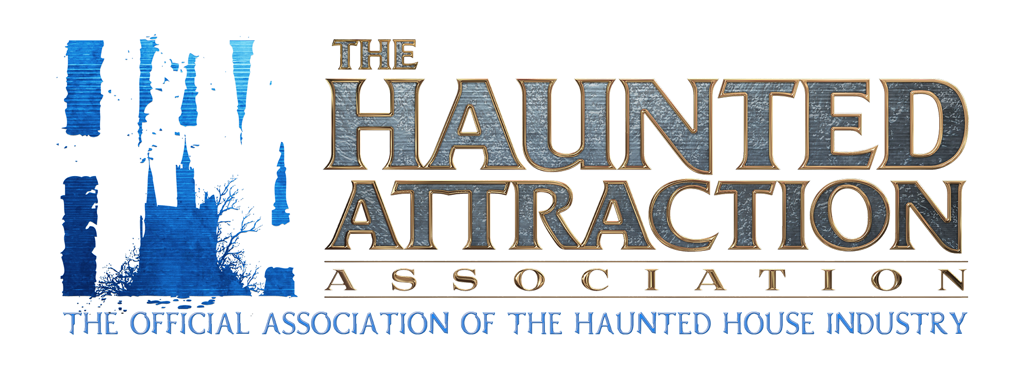

**FACTS & DATA OF THE HAUNTED HOUSE INDUSTRY**

**Presented by**

**The Haunted Attraction Association (H.A.A.)**

Updated 10.2024

**Just how big is Halloween?**

According to the consumer spending index, the National Retail Federation and other data, landing just under the $12Billion mark, Halloween is America’s second favorite holiday. Between costumes, parties, candy and of course, haunted houses to celebrate the fall, the haunted house market is the immersive Halloween experience that millions attend each year.

**How do haunted houses benefit the local community and economy?**

Certainly haunted houses are a business, and as such are generating localized jobs and tax revenue. However, beyond that, over 60% of haunted houses are affiliated with some form of charity work. This ranges from a home haunt raising money for a medically ill child in the neighborhood, to a large attraction raising funds for a non-profit group, school, etc. Nearly all of our member attractions from home haunts to mega attractions donate to local community groups, fundraisers, and civic organizations either through services, discounts or special events.

**How many haunted houses are there in the US?**

New attractions open each year. We estimate nearly 4,300 haunted houses operate throughout the world, to include home/charity haunts, small-medium attractions, and mega/theme park attractions. Of the nearly 4,000 overall attractions, we believe nearly 1800 are for-profit attractions (charge admission), while the remaining are small home, charity, or non-profit attractions.

**What varieties of haunted attractions are there?**

While most haunted houses are indoor themed immersive experiences themed around horror and being scared, other venues may include outside walkthroughs (through a farm or forest), a haunted hayride, corn mazes, agri-entertainment (pumpkin picking paired with a haunted walkthrough experience), and even extend to paintball, live theater shows, and more.

**How has the industry changed over the past decade?**

Our immersive Halloween entertainment industry is always shifting and progressing. Each year it grows,and we see more vendors, more suppliers, more buyers, more professionals and more fans coming to work, play, invest, build and own an attraction.

**Why do people enjoy being scared?**

Similar to a thrilling roller coaster ride, a zip line through a rainforest, or a fun memorable date with friends, haunted houses offer a unique experience: to be immersed in scary, horror, or unsettling spaces, similar to being inside of a horror movie, but be completely safe. Psychologically, we know that humans crave facing their fears and after exiting a haunted attraction, many customers leave with a euphoric feeling and a sense of pride, accomplishment and resiliency. Customers pay admission for a fun time, knowing operators have gone to great lengths to ensure safety for customers and staff is the top priority.

**What’s the largest convention/tradeshow of your industry?**

The largest tradeshow and conference of our industry is TransWorld’s Halloween & Attractions show (now also includes the Interactive Entertainment and Christmas show), where over 12,000 buyers and nearly 500 vendors assemble on a 1 Million square foot convention hall space to buy, trade, sell, become more educated, network, and share successes, all over a four day period. Additionally, there are over 25 regional shows throughout the nation that host over 2,000 attendees each, made up of fans, haunted house owners, buyers, staff, makeup artists, investors and more.

**What are the tactics for scaring your customers?**

Every customer scares differently; while one may be afraid of spiders, someone else is afraid of clowns. We each startle differently too, so the science of scaring really is about building a show that utilizes and often overloads the senses, while balancing safety of customers and staff.

**What is the typical capital investment to start an attraction?**

This ranges on the end goal and overall market. Typically, you'd expect to start an attraction that is small for $200,000-$800,000 depending on a variety of factors. This can easily go into the millions quickly for larger themed attractions. Similar to any business model, forecasting numbers, revenue streams, soft and hard operating costs and more help to decide an initial investment.

**What is the typical lifespan of a haunted house?**

The industry has been vastly growing since the 70's. Even when one attraction sadly closes, several more open, often through mergers. Smaller home haunts (someone who decorates greatly for Halloween at their home) can last for decades, while larger investment operations can last 40+years.

**Who is the typical demographic for haunted house?**

We've found the typical demographic is majority female, by 52%, and 48% male, between the ages of 17-30. This spans all genres of music, clothing, language, culture, style, etc and continues to grow in diversity. This demographic consistently spends a great deal of money for entertainment purposes.

**How many people attend haunted houses each year?**

Generally speaking, of the 4,300 haunted attractions across the globe, approximately 70% are attractions that have less than 8,000 customers. 20% welcome between 8,000-20,000, 7% scare around 20,000-40,000 and 3% or less boast a whopping 40,000-70,000 attendance, typically within a short +/- 40 days of operating dates, usually around the Halloween holiday.

**What do haunted house owners do when it’s NOT Halloween?**

Most large scale attractions leave their site up all year, but we estimate about 70% are temporary (set up and tear down) each fall season. Others are multi-business ventures, like agritourism, and utilize the land for year-round events catering to different audiences, and often open for other events such as a Krampus Holiday event, Vampire Valentines Date Night, and more. Smaller and mid-sized attractions either leave their show up, or strike their sets for storage after the season,and reconstruct the entire business annually.

**What’s the average admission ticket cost of a haunted house?**

Each haunted house is unique, has variable sizes, and can offer a range of included events with a ticket admission, and as such, the average ticket varies greatly. Small-medium attractions charge anywhere from $10-$20, larger mega-attractions can range from $30-$50, and some even as high as $200+/ticket. These range from General Admission, to an exclusive experience cultivated just for specific customers. We’ve seen nearly 74% of large operators yield their revenue from tickets, while the other 26% are diversified into other experiences such as zip lines, midway experiences, alcohol & non-alcohol bars, merchandise and more.

**Are most haunted houses in the United States of America?**

Yes. While exact numbers are always in motion, we know that of the estimated 4,300 haunted houses in the world about 2-3% are outside the United States, and can be found from Europe, to Asia, to the Middle East and beyond.

**Are there industry awards for the best of the best?**

Each year, the Haunted Attraction Association (H.A.A.) unveils a list of around 50 + attractions that meet a very stringent and hard to achieve list of requirements. Those attractions that meet the many requirements are added to the annual “Top Haunts” list of the Association, and credentials are submitted each year to ensure they’re updated. Additionally, the H.A.A. awards a variety of awards in our industry that spans the globe, to award top attractions and vendors of all sizes.

**Who is the Haunted Attraction Association?**

For over 20 years, our industry has grown at a rapid pace. In that same timeframe, leaders of the industry gathered to have an association to share knowledge, become more educated in both the show and business sides of our industry, connect with world class vendors, and leverage our combined efforts. Today the H.A.A. serves as the haunted house and immersive halloween entertainment industry’s official association, with members spanning the globe, from home haunts, to theme parks and mega attractions, and from safety and makeup artists to investors and educators. For more details, visit www.hauntedattractionassociation.com.