UNITED STATES MARINE CORPS

SERGEANT MAJOR JONATHAN S. HENRY (ret.)
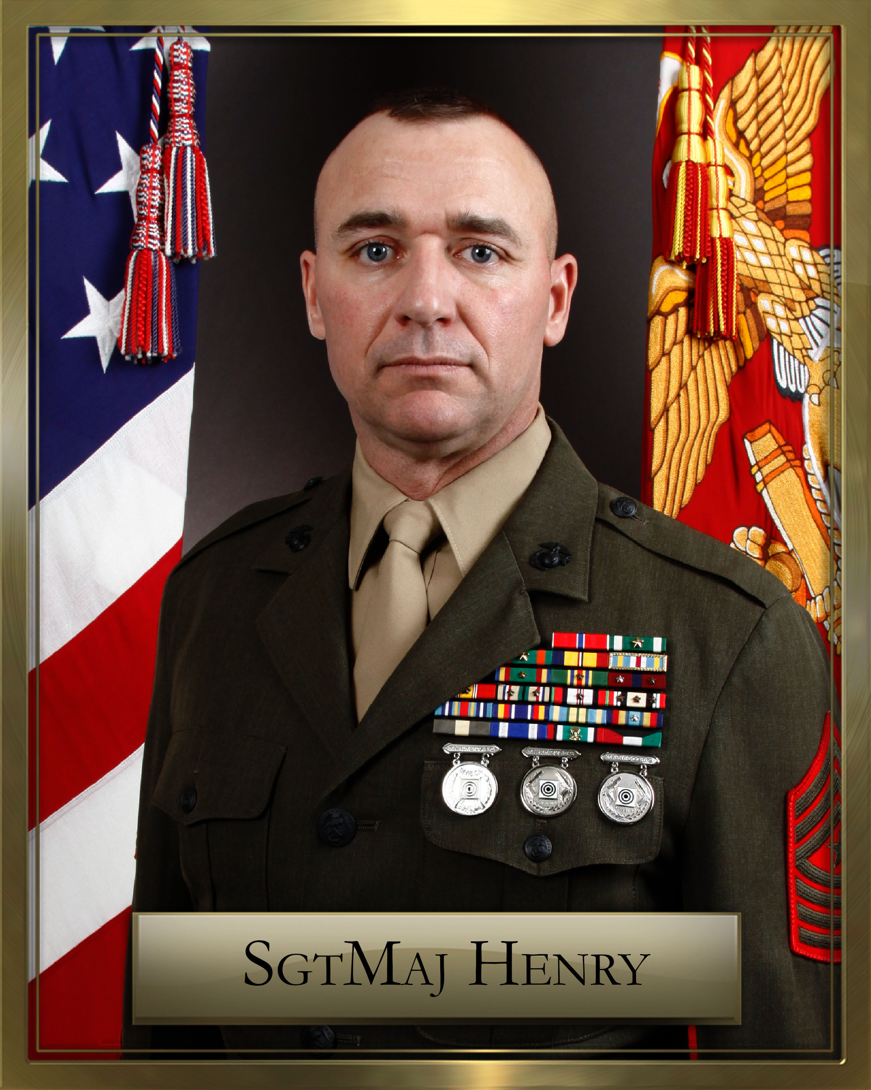
Sergeant Major Jonathan S. Henry enlisted in the Marine Corps and attended recruit training in January 1990 at Parris Island, South Carolina. After Marine Combat Training he was transferred to Marine Corps Engineer School, Court House Bay Camp Lejeune, NC receiving the MOS 1371, Basic Combat Engineer.
He reported to Charlie Company, 2nd Landing Support Battalion, 2nd Force Service Support Group in June 1990 and deployed to the Persian Gulf in support of Operation Desert Shield/Desert Storm. He took part in Operation Intimate Thunder and the evacuation of the US Embassy in Somalia. Upon returning he was selected to the rank of Corporal meritoriously before transferring to Okinawa, Japan in 1992.
In November of 1992, he was assigned to 3rd Combat Engineer Battalion, Okinawa, Japan with Charlie Company, then to H&S Company as the Non-Commissioned Officer in Charge of the Battalion Marksmanship Training Unit.
Corporal Henry transferred to 8th Engineer Support Battalion, Bravo Company Camp Lejeune, North Carolina in December 1993. He served as the Platoon Sergeant then Construction Chief for duties in Socorro, New Mexico, Parris Island, South Carolina and numerous projects on and around Camp Lejeune. At that time he was a graduate of Combat Engineer Journeyman’s Course.
Sergeant Henry attended Drill Instructor School, Parris Island, South Carolina in January 1996. Upon graduation he was assigned to India Company, 3rd Recruit Training Battalion. During his tour he served as a Drill Instructor and Senior Drill Instructor as well as an instructor with Weapons Field Training Battalion.
In May 1998 Staff Sergeant Henry was assigned to Facilities Maintenance Department, Headquarters and Service Battalion, Camp Pendleton California as a Structural Inspector for the base. He also served as the SNCOIC of the Camp Pendleton Competitive Marksmanship Program where the team competed in numerous Competition-in-Arms matches throughout the West Coast and Midwest states.
Staff Sergeant Henry transferred to the Staff Noncommissioned Officers Academy, Quantico, Virginia serving as a Faculty Advisor/ Instructor for the Sergeant’s Course in September of 2001. He attended the Formal School Instructor’s Course, Little Creek VA where he was selected Top Gun graduate by fellow students. During his tour he graduated from the Combat Engineer Chief’s Course, Court House Bay. He served twice as an instructor for the Marine Forces Reserve Sgt’s Course, Camp Crowder, MO. He served a summer at training officers at Officer’s Candidate School Quantico, VA. As a Platoon Sergeant for India Company he was selected by his peers and received the OCS Outstanding Drill Instructor Award.
In October 2004 Gunnery Sergeant Henry was transferred to Marine Wing Support Squadron 272, New River Air Station, Jacksonville, North Carolina. He served as the SNCOIC of the engineer platoon and Division First Sergeant for Engineer Company. Gunnery Sergeant Henry deployed from August 2005 to March 2006 in support of Operation Iraqi Freedom serving as SNCOIC of the Incident Response Platoon for the Explosive Ordinance Disposal Team, Al Anbar Province.
Promoted to First Sergeant in 2006 he transferred to 2nd Marine Logistics Group Forward serving as the Company First Sergeant for Communications Company, Camp Lejeune, NC. He deployed to Iraq in support of OIF from February 2007 until February 2008. He also served as the MLG Forward Director of Cpl’s Course graduating 151 Cpl’s throughout the MLG.
In April 2008 First Sergeant Henry transferred to Assault Amphibian School Battalion, Camp Pendleton, CA. In January 2009 First Sergeant attended the Navy Senior Enlisted Academy in New Port, Rhode Island, graduating Honor Graduate receiving the Peter Tomich Leadership Award for Class 143. He also attended the Senior Enlisted Professional Military Education, Quantico, VA.
Upon his return SgtMaj Henry received orders to 1st Battalion, 1st Marine Regiment, 1st Marine Division for duty as the Battalion Sergeant Major in July of 2010. He served as the Ground Combat Element SgtMaj for the 13th MEU. In 2012 he deployed with 1/1 in support of Operation Enduring Freedom.
SgtMaj Henry completed his tour with 1/1 and was selected as one of the two first enlisted Marines to attend the Command and Staff College, Quantico VA from July 2013 until June 2014 earning a Masters Degree in Military Studies. Upon completion he received orders to Lejeune Leadership Institute, Quantico, VA. He assumed Directorship of the Staff Non-Commissioned Officer’s Academy in Okinawa, Japan on Feb 2015 and completed his tour June 2017. He retired from active duty October 2017.
SgtMaj Henry is married to former Renee Lynn Smith and they have two children, Kristian and Jonathan and a grandson, Kolton. He holds an AA degree in General Studies, a BA in Psychology with Honors, Master's degrees in Public Administration, Pi Alpha Alpha, and Military Studies. Currently he is a PhD student in Leadership Studies.
SgtMaj Henry’s Personal Awards include the Bronze Star, Meritorious Service Metal, Navy Commendation Medal 2nd Award, Navy Achievement Medal 2nd Award, Outstanding Volunteer Service Medal and the Combat Action Ribbon, Second Award. He earned two silver medals and a bronze medal with the pistol and a silver medal with the rifle through the Competition in Arms Program.

