Thinking

A guide on processing information and assembling arguments for success

# Preamble

Thinking is an essential component of human functioning, where our forebrain and grey matter complexities set us apart from all other mammals. The benefit of being thoughtful, is to exercise discipline within ourselves, to take ownership of our cognitions, and assemble information in a meaningful manner in order to more greatly affect those around us. Everything that we say and do can affect others, so we owe it to ourselves to strive for the best possible outcome in every way. Types of arguments below, are some contemporary thinking labels that can be helpful to be aware of, and test out.

# Types of arguments

## Steel Man



[This Photo](http://moviefail.com/movie-review-the-iron-giant/) by Unknown Author is licensed under [CC BY-SA-NC](https://creativecommons.org/licenses/by-nc-sa/3.0/)

Use this type to infer, or select, the strongest possible case that your audience is trying to make. If they’re not that articulate and have fumbled through their case, help them by inferring that they’ve meant something really amazing and argue against that perspective instead of allowing them to flounder around. Check your premise with your audience to make sure you’re being helpful and not overbearing or domineering.

## Straw Man

The opposite of ‘steel man’, straw manning can be a useful tool to use in order to distract your audience. Instead of being logical and helpful, the straw man argument seeks to distract people by flashing some hyperbolic premises around and get you away from the thing you’re trying to achieve. Politicians are great at using this in polemical debate.



[This Photo](https://cognitive-liberty.online/straw-man-fallacy/) by Unknown Author is licensed under [CC BY-SA-NC](https://creativecommons.org/licenses/by-nc-sa/3.0/)

## Red Pill

Popularised by the Matrix franchise, this pill and argument style is to appeal to the logical theories, scientific fact, and uncomfortable realities. Use this to bring people back to facts, ground evidence, and posture a way forward. Being aware of this is helpful in an environment where people use subjective realities with lots of emotion.

## Blue pill

Similar, but opposite to ‘red pill’, this argument style is akin to leaning on things which are completely subjective. Add weight to people’s emotions, postulate feelings, and accepting ‘their truth’s’.

## Deductive Argument

An effective form of contemporary scientific argument. Make many premises and build from findings, in a funnel like manner, toward a conclusion. Use this particularly in conflict, to find meaningful [agreement](https://foundationforchangeaus.blogspot.com/2023/03/agreement.html).

## Inductive Argument

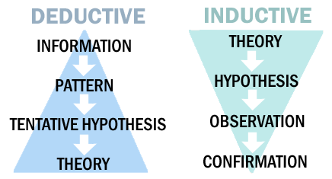

[This Photo](https://wiobyrne.com/action-research/) by Unknown Author is licensed under [CC BY-SA](https://creativecommons.org/licenses/by-sa/3.0/)

The opposite of ‘deductive’ in a sense. You ordinarily begin by making subjective and personal conclusions based upon observations. People ordinarily use ‘induction’ when they really think they’re being ‘deductive’ because they emphasise their own perceptions, ie. Their feelings, thoughts, or observations weigh heavily on their conclusions.