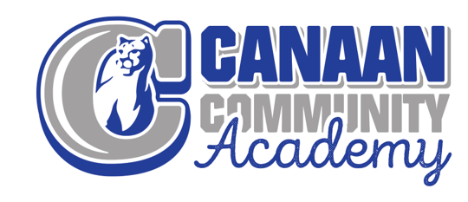
2021-22 Professional Development Plan
The purpose of this plan is to improve student learning by providing meaningful, focused professional development opportunities that are aligned with state standards and Canaan Community Academy(CCA) philosophy and goals. This was developed in partnership with Equitable Education Solutions (EES). The pandemic delayed full implementation of previous PD plans and will resume where it was disrupted while also providing SEL support for students. The Behavior Interventionist, Student Mentor, and Social Worker that work directly with students and staff.

Goals:
Goal 1: Evaluate curriculum maps in a cycle of refinement in order to: (1) build capacity in deeply understanding core curricular elements, (2) create
thematic, interdisciplinary units of study, (3) establish prioritized standards to embed throughout the curriculum. Curriculum development occurs in tandem with
professional learning opportunities on depth of knowledge, project-based learning best practices, and assessment as it relates to curriculum.

Goal 2: Canaan will engage in a cycle of professional learning to collectively construct a building-wide framework identifying expectations and common
language regarding evidence-based best practices in education in order to improve instructional practices. Non-evaluative walkthrough data and a cycle of
instructional coaching will demonstrate the effectiveness of professional learning related to differentiation, blended learning, grading practices, and student
engagement in order to ensure a high-level of instruction and maximal opportunities for learning are provided for all students.

Goal 3: Canaan will continue to develop the work that has been started through Trust Based Relationship Interventions (TBRI) by expanding their professional knowledge in the following areas: (1) Create a system of behavior support and management through a consistent PBIS framework, (2) build capacity of teachers in educational neuroscience and
cultural relevance as it relates to poverty, (3) develop a system that establishes equity for all students through an RTI process.

Professional Development Opportunities:
CCA staff will participate in weekly team meetings to collaborate and collectively reflect on instructional practices and strategies.
Staff will participate in training provided by Five Star Solutions will assist with improvement and implementation of strategies to impact classroom practices by:
- Increasing the staff’s understanding NWEA, ILEARN, and IRead 3 data
  - Instructional strategies suggested
  - Correlation to curricular elements
- Differentiating PD to meet each teacher’s need on how to use data from the PIVOT Data Warehouse
  - Meeting each students need
  - Reviewing classroom needs
  - Reviewing school trends
Staff will participate in training provided by Equitable Education Solutions will assist with improvement and implementation of strategies to impact classroom practices by:
- Providing modules to improve classroom instruction
- Preparing for STEM certification
Staff will participate in training provided by Behavior Interventionist, Student Mentor, and Social Worker.
- Trust Based Relationship Intervention (TBRI)
- Crisis Prevention Intervention
Informal walkthroughs with feedback will assist with improvement and implementation of strategies to impact classroom practices to:
- Increase engagement
- Increase effective differentiation
- Increase use of depth of knowledge questions to facilitate higher order thinking and deeper learning.
- Provide feedback on units of study in order to support curriculum map refinement.
Plan for Measuring PD Impact:
• Behavioral and academic data will be analyzed in a regular cycle for positive
trends as strategies are implemented.
• Increases in student engagement will be measured and analyzed using
informal observation.
• The effectiveness of professional development and its impact on classroom
practices will be evaluated by the responses on teacher/staff surveys.
• Achievement on NWEA will be analyzed three times a year to inform curricular
and instructional practices.
• Achievement on ILEARN will be analyzed when available to evaluate the
percentage of students demonstrating proficiency.
- The students at Canaan Academy will demonstrate an increase in proficiency in ELA and math for SY 2021-2022 assessment data from ILEARN based on the
- following increments:
- ∙An 8.4% increase in students earning proficiency in ELA
- ∙An 8.5% increase in students earning proficiency in math
• Achievement on formative and summative assessments will be analyzed
regularly to establish needed supports and differentiation within the
classroom.
• Teacher effectiveness via informal observation will be used in order to support
teachers on an individualized basis.

