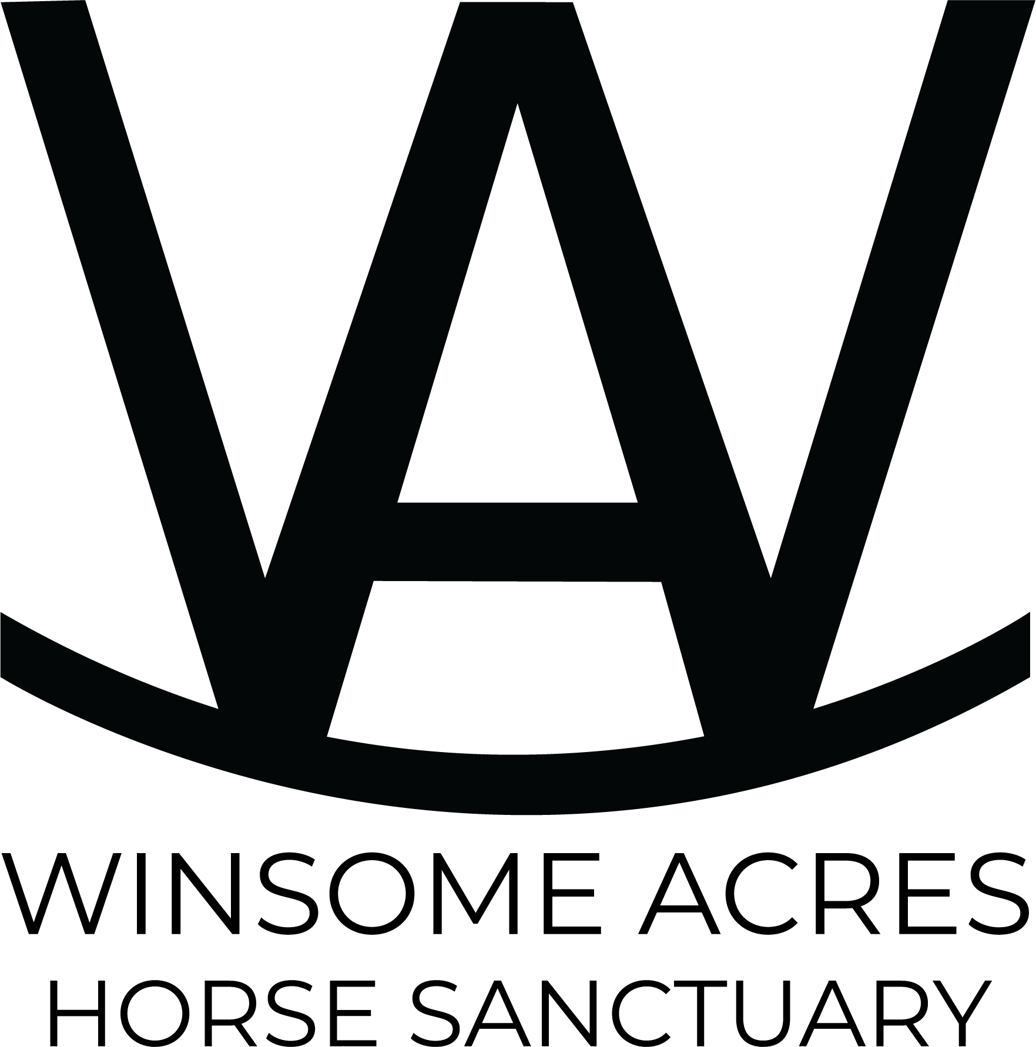
WINSOME ACRES HORSE SANCTUARY
HORSE ADOPTION APPLICATION & AGREEMENT
Providing safe, lifelong advocacy for rescued horses

Applicant Information
Full Name: ________________________________________________
Date of Birth: _____________________________________________
Address: _________________________________________________
City/State/Zip: ___________________________________________
Phone Number: ____________________________________________
Email Address: ____________________________________________
Driver’s License Number: _________________________________
Residence & Property Information
Do you own or rent your property? __________________________
If renting, landlord approval attached? ____________________
Name/address of boarding facility (if applicable):
___________________________________________________________
How many acres is the horse property? _____________________
Describe shelter, fencing, and turnout areas:
___________________________________________________________
___________________________________________________________
Horse Care Experience
Previous horse ownership experience:
___________________________________________________________
Current veterinarian: ____________________________________
Current farrier: _________________________________________
Will this horse be used for riding, companionship, therapy, or other?
___________________________________________________________
How many horses currently live on the property? ____________
References
Veterinarian Reference: ___________________________________
Farrier Reference: ________________________________________
Personal Reference: ______________________________________
ADOPTION TERMS & CONDITIONS
- The adopted horse shall not be sold, traded, leased, gifted, transferred, abandoned, auctioned, or otherwise relocated without the prior written consent of Winsome Acres Horse Sanctuary.
- Winsome Acres Horse Sanctuary retains perpetual ownership interest and the right to reclaim the horse at any time if the horse’s care, safety, or wellbeing is deemed compromised.
- The adopter agrees to provide proper feed, hay, veterinary care, farrier care, shelter, clean water, and humane treatment at all times.
- The adopter agrees that Winsome Acres Horse Sanctuary may conduct welfare checks with reasonable notice.
- If the adopter can no longer care for the horse, the horse must be returned directly to Winsome Acres Horse Sanctuary.
- The horse may not be bred under any circumstance without written approval from Winsome Acres Horse Sanctuary.
- Failure to comply with these terms may result in repossession of the horse by Winsome Acres Horse Sanctuary without compensation.

By signing below, I certify that the information provided is accurate and that I understand and agree to all terms listed above.

Applicant Signature: _____________________________________
Date: ____________________________________________________

Winsome Acres Representative: ____________________________
Date: ____________________________________________________
Winsome Acres Horse Sanctuary • Rescue • Heal • Connect • Thrive

UPDATED ADOPTION REQUIREMENTS & AGREEMENT CLAUSES
- A mandatory site visit is required prior to final approval of any adoption application. Winsome Acres Horse Sanctuary reserves the right to inspect and evaluate the environment, shelter, fencing, pasture conditions, and overall safety of where the horse will reside before placement.
- The adopter agrees that Winsome Acres Horse Sanctuary may conduct ongoing wellness and welfare checks for the life of the horse with a minimum notice period of one (1) week. These checks may include in-person visits, veterinary verification, photographs, videos, or communication regarding the horse’s condition and care.
- The adopter understands and agrees that all horses are adopted 'AS IS.' Many rescue horses may have unique medical, behavioral, emotional, or physical needs, including pre-existing conditions that may require specialized or lifelong care.
- Winsome Acres Horse Sanctuary agrees to fully disclose and transparently communicate all known medical history, behavioral concerns, maintenance needs, medications, limitations, and ongoing care requirements prior to adoption whenever such information is available.
- By proceeding with adoption, the adopter acknowledges acceptance of the horse’s current condition and any ongoing responsibilities associated with the horse’s care and wellbeing.

Applicant Initials: ______________________

Applicant Signature: _____________________________________
Date: ____________________________________________________

