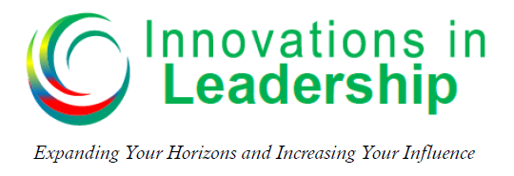

Michael V. Newman – Podcast – Episode 006
How to Improve Your Communication Skills
One of the most, if not the most important leadership skill is communication. Without making a solid connection with people, effective communication is really difficult. Do you know that each of us has a preferred communication style?
“If I understand you and you understand me, doesn’t it make sense that we can work more effectively together?” – Dr. Robert Rohm

Understanding Communication Styles
O_____________

T___________
P___________

R_____________

Predominant Styles
D______________ - Outgoing/ Task-Oriented
I ______________ - Outgoing/People-Oriented
S______________ - Reserved/People-Oriented
C______________ - Reserved/Task-Oriented
Predominant Styles | Personality Type | Secret Fuel | Comments
D
I
S
C

Certain Words and Phrases Make a Big Difference
D – Outgoing/Task-Oriented
Words “D’s” like to hear | Words “D’s” don’t like to hear
- Bottom Line | - Maybe
- Results | - Probably
- Goal | - Perhaps
- Success | - I think

S – Reserved/People-Oriented
Words “S’s” like to hear | Words “S’s” don’t like to hear
- Easy | - Conflict
- Guarantee | - Change
- Harmony | - Rush
- Team | - Risk

If you would like more information on communication styles and the DISC Assessment you can go to: https://innovationsinleadership.com/disc-resources
Resources:
Positive Personality Profiles - by Dr. Robert Rohm
Who Do You Think You Are Anyway – by Dr. Robert Rohm
Answers: Outgoing, Reserved, People, Task, D, I, S, C, Dominant, Inspiring, Supportive, Cautious, Dominant, getting results Inspiring, having fun, Supportive, peace and harmony, Cautious, quality answers, value and bring correct

