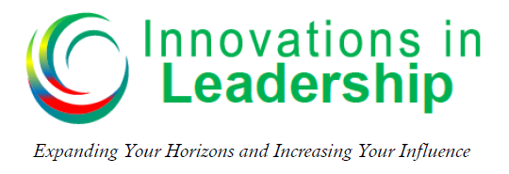

Michael V. Newman – Podcast – Episode 007
How to Improve Your Communication Skills – Part 2
When you are in conflict or having a challenging conversation, consider these three questions:
- What is the source of this ________________?
- How much of this do I own?
- What can I do to ________________ it?
“As leaders we will always have challenging conversations, it is how we handle them that will determine our success.”
Understanding Communication Styles
Outgoing

I
D
Task
People

C
S

Reserved

Predominant Styles | Secret Fuel | Secret Fuel | Secret Fuel
D | Getting Things _______
I | Having _______
S | Peace | H_______
C | Quality _______ | Value | Being _______

Certain Words and Phrases Make a Big Difference
I – Outgoing/People-Oriented
Words “I’s” like to hear | Words “I’s” don’t like to hear
- Fun | - Plan
- Creative | - Budget
- Variety | - Agenda
- Flexible | - Schedule

C – Reserved/Task-Oriented
Words “C’s” like to hear | Words “C’s” don’t like to hear
- Precise | - Spontaneous
- Analysis | - Flexible
- Structure | - Small Errors
- Details | - Hurry
Keys to Understanding Each Style
Predominant Styles | Want to Know | They Are | Greatest Fear
D | What | Doers, Decisive, _______ | Being Taken ___________of
I | Who | Inspiring, Interactive | Rejection
S | How | Stable, ___________ | Loss of security
C | Why | Competent, Cautious | Being __________

Blind Spots
Predominant Styles | Blind Spot | How to Overcome the Blind Spot
D | Caring for __________ | Put people before your goals
I | Having too much fun | ____ more, focus on deadlines and milestones
S | Steady and status quo | Learn to accept _______
C | Over analysis | Focus more on __________ than perfection

If you would like more information on communication styles and the DISC Assessment you can go to: https://innovationsinleadership.com/disc-resources
Resources:
Positive Personality Profiles - by Dr. Robert Rohm
Who Do You Think You Are Anyway – by Dr. Robert Rohm
Answers: conflict, diffuse, Done, Fun, Harmony, Answers, Correct, Direct, Advantage, Steady, Criticized, people, Listen, change, excellence

