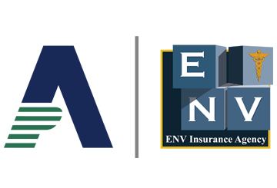
IRS Announces 2023 Retirement Plan Limits
Important Dates
Oct. 21, 2022
The IRS released the 2023 retirement plan limits.
Jan. 1, 2023
The effective date of the 2023 retirement plan limits.
The Internal Revenue Service (IRS) has released Notice 2022-55, containing cost-of-living adjustments for 2023 that affect amounts employees can contribute to 401(k) plans and individual retirement accounts (IRAs).
2023 Increases
The employee contribution limit for 401(k) plans in 2023 has increased to $22,500, up from $20,500 for 2022. Other key limit increases include the following:
- The employee contribution limit for IRAs is increased to $6,500, up from $6,000.
- The catch-up contribution limit for employees aged 50 and over who participate in 401(k), 403(b), most 457 plans and the federal government’s Thrift Savings Plan is increased to $7,500, up from $6,500.
- The employee contribution limit for SIMPLE IRAs and SIMPLE 401(k) plans is increased to $15,500, up from $14,000.
- The limits used to define a “highly compensated employee” and a “key employee” are increased to $150,000 (up from $135,000) and $215,000 (up from $200,000), respectively.
- The annual limit for defined contribution plans (for example, 401(k) plans, profit-sharing plans and money purchase plans) is increased to $66,000, up from $61,000.
- The annual compensation limit (applicable to many retirement plans) is increased to $330,000, up from $305,000.
The amount individuals can contribute to their 401(k) plans in 2023 has increased to $22,500.
Provided to you by ENV Insurance Agency
The income ranges for determining eligibility to make deductible contributions to traditional IRAs, contribute to Roth IRAs and claim the Saver’s Credit (also known as the Retirement Savings Contributions Credit) also increased for 2023. The IRS’ news release contains more details.

