|  |  |  |
| --- | --- | --- |
| **Credit Sesame** | Principal (Recurring) |  |
| **Ashley Furniture** | Principal |  |
| **Jack Daniel’s** | Principal |  |
| **Home Depot** | Principal |  |
| **Metro PCS** | Principal |  |
| **Auto Nation** | Principal |  |
| **Corona Hard Seltzer** | Principal |  |
| **Starbucks** | Principal |  |

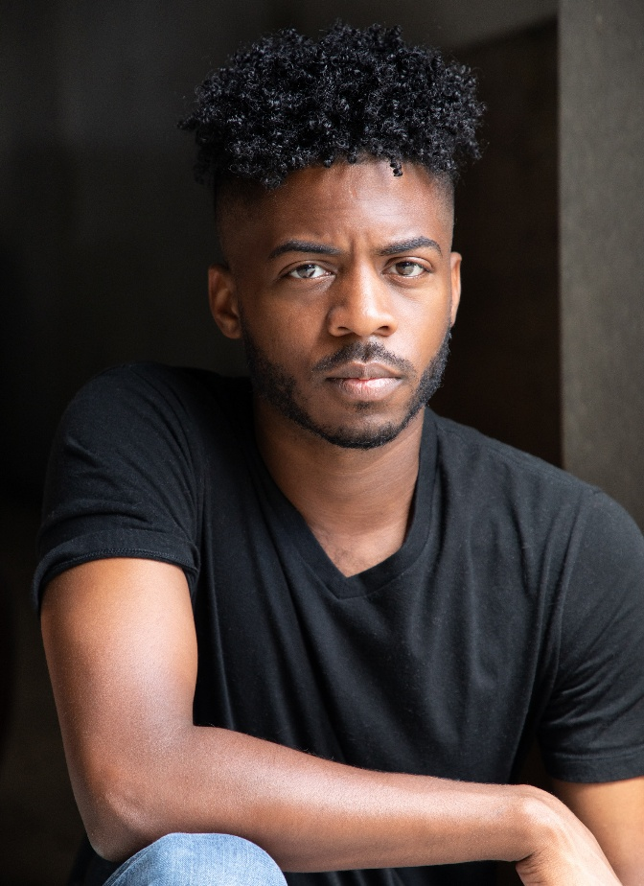

**Special Skills**

|  |  |  |
| --- | --- | --- |
| Fluent in Spanish | Singing (baritone) |  |
| Accents: Spanish, Cockney, Northern England | | |

**Email**

Elvis.casely@gmail.com

**Website**

www.elviscasely.com

**Commercial Acting**

Maile School of Acting – Orlando, FL

Instructor: Jim Braswell

**Film/TV Acting**

The Actory – Miami, FL

Instructor: CJ Bornacelli

**Broward College**

Voice for the Actor (English Dialect)

Theater

Advanced Stage Acting

**Education**

Elvis J Casely Jr

**Eye Color:** Brown

**Height:** 5’7”

**Hair Color:** Black

**Weight:** 140 lbs

**Commercial Credits**

**Bio**

**Phone**

954.699.6593