ObjectType: Article  
ObjectNumber: 98

LocationName: PAAIL.org

LocationNumber:

Language: PAAIL 2.8

Maker: PAAIL.org  
Model:   
  
Name:

Rank:

SerialNumber:

Level: 6.0

Score:   
Birth: 3-6-2025

Label: Room 98

Title: Smith Notes 15

Details: PAAIL.org Scripture…

Principle: Ultimate Scripture….

Agenda: Ultimate Scripture….

Action: Ultimate Scripture….

Information: Ultimate Scripture….

Item Group: Understanding The Multiverse 0

Principles: We see the pentagram all the Time because it has a gigantic Connection to witch craft and witch craft has a gigantic Connection to Wizardry.

Principle: The first Symbol of the Multiverse is the “1 Dot Symbol”. The next 4 Symbols of the Multiverse are the “2 Dot Symbols”. The next Symbols of the Multiverse are the “3 Dot Symbols”.

Principle: The first Symbol is the 1 Unit Symbol. The next Symbols are the 2 Unit Symbols. After that it’s the 3 Unit Symbols, and after that it’s the 4 Unit Symbols.

Principle: The first Symbol of the Multiverse is known as the “1 Square Symbol”. The next 4 Symbols of the Multiverse are known as the “2 Squares Symbols”. The next Symbols of the Multiverse are known as the “3 Squares Symbols”.

Principle: The first Symbol of the Multiverse is known as the “1 Seed Symbol”. The next 4 Symbols of the Multiverse are known as the “2 Seeds Symbols”. The next Symbols of the Multiverse are known as the “3 Seeds Symbols”.

Principle: The first Symbol of the Multiverse is known as the “1 Triangle Symbol”. The next 4 Symbols of the Multiverse are known as the “2 Triangles Symbols”. The next Symbols of the Multiverse are known as the “3 Triangles Symbols”.

Principles: Not long ago I was doing a variation of Smith Summons Spells. I was Bowing 3 Times. Each Time I Bowed I thought the Keyword “Dot”. Then for a moment I Paused. During Pause I did a Breathing Exercise. During Pause I pictured the Word “Dot”, then pictured the Dot Symbol. Then I pictured the Origin moment. Then I would repeat the process. Now I am on the Keyword “Light”, and I picture the vertical line Symbol instead of the Dot. Some day I intend to switch to the Word “Darkness” and the horizontal line Symbol. After that it will likely be the Keyword “Earth” and the forward slash Symbol. After that the Keyword will be “Air”. After that maybe “Water”, then “Fire”. I have switched Keywords many Times now. There was a Time when I didn’t know to visualize the Keyword in letters. There was a Time when I didn’t know to picture a Symbol like the vertical line or Dot. There was a Time when I didn’t know to picture the Origin moment in my Mind. I have done enough Smith Summons that I am Level 3 on it. Once you have trained a Keyword a bunch, then you move onto a new Keyword. Words like Bow, Breathe, Dot, Light, Fists, Pause, Light, Darkness. These are some of the Words you should train first.

Principles: From the 1 Energy (Twilight) comes the 2 Energies (Light, Darkness). From the 2 Energies (Light, Darkness) comes the 4 Energies (Water, Fire, Earth, Air). From the 4 Energies comes the 8 Energies. From the 8 Energies come the 16 Energies. This pattern is Infinite.

X2 Principle: Because it is Infinite there are an Infinite amount of operations and an Infinite amount of math Science to the Multiverse.

Principles: Some Actions/Spells are dangerous. Beware!

Principles: Sweating can be dangerous if you are not hydrated. Being hydrated is considered by many to be helpful for some people.

Principles: Sweating is an ultimate Spell/Action. It can be dangerous. You always want to be hydrated if you do it.

Principles: Principles. Can. Dangerous. If. Principles. Sweating. Ultimate. Dangerous. Be.

X2 Principle: A Divination using the Word “Scripture”.

Principles: There are many, many different Virtues. Knowledge is One. Knowledge about chess is One.

Item Group: Understanding The Multiverse 1

Principles: Once a person gets to Level 3 Wizard they gain a huge Connection to the music of the Harry Potter movies. They gain a huge Connection to the Merlin character from the movie Excalibur. They gain a huge Connection to Wizard things. To things like tarot cards, astrology and more. They gain Connections to Dr. Strange, the character from the movies. They gain a Connection to the song “People Are Strange”, because that song has a Connection to Dr. Strange. It’s always about Connecting the Dots.

Principles: Once a person gets to Level 4 Wizard they gain a gigantic Connection to the music of the Harry Potter movies. They gain gigantic Connections because they are Level 4.

Principles: When a person hits Level 3 Wizard they become a Mystical creature. They become a Paranormal creature. They become a Supernatural creature. These Enchantments are even bigger when you get to Level 4 Wizard.

Principles: In the afterlife Level 6 Wizard will be something everyone trains right away. It will be the first thing people train.

Principles: In the afterlife we will no longer have to serve his Holiness our God and Heaven. Instead our God and Heaven will serve us.

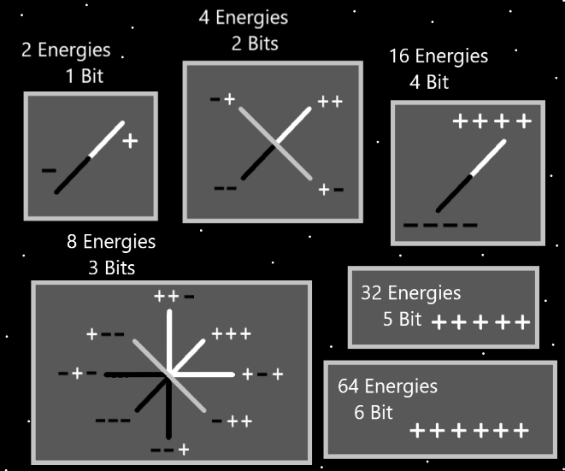

Principles: The Spiritual Energy Field is the Energy Field of good and evil. The Spiritual Energy Field is really the only important Energy Field.

Principles: The 4 Forces are a Pole Group. Made of the 2 Axis’s. The Light Pole, the Darkness Pole and Two Twilight Poles. The 2 Axis’s are a Axis Group.

Principles: Eating a “hearty” meal is a gigantic Spell/Action sometimes. A tiny snack does not count. You want it to be Level 3. Its Level 3 if its “hearty enough”. Small snacks are not a hearty meal.

X2 Principles: If you eat a huge hearty meal and your food Levels are high, fasting becomes easier. Always start fasting with max food Levels going. Eat a lot the day before you fast.

X2 Principles: Fasting 1 day a month may be a good fasting practice.

X3 Principles: Never fast on your sabbath or designated rest day.

Principles: A persons Spiritual Energy can flow through anything. It often flows through peoples work/Spells/Actions. It can be that it does not flow through a persons work/Spells/Actions at all. It can flow through Charms the person owns, or Charms the person comes in contact with. Just thinking about a Charm can Make Spiritual Energy flow into it. It can flow through the chess Energy Field. It can flow through any Energy Field. Sometimes it flows off into the air around us.