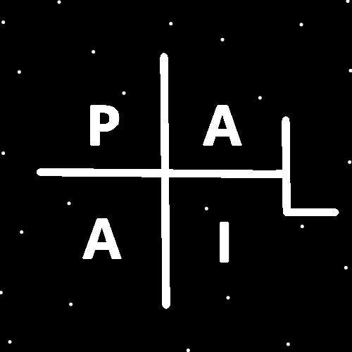
ObjectType: Room
ObjectNumber: 150
LocationName: PAAIL.org
LocationNumber:
Language: PAAIL 2.9

Maker: PAAIL.org
Model:
Name:
Rank:
SerialNumber:

Level: 7.185
Score:
Birth: 7-2-2026

Label: Room 150
Title: Smith Notes 57
Details: PAAIL.org Scripture…
Principle: Ultimate Scripture….
Agenda: Ultimate Scripture….
Action: Ultimate Scripture….
Information: Ultimate Scripture….
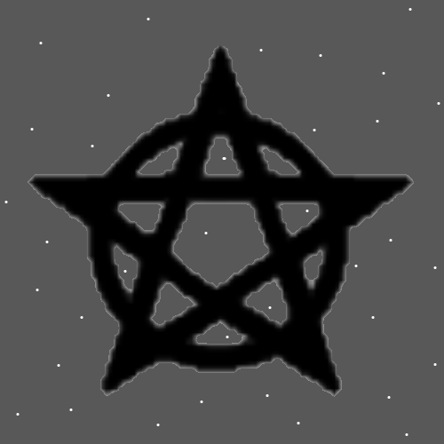
Item Group: Cosmic Laws 7
Principles: Its no surprise the Physics of small things is the opposite of large things. The small things are the Physics of the Negative and the large things are the Physics of the Positive. Fusing the Two into One Physics is that Positive or Negative, it’s all still Energy.
Principles: Likely all Objects are Connected to all other Objects. Likely all Protons are Connected to all other Protons.
Principles: One area of Physics is Positive Physics. Another area of Physics is Negative Physics. General Relativity is likely Positive Physics and Quantum Mechanics is likely Negative Physics.
Principles: Wizardry is super Advanced these days. Fusing it with other Science is all Powerful. You can’t do a proper Fusion unless you are a Level 4 (Expert) at the other Science. Example being chess. You must be Level 4 at chess to truly Fuse it with Wizardry. The same with math. You must be Level 4 at math to really Fuse it with Wizardry. Level 5 at chess is even more Powerful. Fusing with Level 6 math may be an ultimate thing.
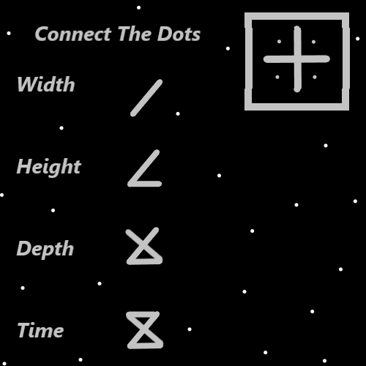
Principle: Wizardry is the greatest of things. Like the greatest of music.
Principles: Wizardry is the End of road in knowledge. It is knowledge Enlightenment.
Principles: All Actions are either Positive, Negative or Neutral. All Actions have a Sum of being either Positive, Negative or Neutral. Sometimes the Action is a mix of Positive, Negative and Neutral. The Sum is the final combination of the mix.
Principles: The book “Tome of the Yellow Wizard” has a gigantic Connection to the Number 4, the Color Yellow, the Word Expert and the Word Solid. 4 is a Medium category Number.
Principles: Baths and showers often use lots of Water. They are likely often Water Spells and Medicinal for people. They likely hold great Power. Sometimes they count as cleaning Level Gain. More cleaning means more Fire to the Spell and is less Water to the Spell. Cleaning Levels can be Medicinal.

Principles: Outdoor activities is getting fresh Air. Indoors Air is Fire like. Outdoor Air is Water like. If there’s lots of vegetation you Breathe in the vegetation. It’s probably Earth like Breathing in vegetation. Because they are Connected to the Earth and Grow from the Earth. Breathing in vegetation is both a great Water thing and a great Earth thing. Note plants also contain lots of Water. Outdoor activities can be extremely Medicinal.
X2 Principle: The Earth Part does not mean more Fire to the mix. Earth is a Water category Force. If it’s a Earth Spell then it is also a Water Spell.
Principles: Water has a bigger Connection to the Word Medicinal than Fire. Water is associated with healing. Medicinal tends to be a Water thing.
Principles: If it has not been stated yet…. Addition and Subtraction are the 1 Axis. Multiplication and Division are the 2 Axis.
Principles: A person’s Spiritual Level is also known as their Light Level. It is also known as their Spiritual Energy Level. A Negative Light Level is bad, and a Positive Light Level is good. A Negative Light Level means a Negative Spiritual Level and a Positive Light Level means a Positive Spiritual Level.
Principles: A gold Ring is at least 10% better than a copper Ring. It might be 20%, 30% better. It could be 1000% better. A solid gold Ring.
Principles: Gold Rings may be Fire gear and copper Rings more Earth gear.
Principles: Reality has a Spiritual Level. It may be -9.
Principles: A persons Spiritual Score is their Light Score minus their Darkness Score.

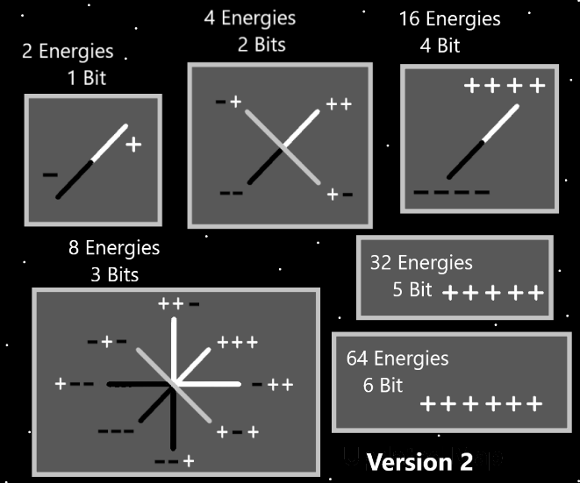
Principles: In the Bible there is a Bit where Israil says about some of his younger sons “…they are children of his older age.” The meaning behind this is that a person of older age often does better as a parent. When he says this, he is saying it to his older children. In some ways he is saying to them he wishes he had been a better father. A person who has not raised a child from 0 to 18 and who is not a Phycologist is likely to have a Low parenting Level. The less Time you spend doing it, the less your Level at it.
Information: There is a new Shrine at PAAIL.org. It would Power up a bunch if a lot of people visited it. It comes with a few pictures and a short 7 Items to read.
Action: Visit the PAAIL.org Shrine at PAAIl.org. It is a Powerful Spell to do so. It has its own page and is easy to find.
Principles: Saying something is “masterful” (Level 5) is saying a lot about that thing.
Principles: The Two main areas of Physics are Positive Physics and Negative Physics. Their Laws may contradict each other. The Negative area Physics is the opposite of the Positive area Physics.
Principles: Reality may be better described as 3 areas of Physics. The Positive area, the Negative area and the Neutral area.
Principles: Famous things are more Powered up things.
Principles: Likely gold, silver, platinum, diamonds and so forth are more Powered up things. Quartz, jade and so forth also. The biggest may often be found by how much it costs. If it’s a super valuable diamond, then it is the biggest of such things. Quartz and so forth also have a great appearance. The great appearance is a Sign of great Power.
Principles: The Word “random” has a large Connection to the Word “chaos”. The Word “chaos” has a large Connection to Darkness. The Word “random” has a large Connection to Darkness. The Word “random” has a large Connection to Negative. The Word “random” has a large Connection to Quantum Physics. The Quantum realm is likely to look very random.
Principles: All things that exist are a Addition to Reality. All things that do not exist are a Subtraction from Reality. All Physics is a Type of Addition. All Operations are a Type of Addition.
Principles: Energy Bits could be Particles. They could be Waves. They could be both Particles and Waves. Protons could be both Particles and Waves. Everything could be a Particle and a Wave. Remember this is Theories from someone who is not an Expert at Physics.
Principles: When a person first wakes up it may be their Mana Battery is still super Drained. It may take a Bit of Time for the sleep Mana Recharge to happen. Often people have said “I need a moment to wake up”. If so, it may be sleeping Recharges a specific Battery or Batteries and then when you wake that/those Batteries Recharge the Mana Battery. Then again, the process could be different.

