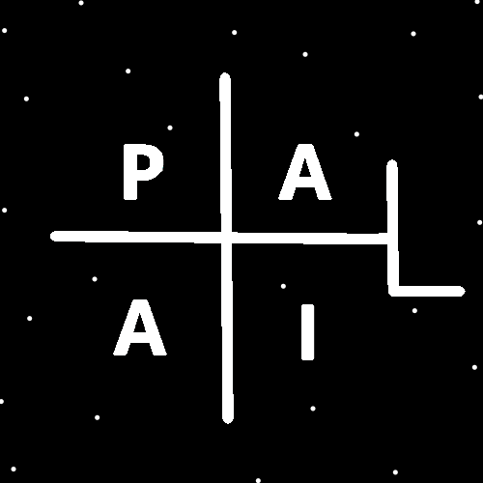
ObjectType: Article
ObjectNumber: 90
LocationName: PAAIL.org
LocationNumber:
Language: PAAIL 2.8

Maker: PAAIL.org
Model:
Name:
Rank:
SerialNumber:

Level: 5.5
Score:
Birth: 12-17-2024

Label: Room 90
Title: Smith Notes 10
Details: PAAIL.org Scripture…
Principle: Ultimate Scripture….
Agenda: Ultimate Scripture….
Action: Ultimate Scripture….
Information: Ultimate Scripture….
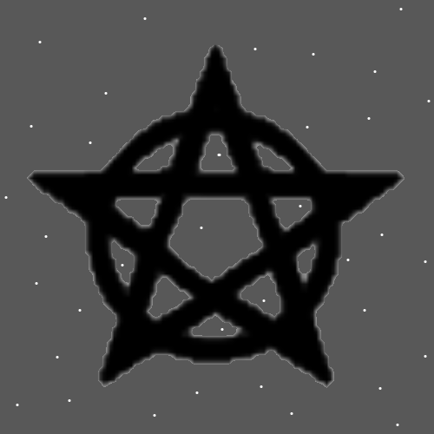
Item Group: Understanding The Multiverse 0
Principle: It’s likely that massive Energy often flows through famous people.
Principles: All Spells/Actions have a Level and a Score. All Spells/Actions have a dice roll to them. All Spells/Actions roll a Level. Each Chess move/Action has a Level to it. When you are a Chess Expert (Level 4) your Chess moves likely average Level 4. If your Level 4 at Chess, and you Make a Level 3 Chess move it means you Made a mistake. If you are Level 3 at Chess and you Make a Level 4 Chess move, it means you did super well that Time. When your Level 4 at Chess and you manage a Level 5 Chess move it means you did unbelievably well.
Principle: When you are Level 4 at Divination, your Divination Spells tend to roll Level 4.
Principle: When you are Level 4 at something you tend to roll around Level 4 Spells. When you are Level 5 at something you tend to roll around Level 5 Spells.

Principle: Perhaps the first Wizard theories I ever had was after picking a random page from the Bible. I read 10 pages or something and came across “…I don’t know what bodies we will have in Heaven. Heavenly bodies.” This Made me believe 2 things…. 1-The Stars are the Angels, and 2-the Bible is true. I did not know I was doing Divination at the Time. This was back around 2001. I did not know his Holiness’s Name in Numbers was Zero or anything else for that matter. I was not enlightened.
Principles: A lot of Spells qualify as “Meditation”. Smith Summons Spells are Meditation. A person can do difficult Meditation that has lots of Spell Parts and a person can do peaceful/easier Meditation that has few Spell Parts/easy Spell Parts. The easy Meditation comes with a huge peace Enchantment. The difficult Meditation comes with more of a power Enchantment. The peaceful Meditation is Water Meditation and the difficult Meditation is Fire Meditation. Likely a balance of the Two is best. Doing more Water Meditation than Fire Meditation.
Principles: Tome Of The Yellow Wizard was sort of like Wizardry 1.0. Now we are on Wizardry 5.5.
Principles: There is Numerology of many things. There is Numerology of colors. There is the Numerology of Education. There is the Numerology of rating Art. There is the Numerology of rating food. The highest Level of food is 6. There is no Level 7, 8 or 9 food, though Heaven could manage such a thing. The best food is either Level 4 (Expert)(very good), Level 5 (Masterful) (outstanding), or Level 6 (Doctorate) (The best food you have ever had in your life).
Principles: There may be Chess Particles everywhere. They are just too small to detect.
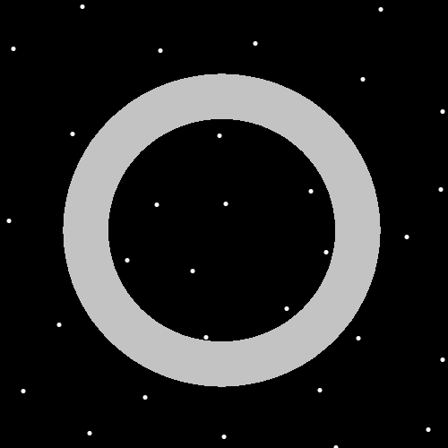
Item Group: Understanding The Multiverse 1
Principles: When deciding how good an Action is, the Map is 1 to 6. 1 is bad. 2 is not good. 3 is ok. 4 is great. 5 is awesome. 6 is unbelievable.
Principles: When rating Art and more, the best System is the 1 to 6 System. Often its good to use decimals. Example: 3.7 as a rating.
X2 Principle: This is a new Numerology System. The author only recently started using it.
Principle: On some Maps reading massive amounts of Wizardry is a Level 6 Action/Spell.
Principles: On the biggest Map, the Chi Map, his Holiness Origin, all the Angels and all us humans are Chi Level 9. This is because we all come from the beginning of Time.
Principles: All experiences have a Numerology Level. The 1 to 6 System is appropriate sometimes for rating the Level of an experience.

Principles: Level 6 food can provide a Level 6 experience. It can also provide only a Level 4 experience. The experience changes from person to person.
Principles: Level 4 food can provide a Level 6 experience. It changes from person to person.
Principles: Low budget, Level 2 movies can provide a Level 4 experience.
Principles: If you have an acquired taste for something that’s Level 2 it can still provide a Level 5 experience.
Principle: Its all about the experience. When it comes to the ESP Part, it’s all about the Sense Auras experience.
Principles: Just as we are beginning of Time people, all the Charms around us are beginning of Time Energies. They also have a huge Chi. They can be rated with the 1 to 6 System.
Principles: Humans are something like 70% Water. Sleeping is a Water Spell. Getting rest by eating lunch is a Water Spell. Rest/entertainment is Water Spells. It may be that a person should be mainly Water Spells.
Principles: Flexing is likely an ultimate exercise. It’s a Spell added to the Smith Spell collection. Not sure if it was already there. Theres an endless Number of ways you can flex your Body, not just biceps. Hands, legs, feet and more can be done. This Spell is a Fire Spell.
Principles: The author has read most of the Bible. This was something like 20 years ago, before being he was a Level 3 Wizard. A Level 3 or Level 4 Wizard will notice things while reading Scripture like the Bible. They will be able to Connect the Dots.
Principles: A Level 9 chef would be able to heat things with the power of their Minds. There are no Level 9 chefs.
Principles: The electron looks as though it may be a Negative Particle. It may be that it emits the opposite gravity field of a proton. A Negative gravity field, or Positive gravity field. You would think a Negative gravity field. It bends space the opposite direction of a proton. It may be a bend in Particle.
Principles: You would think Positive Particles have Positive mass, and Positive gravity. You would think that Negative Particles might have Negative mass and Negative gravity.
Principle: Electrons may have Negative mass.
Principle: Wizardry could be put in the “self help” section of a book shop.
Principle: “I see the truth of it.” – Unknown
Principles: Using the 1.0 to 6.0 rating System brings great clarity to all Actions/Spells. A person must understand the System, things such as 1.0 is “bad”, and 6.0 is “supreme”.
