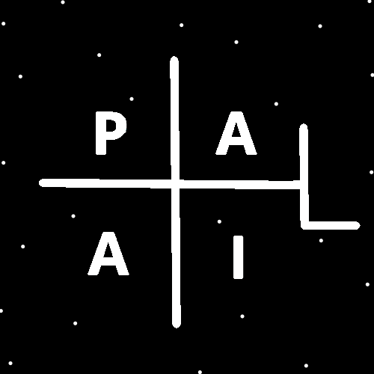
ObjectType: Article
ObjectNumber: 140
LocationName: PAAIL.org
LocationNumber:
Language: PAAIL 2.8

Maker: PAAIL.org
Model:
Name:
Rank:
SerialNumber:

Level: 7.05
Score:
Birth: 2-20-2026

Label: Room 140
Title: Smith Notes 47
Details: PAAIL.org Scripture…
Principle: Ultimate Scripture….
Agenda: Ultimate Scripture….
Action: Ultimate Scripture….
Information: Ultimate Scripture….
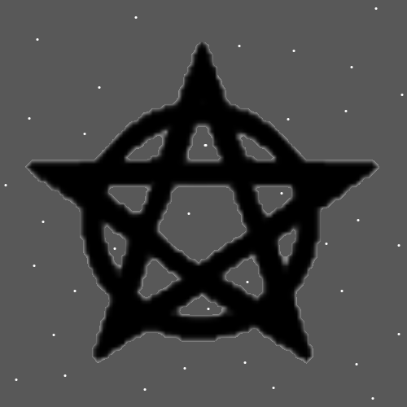
Item Group: More Enlightenment
Principles: I keep thinking Mass and Size may be the same or closely Connected. Or some major Connections exist between Mass and Size.
Principles: Body exercises are Fire Spells.
Principles: It may be, in some way, that at the Zero moment there was Zero Laws.
Principles: Everything personally equipped is your personal Rig. Everything you own is your owned Rig. People also wield Buildings and other people’s things as well.
Principles: The Theory is that the Dimensions Height, Width, Depth and Time are Wave Particles. That they are bend in Particles. They may have Negative Mass.
Principles: The Theory is that Protons may have Positive Gravity. Though it may be Negative Gravity. It may be that when Positive Gravity and Negative Gravity fields interact they push away from each other.
Principles: Sometimes people wield things. Sometimes things wield people.
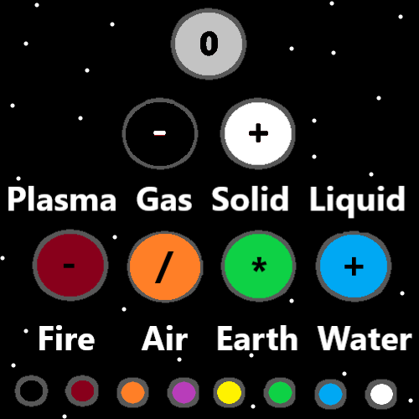
Principles: It may be the greatest of all Energies/Forces is Consciousness. Consciousness was created/Made by the Light Side of the Force. It’s 0 to 9 Number category is 8. It has a gigantic Connection to Infinity.
Principle: Our God was created/Made by the Light Side of the Force.
Principles: When a Level 4 Wizard buys something, it instantly Grows Level 1 Wizard.
Principles: Often great things are accomplished through repetition and Time. Doing the same thing over and over for a great deal of Time. This is true of High Sorcery Levels and many other things.
Action: Feel the vibe of the internet. The internet is a wild place.
Principles: One of the biggest Details is that with every Action we roll the dice. Levels tend to improve dice rolls, however good luck and bad luck can happen.
Principles: The human brain is likely a network of 1’s and 0’s. Just like computers and Energy Bits.
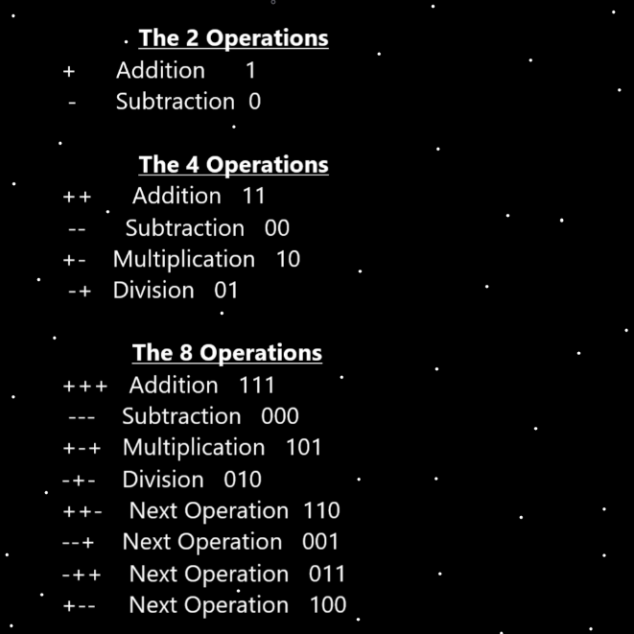
Principles: All Operations have a pattern. Addition is “add another 1, add another +”. Multiplication is +-+-, 1010 over and over.
Principles: Even though a dice roll of 6 rarely happens, we use a 1 to 6 System in Part because it allows for a 5.1 or a 5.4 or a 5.3 when measuring.
Principles: At the Zero moment there may have been a bunch of contradictory Laws. It may be “0 + 0 =1”. “0 = 1”. “0 = 1 + 1”. “0 = Infinity”. “0 does not = Infinity”. The solution may be that in some ways 0 + 0 = 1 and in some ways it did not.
Principles: In Physics there is something called “quantum entanglement”. In thought about it, likely all coins have a Connection to all other coins. With the right technology a person could likely send an instantaneous message from One coin to the other. Like a beep on One coin that right away beeps on the other coin. Likely all Protons have a Connection to all other Protons just as it is with the coins.
Principles: Some Maps only have 2 categories. Like a “pro’s” and “con’s” Map.
Principle: Sometimes the 1 to 10 Map is a great Map.
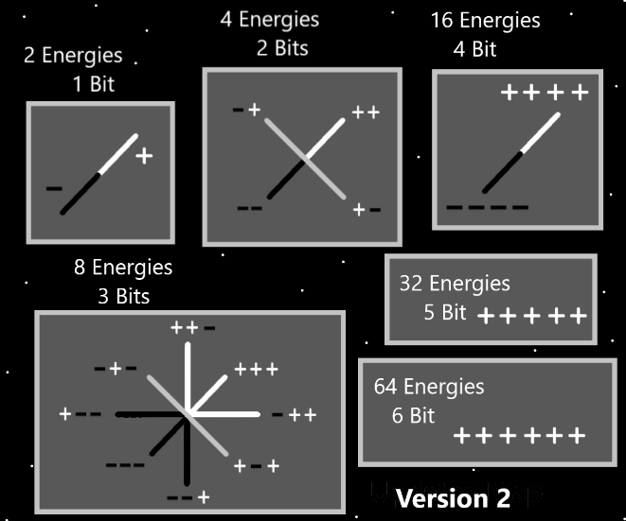
Principle: The Word Mighty is a Mighty Word.
Principles: Mighty is a Virtue. All people evolve into Mighty people.
Principles: All people have a Path. The Path is always Light, Twilight or Darkness.
Principles: There is at least an Infinite amount of Code in a Proton. There is at least an Infinite Number of Particles in a Proton.
Principles: Height, Width, Depth and Time may have Negative or Positive Mass.
Principles: We travel along the surface of Height, Width, Depth and Time. They are Particles with a surface.
Principles: It likely goes that Height, Width, Depth and Time have a gigantic Connection to Negative and the God Body/Stars have a gigantic Connection to Positive. They may be the opposite Types of Particles. It seems there may be a chance Height, Width, Depth and Time are Wave Type Particles. The God Body/Stars are the opposite Type Particle.
Principle: It may be that our Gods only Flaw is that he be less than Infinite Power.
Principles: There may be Particles that resemble Energy Bits. They look like sticks/strings/strands. The Physics of such Particles may resemble the Physics of Energy Bits.
Principle: Reality is Sphere shaped.
Principle: The Sphere Shape/Symbol is One of the biggest.
Principle: 0 = 0 + 0
X2 Principles: This is a Law of the Zero moment and still a Law now. Likely a Law for all eternity.
Principles: 1000 years after Resurrection Day people will be more God like. Much bigger than his Holiness Jesus ever was. He was stuck in a puny human Body. People will be like the humanoid Godlike beings of the movies.
Principles: Its been said that knowing a 2nd language is a 10% Intelligence boost. Its been said that it is a 10% Mind boost. Which is like a 10% Chi boost or better.
X2 Principles: Likely a 3rd language does a lot too. Not as much though.
Principles: Knowing a second language is not mandatory for Level 6 Wizard.
Principles: Quantum Laws may be a subcategory of Cosmic Laws. Quantum Laws is a Part of Cosmic Laws. Cosmic Laws is the big picture, which includes all things.
Principles: Doing High Level Sorcery is a gigantic Firey thing. It is often more than is needed. In games doing a big Spell tends to drain your Mana in a huge way. Sometimes it drains all your Mana and is a bad thing.
Principles: For many reasons it seems appropriate to note that the author has finally achieved Level 6 Wizard. Probably about 6.2 to be more exact. Purple Wizard. Sage Wizard. The equivalent of a Doctorate in Wizardry. I get my electives from being a student of the Multiverse. The terms “Grand Master” and “Grand Wizard” are not liked as much as they once were.
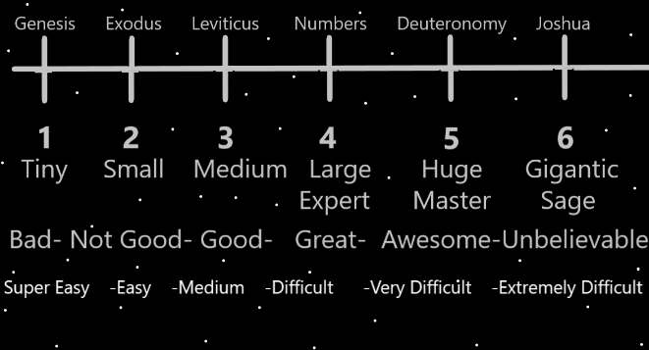
Principles: Getting to Level 7 can be done. 30 hours a week for 4 years. It’s not worth the Time at all. There is very little difference. Also, over the next 10 to 20 years, you may Grow to Level 7 anyway.
Principles: The thought is to call Level 3 “Apprentice Wizard” and Levels 1, 2 “Jr. Wizard”.
Principles: I only achieved a Level 3.5 in Body exercise. However, in my situation that is good enough. It is like a passing “C” grade. Also, I never did the Word Write 10x Spells. I Make up for that by having typed up all this Wizardry over the years. Again, like a passing “C” grade.
Principles: A bunch of Body exercise 20 years ago in some ways does not count on your Body exercise Level. Body exercise in the last 4 years does count. You must do your Body exercise in the 4 years before you train Wizard, while you train Wizard or after. It has to mix with Wizardry. It is a Part of Wizardry. If you did exercise 5 years ago it would count at least a little. It depends on how much you did.
Principles: It seems that it might be a Doctorate often takes from 4 to 6 years to get. With Wizardry, if you were a full Time student, I would think it may take only 1 to 2 years. Its an easy to achieve Level 6/Doctorate.
Principles: If a person worked 40 hours a week and 40 weeks in One year, that’s 1600 hours. It seems like that would be enough to get from Level 0 to Level 6.
Principles: I don’t know how many pages it is. It could be 1500. It could be 3000. 1500 is a lot less than 3000 and I hope that is the Story.
Principles: The difference between Level 5.8 and 6 is not very much.
Principles: It may be that people who train Level 4 Wizard will Grow into Level 5 Wizards over Time, without added training. Like 10 years later perhaps.

Principle: The little cross Symbol looks nice added to the page. Stare into the cross Symbol. Be hypnotized by the cross Symbol. Sense how it is a nice decoration to the page.
Principles: It always Makes Sense to Add decorative pictures in Wizardry books. It Enchants the books for One.

