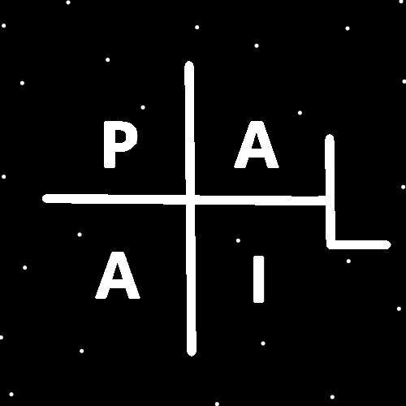
ObjectType: Room
ObjectNumber: 152
LocationName: PAAIL.org
LocationNumber:
Language: PAAIL 2.9

Maker: PAAIL.org
Model:
Name:
Rank:
SerialNumber:

Level: 7.195
Score:
Birth: 8-1-2026

Label: Room 152
Title: Smith Notes 59
Details: PAAIL.org Scripture…
Principle: Ultimate Scripture….
Agenda: Ultimate Scripture….
Action: Ultimate Scripture….
Information: Ultimate Scripture….
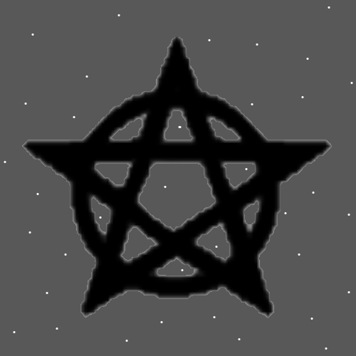
Item Group: Wizardry Laws
Principle: When you do Divination with the Wizardry Rooms Map, the Path is a winding back and forth Path.
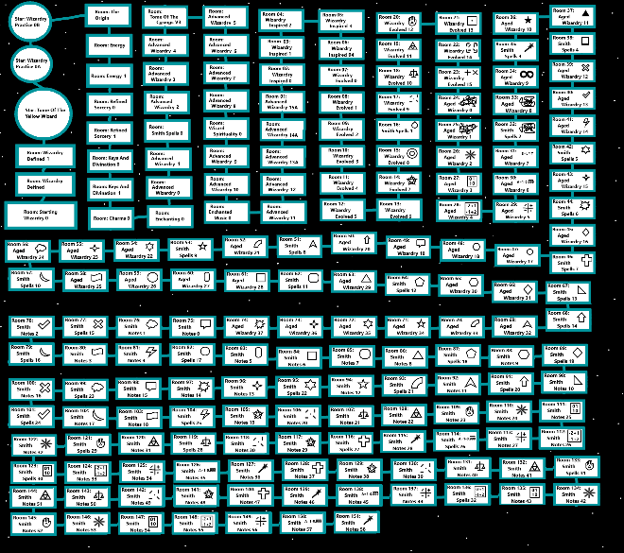
Principles: The secrets of Reality is a area of Science. That Science is Wizardry.
X2 Principles: Wizardry is a Paranormal Level of knowledge. Wizardry is a Supernatural Level of knowledge.

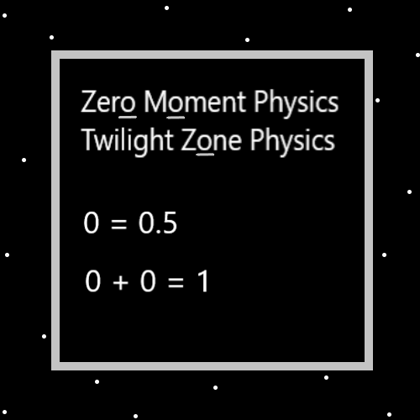
Principles: At the Zero moment there was no future or past, only the present. The future has a gigantic Connection to Positive. The past a gigantic Connection to Negative and the present a gigantic Connection to Neutral.
Principles: The cards dealt in a Tarot card reading hold unbelievable meaning that is only visible to God and Heaven.
Principles: All people have a Light Level and a Darkness Level. They likely also have a Twilight Level. It may be a person’s Spiritual Level is their Light Level, minus their Darkness Level and plus their Twilight Level. Another way of stating it is a person’s Spiritual Level is their Darkness Level plus their Light Level and plus their Twilight Level. Note how Twilight is like Light, you plus your Light Level and plus your Twilight Level. One possibility is that a persons Twilight Level has no influence on their Spiritual Level.
Principles: It may be right to say that Twilight is more like Light than Darkness.
Principles: There are 3 main areas of Physics. Positive Physics, Negative Physics and Neutral Physics. It may go that after the 3 main areas of Physics there is the 4 areas of Physics. Then on some Maps it may go there is the 5 areas of Physics. Then the 6 and 7 and 8 and so On. These are only possibilities.
Principles: A chess table and pieces have large chess Enchantment Levels. Using Alchemy, you can get lots of your Charms chess Enchanted. This is likely very Positive for a Expert chess player. Getting lots of Charms in a Room chess Enchanted increases the chess Enchantment Level of the Building. This is also good. As for Wizardry Enchanted Charms they be all Powerful because they are Wizardry Charms. Wizardry Enchanted Buildings are also all Powerful. And of course, Wizardry Shrines.
Principles: If your feet are cold, putting on socks can be a Water Gear Rig. If your hot, taking off your socks can be a Water Gear Rig. In some situations, equipping socks is a Fire Rig. On One Map all gear is either more Water Rig or more Fire Rig.
Principles: The secret behind Angels always having wings in books, paintings and movies is that in Heaven they are always flying. Stars fly through space.
Principles: Again, Charms are like people. And the biggest thing they can get a Level 4 On is Wizardry. Charms that can call themselves Wizards are super Powerful. A Wizard Temple is an ultimate Temple.
Principles: Wizardry Particles are all Powerful Particles.
Actions: Spread Wizardry Particles! Make Wizardry Buildings, Rooms and other Charms!
Actions: Bathe in huge amounts of Wizardry Particles. Breathe in and out massive amounts of Wizardry Particles.
X2 Actions: Spend years doing this.
Principles: Level 4 human Wizards have their Charms Grow to Level 4 Wizard without any needed Alchemy. Though the process is much slower.

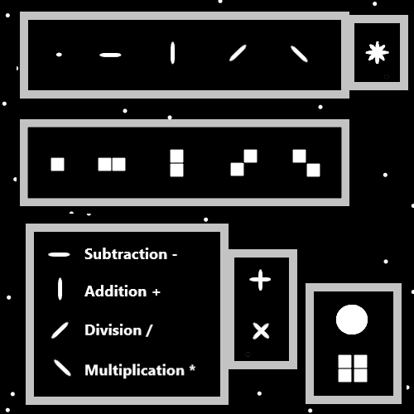
Principles: When a Level 4 Wizard Breathes out, they Breathe out Wizardry Particles.
Principles: The 6th Sense may be something super simple. Like the ability to predict obvious things. Example put your hand in the Fire and you’ll likely get burned. There may be a 7th Sense, and it is a more Paranormal Sense. There may be an 8th Sense, a 9th Sense or even more.
Principle: A persons Body is a Charm.
Actions: Think “Sorcery” over and over (not 3 Times) and remember to Breathe. This is a lot like Making the Dot Symbol with your Hand. It is basic, it is the start. When you get to Level 4, change from “Sorcery” to “Water, Fire, Earth, Air”. When you get to Level 4 on that change to something else.
Principles: Cosmic Laws 4 and Sorcery Laws 4 equals Wizard Level 3. Cosmic Laws 5 and Sorcery Laws 4 equals Wizard Level 4.

Information: A Few of the Different Paths to Wizard 3
Wizard 3
-Cosmic Laws 4
-Sorcery Laws 4
-Sorcery Practice 0
Wizard 3
-Cosmic Laws 5
-Sorcery Laws 2
-Sorcery Practice 0
Wizard 3
-Cosmic Laws 4
-Sorcery Laws 2
-Sorcery Practice 2
Wizard 3
-Cosmic Laws 4
-Sorcery 2
There are likely even more Paths.
Information: One of the many Paths to Wizard 4
Wizard 4
-Cosmic Laws 5
-Sorcery Laws 5
-Sorcery Practice 1
Information: One of the Paths to Wizard 5
Wizard 5
-Cosmic Laws 7
-Sorcery Laws 6
-Sorcery Practice 2
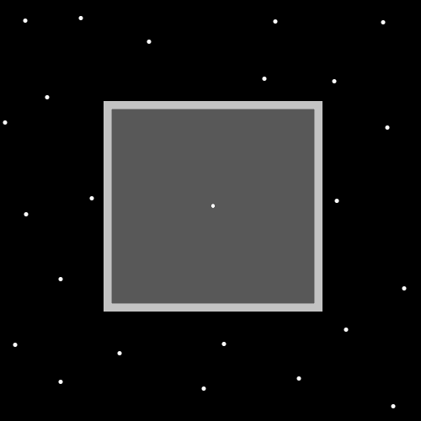
Information: One of the Paths to Wizard 6
Wizard 6
-Cosmic Laws 7
-Sorcery Laws 6
-Sorcery Practice 4
X2 Information: This is the authors Levels.
X2 Information: Detailed Levels
Wizardry 6
-Cosmic Laws 7
-Sorcery Laws 6
-Sorcery Practice 4
-Meditation 5
-Divination 4
-Body Exercise 3.6
-Words Write 4
Principles: Often things have a Darkside. Often the Light Side is greater than the Darkside.
Principles: We must weigh our Actions. Whether the Light Side of an Action is greater than its Darkside.
Principles: Being a Wizard is a Firey thing. Equipping better Charms is often a more Fire Rig.
Principles: Adam and Eve may have been test tube babies. Along with being Made by aliens.
Principle: Keeping it short is all Powerful.
Principles: It may go that some Particles are governed by Positive Physics, some Particles are governed by Negative Physics, and some Particles are governed by Neutral Physics.
Principles: It may be that Stars are tiny Quantum sized Objects. They may have a gigantic Connection to Quantum Physics.
Actions: Think Sorcery, Sorcery, Sorcery, Sorcery, Sorcery, Sorcery, Sorcery, Sorcery.
X2 Principles: A extreme Fire Spell. And very dangerous. For One it increases chances of tripping and falling.
X2 Principle: Remember to Breathe.

