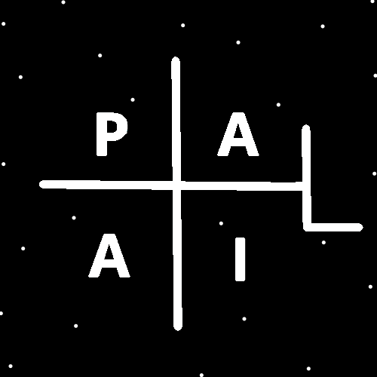
ObjectType: Article
ObjectNumber: 131
LocationName: PAAIL.org
LocationNumber:
Language: PAAIL 2.8

Maker: PAAIL.org
Model:
Name:
Rank:
SerialNumber:

Level: 6.5
Score:
Birth: 12-22-2025

Label: Room 131
Title: Smith Notes 40
Details: PAAIL.org Scripture…
Principle: Ultimate Scripture….
Agenda: Ultimate Scripture….
Action: Ultimate Scripture….
Information: Ultimate Scripture….
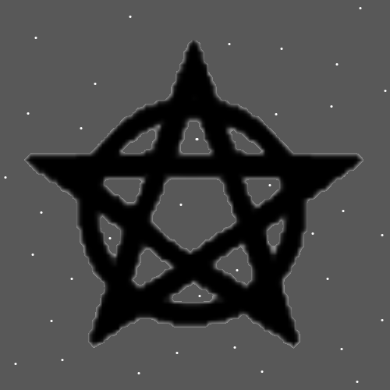
Item Group: More View Of The Multiverse
Principles: If you look at the PAAIL.org Map of it all, the Map looks like a winding Path.
Principles: Space may have Mass. It may be Negative Mass. It may be Positive Mass.
Principles: At Level 4 a person is a Wizard. Levels 1, 2 and 3 a person is a “Junior Wizard”.
Principles: Perhaps it would be good Science to call Levels 1 and 2 “Junior” and Level 3 “Apprentice”.
Principles: Gods Systems for measuring things like speed, distance, heat, Time are the ultimate Systems for measuring things. If only humans could figure them out……
Principles: For God, 4 is Expert, 5 is Master and 6 is Sage. This is One of Gods measurement Systems.
Principles: When speaking of One’s Level, it’s always about what their “Expertise” Level is. Even when One is a Master or Sage, they are still also an Expert on some Maps.

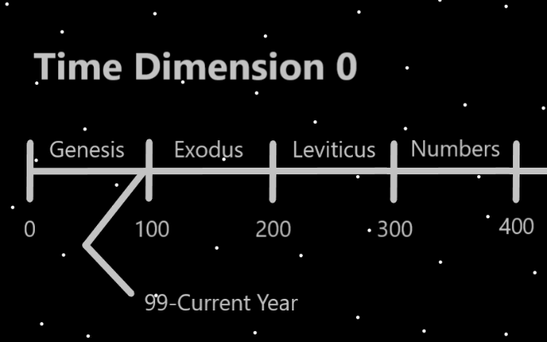
Principles: A Spiritual Level 8 person is a Sage, a Holy Person and a Prophet. The Level 6, 7, 8 Words. Not just the 8 Word.
Principles: The disappointing truth is that few people ever Make it past Spiritual Level 6/Sage. It’s common to Make 6. It’s super rare to Make 7. This is because humans on a Cosmic scale only live a blink of an eye.
Principles: If you wanted to focus on chess, you could think in your head “chess, chess, chess…” over and over. You can even sing it in your head. The sing it in your head may be a super Powerful Spell. You may be able to make us chess songs to repeat in your head. Songs that use other chess Words and so forth. It would likely be something you don’t do the entire chess game. Just a little here and there. If you did the entire chess game it might be a huge Drain. Which would be good if you are training. Not good when you want to win.
Principles: Two Types of Spells are Training Spells and Performance Spells. When Training chess you would use Training Spells. On days when you compete you would not. Training is Draining and you want to be full Power like when competing. Plus more reasons you don’t use Training Spells.
Principles: Sometimes people Keep things that in turn Keep them.
Principles: Gods Systems use the Word “Unit” all the Time. Also there are Terms like “mega Unit”, or “micro Unit”.
Principles: There are an Endless amount of places where there is a “Line Of Code” that says “do not have a pink elephant here”. Also, you could say “Subtract a pink elephant here”. Also, you could say “Negative On pink elephants here. Also, you could say more of them. There are a collection of Energy Bits that Add up to that Line of Code.
Principle: Reality is Made of Code.
Principle: The first Level of Code is Energy Bits.
Principle: On some Maps Reality is Made of 1’s and 0’s.
Principles: In may be there are “Bend In Particles” and “Bend Out Particles. Bend in Particles may be Transparent. On some Maps bend out Particles may be 1 Particles and bend in Particles are 0 Particles. On some Maps it may be that all Particles are Type 1 or Type 0. 1’s and 0’s. Like computer programs.
Principles: A lion has a being that can say I am the lion. A plant is Made of many beings that can say we are the plant, however there is no One being like with the lion. A rock likely has no One being like a lion. Still a rock May be alive, if things like Protons are alive. The rock is like a plant. Not like the lion. One possibility is that a Proton is like a rock, however it is Made of living beings. These are all far-reaching Theories.
Principle: It may be that Protons are not Sphere Shaped at all. They may be like rocks, often having their own unique Shape. With many Sides as a possibility.

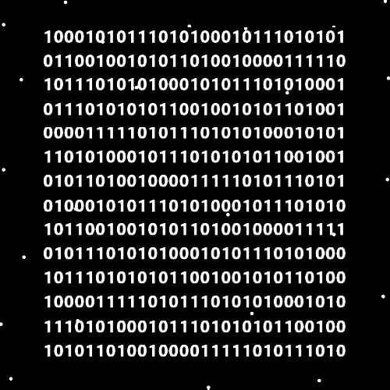
Actions: Stare at the above Map and Sense how Reality is Made of 1’s and 0’s.
Principles: Principles can lead to Agendas. Agendas can lead to Actions. Actions can lead to new Information. Information can be new Principles. Then we start the Cycle over again.
Principles: Principles and Information are Laws. Agendas and Actions are Spells.
Principles: There are the Laws of Wizardry and there is the Spells of Wizardry.
Principles: One Part of Wizardry is Sorcery Laws. Another Part is Cosmic Laws.
Principles: To be an Expert Wizard you might need to train both Cosmic Laws and Sorcery Laws. You do not need to do other Sorcery training though. Like Body exercise, Breathing exercise, or Meditation exercise.
X2 Principles: Meaning Level Cosmic Laws 5, and Level Sorcery Laws 4.
Principles: There may be lots of different Paths for getting to Level 4 Wizard. Because a person can do Body exercises, Breathing exercises, Meditation exercises and more. A person could have Level 4 Cosmic Laws and mix that with other things.
Principles: The Shrine is like the ultimate Alchemy table.
Principles: Seems like I read in the Bible something along the lines of “with the faith of a mustard seed you will move mountains”. Many gigantic things have small Beginnings.
Principles: You would think that Energy Bits may be simplistic. It seems likely they have a physical View. It may be when you Zoom in max and look, you see a bunch of squares Made of sticks. Each square has 12 sticks. There is something that reminds One of the game Minecraft. Reality may be Made of Infinitely small squares. Like in Minecraft. It seems notable to point out that it looks like squares might share Poles/sticks with other squares. See Maps below.
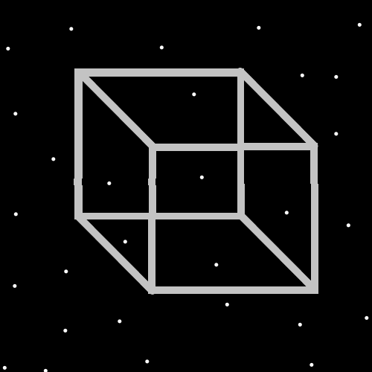
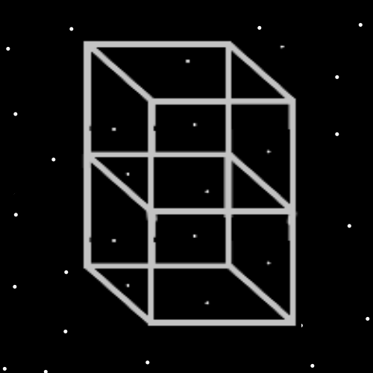
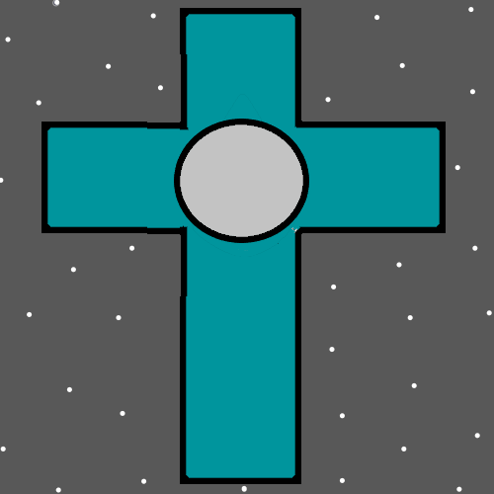
Principles: His Holiness Jesus likely has a gigantic Connection to the plus Symbol. Along with the Christian Cross.
Principles: Some Spells are 1 second Spells, some are 2. Some are 5, some are 30. Becoming a Doctor at something is casting the Spell “Summon Become A Doctor”. It usually takes years to cast that Spell.
Principles: All things a Wizard owns Grow Wizardry Levels. When a Charm reach’s Level 4 Wizard it becomes that the person auto casts the Spell “Summon Level 4 Wizard”. It likely even Drains a persons Mana when it happens. A small Drain.
Principles: All humans can be ultra-Powerful when it comes to Charms Alchemy. This is Partly because humans are Beginning of Time beings.
Principles: Often when it’s right it visually looks right. The best Meditation headgear would look right.
Principles: Long ago the Word “Rune” was first used. A Charm can be Runed by Adding Symbols. Never Rune a thing if it decreases its money value.
Principles: It tends to be a much bigger Enchantment when a thing is manually Runed by a person, rather than a fast machine.
Principles: If you wanted to Make some Wizardry Items, you could sell kits that people can use to Enchant the Item. Rather than come stitched with Runes it could come with a sowing kit and instructions on stitching it. It’s always nice to get a little paperwork with a Charm. Something that tells who Made it. Ideally it has a Serial Number. A person could Keep Charm paperwork at a Shrine and do a gigantic amount of Enchanting.
Principles: Charm paperwork is a Powerful thing. Antiques often come with paperwork. New objects sometimes come with paperwork. Sometimes you can get a recipe when you buy a Charm. This is some Level of paperwork on a Charm. Greater paperwork includes who Made the Charm, when it was Made, where it was Made, people that have owned it and so forth. A person can manually Make this paperwork when the buy or Make something.
Principles: Often Charms get to Level 4 and then don’t Grow much from there. They stay at Level 4.
Principles: A person could Make a really nice Wizard book that is pages full of stuff the person owns. Information like when they got it. And a bunch of other Information. The problem is it would take too much Time. You could still Make a book of the things in your Wizard Bag. Then Keep that book in the bag. This is a nice Powerup for the bag. At least 10%.
Principles: Having a Wizard Bag that is full of money worthless stuff can Make bandits less likely to steal your bag.
Principles: The best Wizard Bag is One that often stays personally Equipped when you sit.
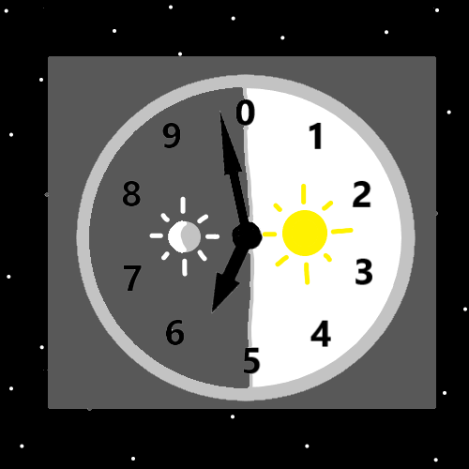
Principles: It is not the teaching that all people should wear bags all day long. Wearing a bag is a Firey thing. It is dangerous. It is likely all Powerful when it comes to Meditation.
Principles: The Story is that Wizard Bags are ultimate Sorcery.
X2 Information: The author never has a Wizardry Bag Personally Equipped. They are not required.
Principles: You also want your other main Enchantments on your Wizard Bag. If you are a chess player you want your bag to have a Level 4 chess Enchantment.
Principles: Using Shrines is the best/fastest way to Enchant a Wizard Bag.

