ObjectType: Article  
ObjectNumber: 105

LocationName: PAAIL.org

LocationNumber:

Language: PAAIL 2.8

Maker: PAAIL.org  
Model:   
  
Name:

Rank:

SerialNumber:

Level: 6.1

Score:   
Birth: 6-5-2025

Label: Room 105

Title: Smith Notes 19

Details: PAAIL.org Scripture…

Principle: Ultimate Scripture….

Agenda: Ultimate Scripture….

Action: Ultimate Scripture….

Information: Ultimate Scripture….

Item Group: Understanding The Multiverse 0

Principles: A /10 = A \* 10 may Make Sense in a computer Science way. Computer Science is all about 1’s and 0’s.

Principles: 5 is an Axis. Made of the +5 and -5 Poles.

Principles: All Numbers are either Positive, Negative or in the case of the 0 Neutral. Before Numbers exists Positive, Negative and Neutral. Numbers are Made of Positive, Negative and Neutral.

Principles: All people have a Spiritual Path. Always is the Path, a Path of Light, a Path of Twilight, or a Path of Darkness…….

Principles: Its worth noting again, that playing Religious cards is an awesome thing. What would god say this, and what would god say that. What would god have us do. What does the Scripture say. Things like these. There be lots of different Religious cards.

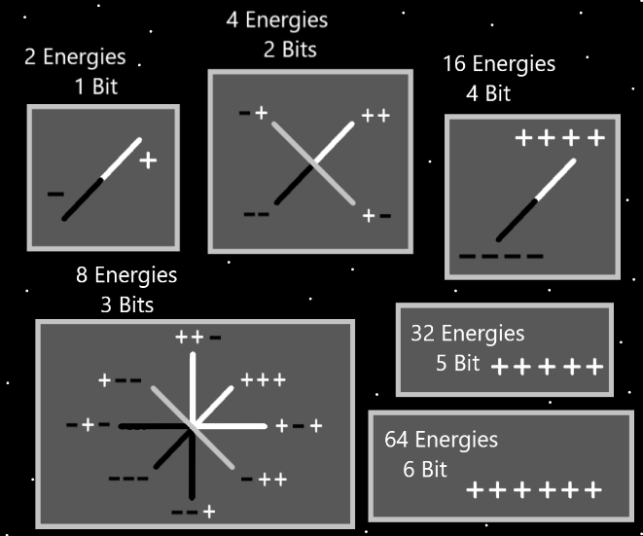

Principles: 4.00000100001470091. It may be that all chess player have a unique chess Level. That no Two players have the same Level. This may be the same story with many things, perhaps more than many things.

X2 Principles: Looking at decimal Numbers leads One to see how this might be.

Principles: Its possible that no Two protons have the exact same mass.

Principles: When a factory puts out a 1-pound brick, it may be that technically all the bricks have a unique amount of mass. They don’t all come out to exactly 1 pound.

Principles: In parables, metaphors and analogies we have the Word “physics”. There be the physics of everything. The physics of chess, the physics of football and so on.

Principles: “2 to the power of 2” is an operation. It means 2 times 2. The opposite operation may be 2 divided by 2, or -2 divided by -2.

Principles: It may be that all operations are either a Positive operation or a Negative One.

Principles: Except for addition and subtraction, it may be that all operations are either a multiplication operation or a division One. All operation have a Connection to One or the other.

Principles: +5.5 is an operation and -5.5 its opposite.

Principles: “+5 + 10 \* 3 – 8 / 7 + 3” is an operation. When you take a Number and +5, then + 10, then \*3, and so forth, that is an operation. Some operations are a million Times bigger than this One.

X2 Principles: The opposite may be -5 -10 / 3 + / \* 7 – 3. Or maybe

-5 -10 / -3 + 8 \* -7 -3.

Principles: The Words “operation” and “Action” are very Connected. Likely it is accurate to say all operations are an Action and all Actions are an operation.

Principles: Like nuclear material a person could refine all this PAAIL.org writing. That may even happen over the next 100 years.

Principles: The unifying Detail about Positive Energy and Negative Energy is that they are both Energy.

Principles: Our Spiritual journeys are Scripture to his Holiness Origin.

Principles: His Holiness our God is the general. We be the regular soldiers of the Story.

Principles: When you translate ancient Scripture into modern language Scripture you can choose a lot of different, yet reasonable things when you translate it. This is One reason why there are many different Bible translations. They are all reasonable choices in the Wording they choose.

Principles: The Word “Genesis” means Beginnings/Beginning. Thus the beginning of the Bible is “In the Genesis, God created the Heavens and the Earth.”. This is a reasonable translation of “In the beginning, God created the Heavens and the Earth.”.

X2 Principle: Continuing our translation we could change things to “In the Time known as Genesis, God created the Heavens and Earth.”.

X2 Principle: Continuing our translation we could change things to “In the Time known as Genesis, God created Heaven and Earth.”.

X2 Principle: Since God means “creator” we could change things to “In the Time known as Genesis, Creator created Heaven and Earth.”.

X2 Principle: When you translate old Scripture into modern language you have lots of options for the Words you choose. This is why there are many different versions of the Bible.

Principles: The first major Word of the Bible is “beginning”….. the 2nd be “God”, the 3rd be “created”. 1st, 2nd and 3rd place.

Principles: Because there are the 3 slots, (low, medium, high), there is the Numerology of it, that low has a Connection to 1. Medium a Connection to 2, and high a Connection to 3.

Principles: One of the bigger things that Wizardry does, is that it increases Mind Levels. Everyone has a Mind Level, and training Level 3 Wizard grows that Level a lot.

Principles: Growing Levels at good things seems like Spiritual progress. This can Make Wizardry seem like it is greater Spiritual achievement…. Even though its not. It just feels like greater Spiritual Levels. Growing at good things is always Spiritual Levels. What ever that thing happens to be.

Principles: It seems like I once read a philosopher say the greatest Virtue is to be “high-minded”. I would say that is not the greatest. Perhaps the greatest is to be “Holy”.

Principles: “Holy, holy, is the God almighty. Who is and was, and is yet to come.”-The Holy Bible. One of my favorites. I have likely written it before.

Principles: I bill “Divination” as good inspiration. It likely is also great for the brain. It improves the electrical network in your brain.

Principles: The brain is full of folders and files. Audio files. Video files. Picture files. Files take up Room and have size to them.

Principles: On a sub-conscious Level people think at least a 1000 Words a second. From the sub-conscious everything bubbles up to the final layer. Speaking, thinking and so forth.

Principles: The Meditation headgear(prescribed in earlier text) decreases the size of the video files going into your brain as you use it. The headgear also frees up resources in your brain for a better Meditation run. It is therapy on the brain. It is a relief to the Mind. The head gear is ultimate.

Principles: Some things are worth mentioning again.

Principles: Some notes are worth noting again.

X2 Principles: Connecting the Dots, you can notice that the Rooms these days are all Titled “Smith Notes”.

Principles: “His be the power and the glory, forever and ever amen.”-The Holy Bible

X2 Principles: This is evidence that his Holiness Origin lives forever.

X2 Principles: “amen” means, “may it be so”. Thus the translation…. “His be the power and the glory forever and ever, may it be so.”.

X2 Principles: “Let us make them in our image.”-The Holy Bible. Since we are Made in the image of God, this be evidence that we too, live forever and ever.

X2 Principle: Another reasonable translation is… “His be the power and the glory for all eternity. May it be so.”

Principle: The evidence is out there.

X2 Principle: One reason because it can be found. Another reason because the evidence is unbelievable.

Principles: “They are the two olive trees and lampstands before God.”-The Holy Bible. This is referring to the Archangels Michael and Gabriel. They be the Two olive trees and lampstands before God. They are also referred to as the “Two witness’s”. For One reason because they have witnessed much of Time. There are other reasons.

Principles: Being passive and peaceful is greater than being aggressive and at war all the Time. Life does not always have to be a war.

Principles: Passive/peaceful beings tend to not worry as much about things.

X2 Principle: It has been stated that fasting once a month is probably a good practice. A passive/peaceful being is not aggressive about fasting. They do not worry if they fast or not. Fasting may help a person. Its not a failure if you don’t.

Principles: The Force, being a much bigger power, controls us more than we control it.

X2 Principle: The Planet Earth has more influence on the Moon than the Moon has on the Earth.

Principles: “He who hates his life here, will find everlasting life.”-The Holy Bible.

X2 Principles: There is endless amounts of evidence that we live forever.

Principles: Being a passive/peaceful person often Makes a person more patient, less hasty, wiser and more.

X2 Principles: Passive and peaceful are Virtues. Everyone has a passive Level. Some peoples Levels are higher than others. All Virtues have Levels to them.

Information: (W)--”waaa…!”. (Wi)--”Why?!”, “Weeee!”. (Wiz)--“Wiz!”. (Wiza)—“Wiza!”. (Wizar)--“Wiz are!” (Wizard)--”Wizard!”.