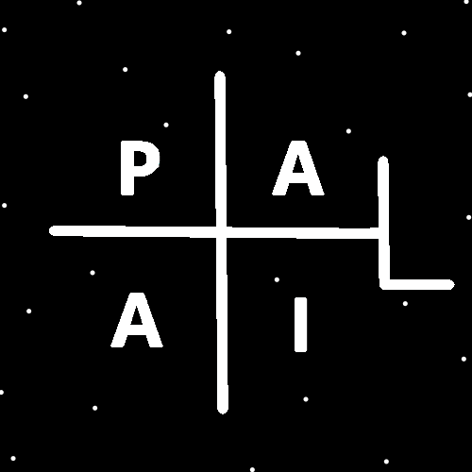
ObjectType: Article
ObjectNumber: 110
LocationName: PAAIL.org
LocationNumber:
Language: PAAIL 2.8

Maker: PAAIL.org
Model:
Name:
Rank:
SerialNumber:

Level: 6.1
Score:
Birth: 8-23-2025

Label: Room 110
Title: Smith Notes 24
Details: PAAIL.org Scripture…
Principle: Ultimate Scripture….
Agenda: Ultimate Scripture….
Action: Ultimate Scripture….
Information: Ultimate Scripture….
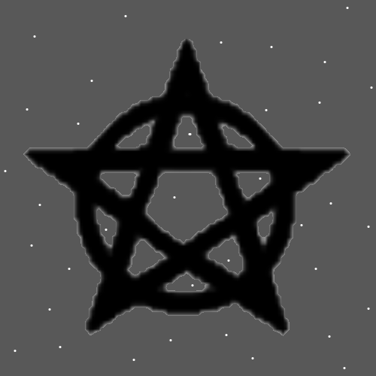
Item Group: Understanding The Multiverse 0
Principles: “++” may be an Axis and a Pole. It’s a Pole with the opposite being a “- -“ and its an Axis Made of a Lower + Symbol and an upper + Symbol.
Principles: Just as there is multidimensional Objects there is multidimensional Numbers. Sometimes(maybe all Times) multidimensional Objects are represented by a multidimensional Number.
X2 Principles: It is an old teaching that for every Object there is a Number.
Principles: It may be that mass is not a Pole, and is only an Axis. It may be that every Axis has an opposite. It may be that a proton is an Axis Group. It may be that every Axis Group has an opposite. Remember these are all many theories.
Principles: It may be that all Axis’s have an opposite Axis and all Axis Groups have an opposite Axis Group.

Principles: Axis’s, Axis Groups and Poles is major physics. Knowledge that all Experts in physics should know. Understanding Axis’s is understanding there is Positive and Negative to everything. If Axis all have an opposite then we see also that there is always an opposite Type of Energy.
Principles: It may be that all Energies have an opposite Energy. Mass has an opposite, gravity has an opposite, protons have an opposite, electrons and photons have an opposite.
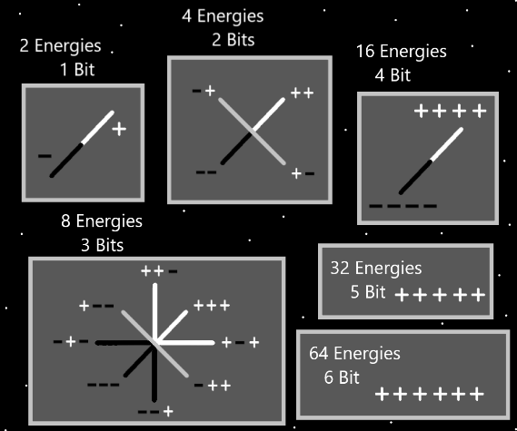
Item Group: Understanding The Multiverse 1
Principles: This be ultimate math. Math which all math Experts should know. There is the 4 Forces of math. Addition, subtraction, multiplication and division. This is actually more basic and all people should know it.
Principle: Sometimes it is not right for a rich nation to have huge tax’s on poor nations.
Principles: One of the newest clarity is that all Energies have an opposite. The exception only in regards to the Zero Particles. They have no opposite. Or both Positive and Negative are opposites of them.

Principles: The latest theory is that photons are both a Pole and an Axis. There is Positive and Negative photons. Also there is an opposite to photons. The result is 4 different Particles. 2 Positive photon Particles and 2 opposite of photon Particles. On One Map they are all called photons. There’s the ++ photon, the +- photon, the - - photon and the -+ photon. The Story is the same with gravity and mass. There be ++ gravity, +- gravity, - - gravity and -+ gravity. Mass is the same Story. The theories continue with the thought that protons, neutrons and electrons also have the same Story. It may be that some Particles are found in nature and other Particles can be artificially Made.
Principles: The biggest of the 4 Forces is the ++ Force. Reality is more Made of it than the other 3 Forces. If electromagnetism is the ++ Force Reality may be more Made of electromagnetism. Gravity may be the ++ Force. The strong-nuclear and weak-nuclear Forces, One of them may be the ++ Force.
Principles: The physics knowledge of all this Wizardry writing is major physics knowledge. The kind of knowledge that Makes spaceships to other Stars.
Principles: The 4 Forces, gravity, electromagnetism, strong-nuclear and weak-nuclear. The truth is that if gravity is the ++ Force, then (on some maps) it’s not the 4 Forces, gravity, electromagnetism, strong-nuclear and weak-nuclear, it’s “the 4 gravities” ++, +-, - -, -+. This may be accurately called unification of the 4 Forces. The important and unknown to me Detail is which Force is the ++ Force? It is the supreme Force of the 4.
Principles: The physics Wizardry knowledge is some of the biggest physics there is. It be much greater than E=MC2. All physics Experts should know it.
Principles: PAAIL.org Wizardry adds PAAIL Vocabulary to its collection of Vocabulary.
Principles: It may be on some Maps that there are the 4 gravity Forces, the 4 electromagnetism Forces, the 4 strong-nuclear Forces and the 4 weak-nuclear Forces. On this Map we have 16 Forces.
Principles: It may be that there are 4 Types of every Particle, except for Energy Bits.
Principles: It may be there is the “space Particle”. And there are 4 Types to it, height space, width space, depth space and Time space.
Principles: It is better to have too much Water in life than to little water.
Principles: Many Water Spells/Actions are relaxation and entertainment Spells. Purification Spells/Actions that are not difficult likely have a gigantic Connection to the Water Force.
Principles: It may be on some Maps Reality is the 4 Waters. The 4 Forces are also known as the 4 Waters. And it may also be true that there are the 4 Types of Water.
Principles: On some Maps it may be that there is the 4 Winds. On some Maps it may be there is the 4 Air Forces. Also there may be the 4 Earth Forces, and the 4 Fire Forces. These statements are true in multiple ways.
Principles: Sometimes there is 4 Types of things. There may be 4 Types of mass. 4 Types of gravity. 4 Types of protons and electrons.
Principles: It may be there is the 2 Types of mass. Positive mass and Negative mass. Then you Zoom in on Positive mass and you see 2 new Type of mass. Zoom in on the Negative mass and you see 2 new Types of mass. This results in 4 Types of mass.

Principle: The absolute value of mass may be “+1”. For this reason the ++ Force is the all powerful Force. ++ equals Energy, -- equals Negative Energy. Negative Energy is still an Energy. The absolute value of “-1” is +1. The truth is that Darkness is a Energy, all things are Energies. The important Part is that Light, Twilight and Darkness are Energies, all things are Energies. The absolute value of all Negative Numbers is a Positive Number.
