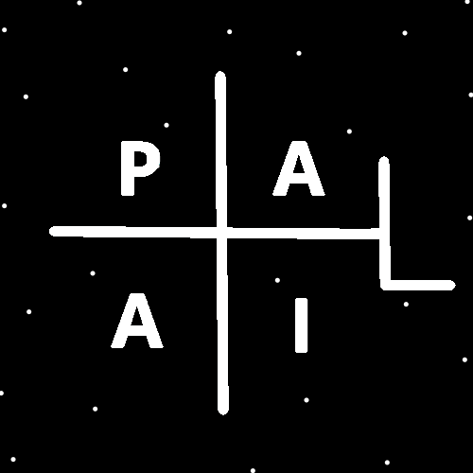
ObjectType: Article
ObjectNumber: 141
LocationName: PAAIL.org
LocationNumber:
Language: PAAIL 2.8

Maker: PAAIL.org
Model:
Name:
Rank:
SerialNumber:

Level: 7.08
Score:
Birth: 3-16-2026

Label: Room 141
Title: Smith Notes 48
Details: PAAIL.org Scripture…
Principle: Ultimate Scripture….
Agenda: Ultimate Scripture….
Action: Ultimate Scripture….
Information: Ultimate Scripture….
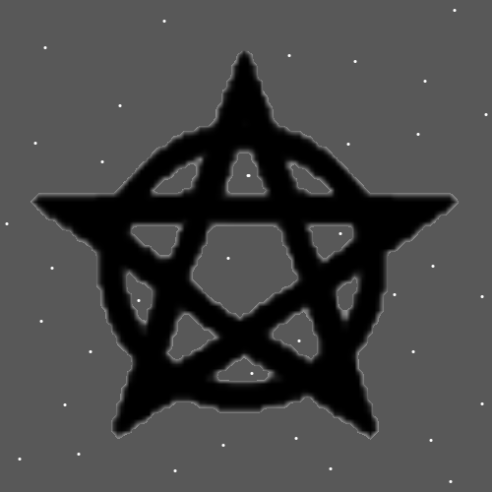
Item Group: More Enlightenment
Principles: Wizardry is groundbreaking Science that helps all other Science. New technology can be achieved by mixing Wizardry with other Science. It is recommended to all Scientists.
Principle: Its possible the Electron is the opposite of a Proton. Its possible that in some way a Anti-matter Proton is a opposite. It is possible that the Electron is not the opposite of a Proton.
Principles: The Theory is that the Mass of a “A” Particle is “A”. Its Name in Numbers is “A” and its Mass is “A”. Also, the Energy in a “A” Particle is “A”. It seems that all Particles may have Mass and their Mass Number is also their Name in Numbers and their Energy Number. It may be the Energy Number is the “absolute value” of the Mass. Negative Mass Particles would then have Positive Energy Numbers.

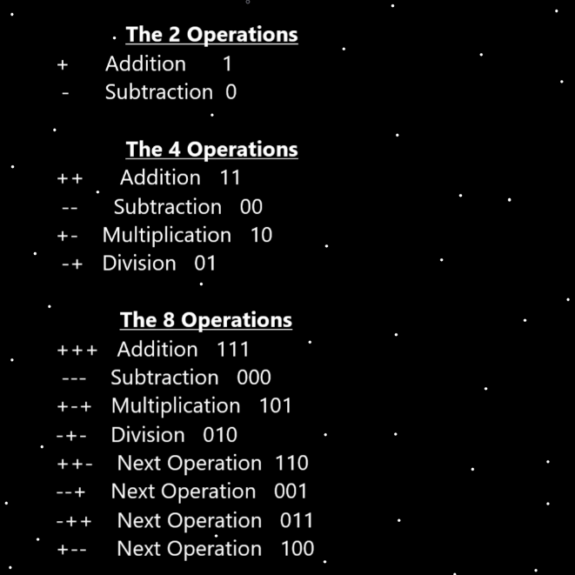
Principles: It may be that Protons/Neutrons/Electrons each have a unique amount of Mass. Really close to the same. As an example something like Protons are Particles with a Mass ranging from 20 to 30 Units of Mass/Energy. Mass and Energy Numbers the same, except always the Energy Number is a Positive Number and Mass Numbers can be Negative.
Principles: Energy Bits would be simplistic, always have the same Mass Number and “Macro-Particles” (things bigger than Energy Bits) have unique Mass Numbers.
Principles: In the God Science speed measuring System, the speed of Light may be 1. To say “E=MC2” we also must use the God System when measuring speed. A System I do not know.
Principles: The Theory goes that the “Hippocampus” (a Part of the brain) is the Location where the Soul is at. It Makes Sense to me because of its Shape and Location (connected to the spine and the brain).
Principles: The Theory goes that “Calabi-Yau”s (a Part of Physics) are Souls.

Principles: If your Number for speed is wrong, then your Number for E is wrong in “E=MC2”. Also, if “E=MC2” does not work for measuring Energy in Photons it does not work for measuring all Energy. Then there is measuring the Energy in Height, Width, Depth and Time. The Theory is that E in a Positive Energy Bit is “A”. It may be the E of every Particle is the Particles Name in Numbers.
Principles: After looking up “Waves”, it seems likely there is the Two Parts. The Up and Down Part – Positive Part and the left and right Part – Negative Part.
Principles: If Photons have Positive and Negative Mass then the Positive Mass is the Up and Down Part and the Negative Mass is the left and right Part.
Principles: Its possible there are 2D Particles. Photons could be 2D Particles. Electrons could be 2D Particles. Its possible there are 1D Particles. It seems extremely likely that there are 1 million like Dimensional things over all eternity. Though maybe not that exact Number. It’s only an example Number.
Principles: It may be Energy Bits are the 1D Particles or are 1D Particles.
Principles: It may be Protons are 4D, they have a Time Side. Photons may be 3D, One Side a Time Side.
Principles: There is the obvious mystery of why Photons are called Light.
Principles: The Beginning of Time has a gigantic Connection to the Darkness. We, being from the Beginning of Time have a gigantic Connection to the Darkness.
Principles: “Rigorous exercise” is the most Powerful of exercise. Sweating exercise counts and intense exercise counts as “rigorous exercise”.

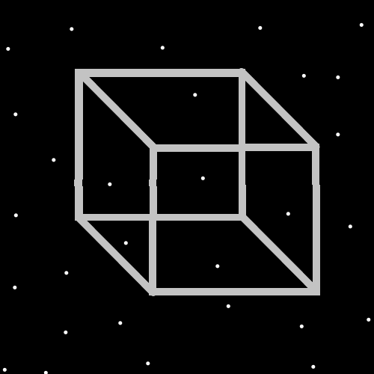
Principles: Some people get “natural exercise”. Like working on your feet for 8 hours. A person can obtain Level 4 Body exercise doing natural exercise. Body exercise Level 4 plus Expert Wizard equals Level 5 Master Wizard. Remember Body exercise is 1st place. It does a lot.
Principles: When a person hits Level 4 Wizard, 6 months later they will be at least Level 4.5. That plus Level 4 Body exercise equals 5.
Principles: Instead of well-organized books, PAAIL.org Wizardry is mostly research and development notes.
Principles: Add a Spell Part adds Power. It also partially reduces the Power of the other Spell Parts. Sometimes when you combine Parts you get less Power out of the individual Parts.
Principles: It might be best to say that pages of Words are Maps.
Principles: In PAAIL Science there are 4 Types of Items. Principle Items, Agenda Items, Action Items and Information Items. It seems best to Make many Maps a Information Item.
Information: “Two girls with green eyes. What does it mean?”. – Big Trouble In Little China.
X2 Principle: I think I remember the line right.
X2 Principle: “What does it mean?” is the kind of statement you might here from someone who knows a lot of Mysticism.
X2 Principle: The author experiences the “What does it mean?” experience all the Time. It comes from Divination. It is Divination.
Principles: Much education Makes a person’s Chi more Mighty. Wizardry can do so a gigantic amount.
Principles: I hit Level 1 Wizard in 2001. There is a God. The Bible is true. The Stars are the Angels. Numerology is real. Some other things too in that year. Can’t remember real well.
Principles: Note how the Symbol for the Number 1(often) is a up and down line. Note how the Symbol for Positive Energy Bits is a up and down line. Positive Energy Bits and the Number 1 have a gigantic Connection.
Principles: I denounce the statement “What doesn’t kill you Makes you stronger.”. To much Fire is a mistake.
Principles: Height, Width, Depth and Time are 1 Dimensional Particles. Protons sit on them, which is a Connection and the Protons bend those Particles. Holding a tapestry’s corners, you could put a weight at the center and it would bend the tapestry. Height, Width, Depth and Time may have Negative Mass. They may be “bend in Particles”.
Principles: In the past it has been stated that being able to speak a 2nd Language is a 10% Mind boost. It would be more accurate to say it’s a 10% Chi boost. It does a lot.
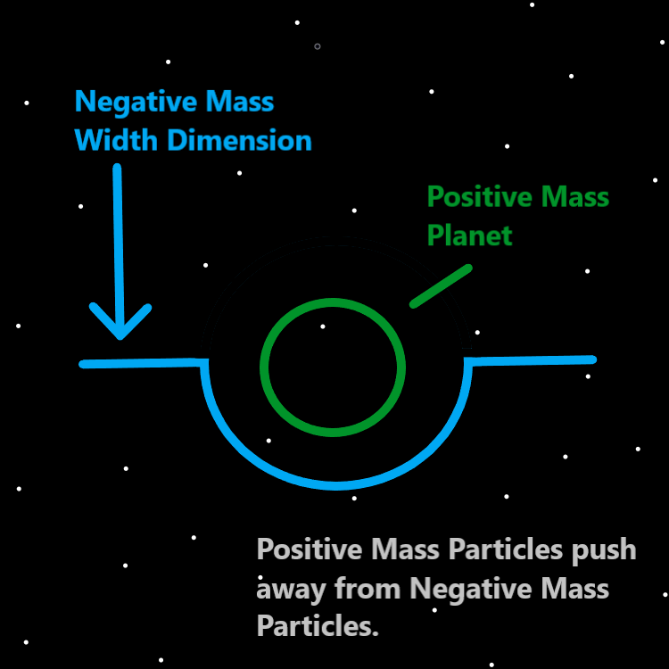
Principles: When Two Planets come near each other they start pulling towards each other. This is Positive Mass interacting with other Positive Mass. When Positive Mass and Negative Mass Objects interact they push away from each other. They do the Opposite.
Principles: Wizardry Particle Physics is One area that has more Theoretical to it. It is all Theories.
Principles: Reality is Particles Connected to Particles. Connections are a core thing of Reality. This is not new yet is worth stating again.
Principles: Ultimate Wizardry videos could be Made that would be all Powerful. They could be nuclear. Probably 6 hours to Blue Wizard. At most.
Principles: Breathing is likely a Air Spell. Breathing exercises also a Air Spell. Air is more Connected to Fire than it is Water. There is a Firey Side to Breathing exercises and other Breathing Spells.

Principles: Have equipped shoes, socks, underwear, pants, shirt, glasses, watch only then Add a hat Spell Part and you get at least a 10% boost On Gear. Then Add a ring Spell Part and the ring gives another 8%. The Power of the hat is reduced though to 8%, for a total of 16%. The Numbers are not right at all, they are an example of how Adding another Spell Part reduces the Power of the other Spell Parts. Equipping a hat in the provided situation is more like 15% to 20% boost.
Principles: Lots of Gear is a Firey Rig. Less Gear a Air Rig. Less Gear a Earth Rig. Less Gear a Water Rig.
Principles: On a Cosmic scale her Holiness Dot is young and Small. This is True of us all.
Principles: Height, Width, Depth and Time are likely each a 1D Particle. They may not be the only 1D Particles in the Multiverse. The Theory goes there may be 2D Particles, 3D, 4D, who knows, even 5D Particles. Or they will exist someday 12D Particles. As Reality evolves.

