ObjectType: Article  
ObjectNumber: 84

LocationName: PAAIL.org

LocationNumber:

Language: PAAIL 2.8

Maker: PAAIL.org  
Model:   
  
Name:

Rank:

SerialNumber:

Level: 5.5

Score:   
Birth: 9-23-2024

Label: Room 84

Title: Smith Notes 6

Details: PAAIL.org Scripture…

Principle: Ultimate Scripture….

Agenda: Ultimate Scripture….

Action: Ultimate Scripture….

Information: Ultimate Scripture….

Item Group: Understanding The Multiverse 0

Principles: It may be that a major moment of the Multiverse was when his Holiness Origin obtained self-awareness. There is a passage in the Bible “…the great I am.”. His Holiness Origin may be “the great I am”.

Principles: It may be right to say there are Two Types of Spells/Actions. Training Actions/Spells and Performance Actions/Spells. Rest/Water Actions/Spells may be Performance Spells. Rest Actions/Spells are Performance Spells. Rest Spells are Water Spells.

Principles: Most people are like uncut gems. Older people are less uncut.

Principle: “This is my son, in whom I am very pleased.” -From the Holy Bible, when His Holiness Origin speaks about his Holiness Light.

Principles: Sometimes there is a healthy way, and yet also a even healthier way. Sometimes there is a great way, and yet also an even greater way. Sometimes there is an excellent Path, and yet there is also an even better Path.

Principles: A person is a collection of Enchantments/Auras. All Enchantments/Auras have Levels.

Principles: A Charm is a collection of Enchantments/Auras. All Enchantments/Auras have Levels.

Principles: All things are a collection of Enchantments/Auras. All Enchantments/Auras have Levels.

Principles: All things are a collection of Properties. All Properties have Levels.

Principles: Properties, attributes, Enchantments, Auras… these Words are very Connected.

Principles: Reading Words like “Enchantments” and “Auras” are good for Wizardry Level gain.

Principles: Reading math Vocabulary Words is good for math Level gain and are a Part of math Training.

Principles: The apocalypse Details are endless. One is that people have to operate dangerous, heavy machinery Charms known as cars. People often need them to get to work and even to buy food.

Principle: The Vocabulary Words “System” and “Systems” are likely major Vocabulary Words of the Multiverse. Like the Words “Cycle” and “Cycles”.

Principle: It may be right to say all Numbers have a Color, Direction, 2D Symbol, and also it may be right to say that for every Number there is a System.

Principles: Mapping Systems is a Part of Science. A Map can sometimes explain a System. A person can Make a Map of a System.

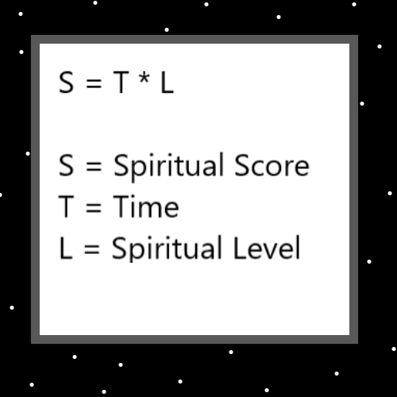

Principles: A Religious Order is a System. A social network on the internet is a System. A government is a System. For learning Expert math there is a System.

Principles: A person is a System, Made of Fire, Water, Earth and Air.

Principle: Having major Vocabulary Words of the Multiverse spread all through your Mind is a powerful Enchantment.

Principle: All this reading of the Word “System” over and over has improved the electrical System of your brain.

Principle: Like people often speak of “Cycles” a person can speak of “Systems”.

Principles: The Word “System” reminds me of the Words “Order” and “Law”. It may be that “System” is a Numerology category 3 Word.

Principles: The biggest Vocabulary Words of the Multiverse is a major thing. Some Words are bigger than others.

Principles: The Agenda of Wizardry is to use the biggest Words of the Multiverse. They are most important. Some are Cosmic scale Words. Some are Mystical Words.

Principles: Mystical Words can sometimes be more poetic.

Principles: Sometimes a person can use more plain-spoken Scientific Words. Example:

Spell = Mystical…..Action = Scientific.

Principles: It can be beneficial to write Vocabulary Words over and over 10 Times. If you were wanting a chess Enchantment you would write Words like, “chess”, “king”, “queen”, “bishop”, “knight, “castle” and “pawn”. Each 10 Times. You would want to do at least 30 minutes of chess Words. This Spell is especially good if you have just started Training chess. It does less for someone who is already a Master at chess.

X2 Principle: I believe in the Spell book this Spell is called “Word Write 10X”

Principles: As a Spell a person can Connect to PAAIL.org, by doing Word Write 10X with the Word “PAAIL”, then do “PAAIL.org”, then do, “Principle”, “Agenda”, “Action”, “Information”. A total of 6 Word Write 10X Spells, or is it just 1 Spell? On some Maps its 1 Spell. On some Maps its 6 Spells. On some Maps its both 1 Spell and 6 Spells. On some Maps its 60 Spells, 1 for each Word. On some Maps its 60 points of Score.

Principles: It may be that the Earth Part of a person is their upbringing. The lowest Chakra is known as the “root” Chakra.

Principles: On some Maps it may be that “Chakras” are all about the Age of a person. The lowest Chakra is known as the “Root” Chakra , and the highest is known as the “Crown” Chakra.

X2 Principle: Only on “some Maps”. Not all Maps.

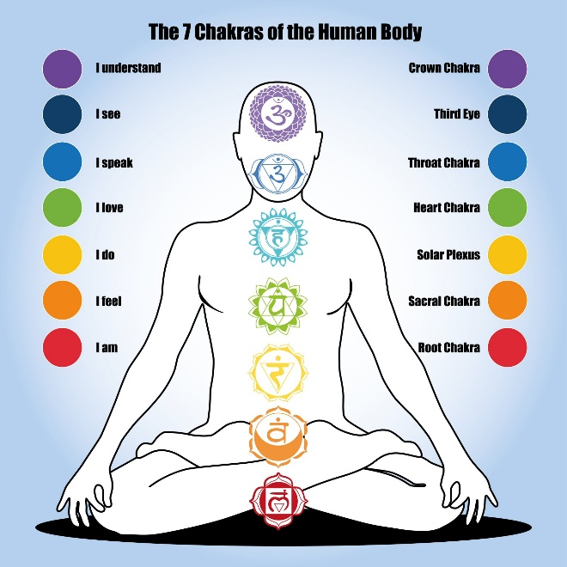

-Image brought to you by the internet.

Principles: The “Heart” reminds me of the center of a life. A persons middle aged years. The “Throat”, “Third Eye” and “Crown”, reminds me of a persons older Age years. Root reminds me of young, and Crown as old.

Principles: “Sacral” -Definition. Of, for, or relating to sacred rites or Symbols. This reminds me of young Aged people.

Principles: There are only 7 Archangels. 2 to 8. On some Maps the “Root” may be the 2 Chakra.

Principles: On some Maps it may be that “Root” is 0 to 10 years of Age. “Sacral” is 10 to 20. “Solar Plexus” is 20 to 30. “Heart” is 30 to 40. “Throat” is 40 to 50. “Third Eye” is 50 to 60 and “Crown” is 60 and older.

Principles: Major Vocabulary Words of the Multiverse is Partly Wizardry Science. Wizardry is ultimate Words. These Words are especially good for the electrical System of the brain and such Words are useful in Sorcery. Ultimate Words is ultimate power. Ultimate Words is ultimate Science.

Principles: All Religious Orders who Worship his Holiness Origin, Worship the same God. Often people don’t have enough respect for other Religious Orders.

Principle: It Makes it hard to understand others, if you don’t understand yourself.

Principle: In the after life there will be no lifeforms killing other lifeforms. “…the lion will lay down with the lamb.” -The Holy Bible

Principle: There are lots of books a Wizard could quote from.

Action: Force this Vision into your Mind. Picture everyone on the Planet with a military helmet on.

Principle: Doing Word Write 10X Spells Runes your Chi.

Principles: Those that do good, serve his Holiness Origin. You do not need to believe in a God to serve a God.

Principles: In the afterlife, when Heaven serves us, you will be able to play games like “Planet Builder 100 Trillion”. A game where you get to build on your own Planet. Its called 100 Trillion, because 100 trillion books were written in Heaven about what would be the best design for a Planet builder game.

Principle: Wizardry can be a more God like perspective/View.

Principles: Even if PAAIL.org Wizardry is 2000 pages, that’s not a lot in many ways. A person may be able to do it in 4 years with little effort. 4 years, that’s 500 pages a year. 10 pages a week.

Principle: One amazing thing about the Level 6 Wizard is that if you are 40 hours a week a student, you can get it in like 1 to 2 years. Probably 1 year. That’s a very short amount of Time for a Doctorate. Even if its 2 years.