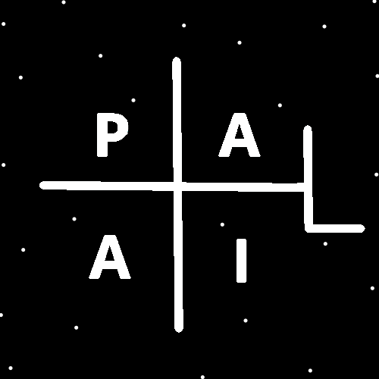
ObjectType: Article
ObjectNumber: 132
LocationName: PAAIL.org
LocationNumber:
Language: PAAIL 2.8

Maker: PAAIL.org
Model:
Name:
Rank:
SerialNumber:

Level: 6.5
Score:
Birth: 12-25-2025

Label: Room 132
Title: Smith Notes 41
Details: PAAIL.org Scripture…
Principle: Ultimate Scripture….
Agenda: Ultimate Scripture….
Action: Ultimate Scripture….
Information: Ultimate Scripture….
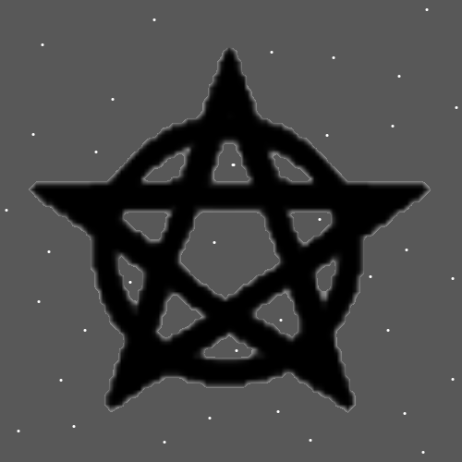
Item Group: More View Of The Multiverse
Principles: The count is that it’s a grand total of about 214 files. Even if its 10 pages each average, that’s only 2140 pages!!!!!!!!!!!!!!!!!!!!!! I keep thinking I may be wrong with my estimate. If not wrong then a person can read it all in 1 year, if they read a tiny 178 pages a month.
X2 Principles: I know that many files are only 5 pages or less. The final Number of pages may be more like 1700. A lot less than 2140.
Principles: Gods Laws Change. Some older Scripture no longer represents Gods Laws. They pass false truths about Gods Laws.
Principle: Not all Scripture is 100%.
Principles: PAAIL.org is described as “the One true Religion”. It may be better described as “the more 100% Religion”.
Principles: Perhaps the Words “true” and “false” should be major Vocabulary Words. As a Level 3 programmer I can say they are major Vocabulary in programming.

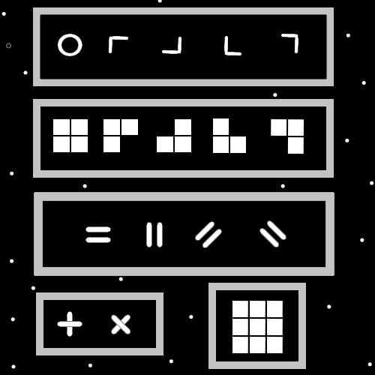
Principles: If its been only 2000 pages, people are encouraged to read it all and stay current by reading new articles as they come out. 2000 pages can be read in 2 years reading a tiny 83 pages a month. In 1 year, 166 pages a month. Become Expert Wizards and stay current by reading new articles as they come out.
Principles: There are 2 square Symbols, 3 square Symbols, 4 and so forth. Also known as 2 Dot Symbols, 3 Dot Symbols and so forth. A straight short line is 2 Dots. 2 squares.
Principles: If Positive Mass Objects gravitate towards each other, then a Negative Mass Object might push away from Positive Mass Objects.
Principles: All Charms (like people) have a “Biography”. Charm paperwork is Biography paperwork. Charm paperwork is a really nice thing. Ideally you have when it was Made, where it was Made, by who it was Made and a Serial Number. If you were to sell Wizard Items online you would want to include mini Charm Biography paperwork that comes with the Item.
Principles: Charm paperwork books can be ultimate Charms. Ultimate Wizard Charms. Ultimate Wizard books.
Principles: Wizard books are found in many many games. A person could Make a very nice “personal Wizard book”. A personal Wizard book could exist in many forms. One that has the persons Name at the front of the book and their bigger Level 3 or Higher Levels listed under their Name. A “personal Wizard book” is likely an all-Powerful thing.
Principles: A journal instantly becomes a personal Wizard book. Though journals may not be right for many people. This is only an example of a “personal Wizard book”.
Principles: A person could put pictures in a book and turn it into a personal Wizard book.
Principles: A person could write their Name or have their Name printed over and over and it would turn into a personal Wizard book.
Principles: A really nice/expensive Wizard book comes with the Wizards Name printed/Runed on the cover of the book. And it has a nice cover. If you are a rich Wizard.
Principles: Just a person’s Basics written at the Beginning Makes a personal Wizard book. When they were born. Where they were born. And Name.
Principles: Wizard book Ageing is like everything else. It starts out Level 1. Quickly gets to Level 3. Then a little while after that it gets to Level 4.
Principles: You definitely want to sign your Personal Wizard Book.
Principles: Personal Wizard Books do not need to be handwritten. A machine can print them out.

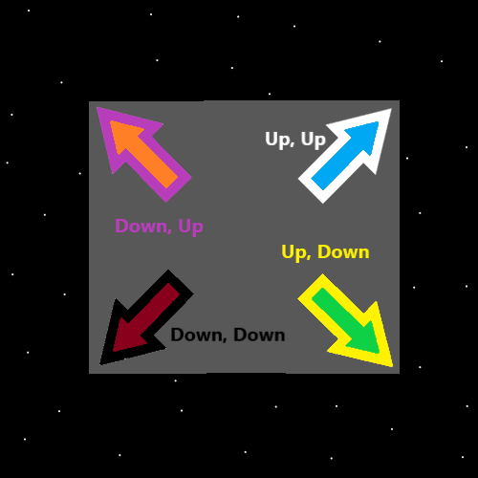
Principles: A persons Personal Wizard Book should fit in their Wizard Bag. The weight of the Bible is a great weight. It’s hard to say what the right weight is though.
Principles: However you Make your Personal Wizard Book, it is a gigantic Charm.
Principles: If One were to Keep a Personal Wizard Book in their bag it may be right to Keep the bags Charm Biography paperwork in the Personal Wizard Book.
Principles: Personal Wizard Books are best Kept wrapped in cloth or put in some nice container. If wrapped in cloth, then rope or ribbon should be used to Keep the cloth On.
Principles: Containers are an extremely under rated Item. Often the greatest Charms are Kept in lavish Containers.
Principles: Lots can be said about Personal Wizard Books. They are a super new thing.
Principles: Personal Wizard Books work better when they get to Level 3 or 4. Depending on the situation they are likely to give a 15 to 30% increase. 30% the Power of the Wizard Bag. It can shrink as the Bag Evolves, as the Wizard Evolves. This is where the 15% situation can happen. Likely 25%.
Principles: Using Shrines for Enchanting speeds up Enchanting.
Principles: Things that do not exist are Physics. It is a Physical Law when something does not exist.
Principles: It may be things that do not exist are Particles. On the 1’s and 0’s Map, these Particles would be Type 0.
Principles: It would seem there is a bunch of Energy Bit Code that says, “place 0 mountain size pink elephants here”. This Code can be found all throughout the entire Universe. And this Code is Made of Physical Particles. Energy Bits are Physical Particles.
Principle: Ideally a person stays on the up and up.
Principles: One of the biggest Maps is the Energies that exist Map. All Energies exist on this Map, and they all have a Positive Number. For every Energy that exists there is a corresponding Positive Number. The thought is that Addition might be 1 or 0.1 or something. That Subtraction might be 2 or 0.2 or something. Multiplication might be 3, Division 4. If 0 is a Positive Number perhaps 0 is Subtraction and 1 is Addition. Then 2 is Multiplication and 3 is Division. Perhaps 1 is not Addition it is the Word Positive. Then down the road maybe Addition is like 1.1 or something. Subtraction could be 1.2. 2 could be Negative. These things are very unclear. It seems very possible 1 is the Number for the Word Energy. Then somewhere down the road is the existence of Addition, like 1.1 or 1.01 or 2 or something. A very unclear Map, however it is One of the biggest. Some of the biggest Numerology. “A” is a Positive Number it may be the Word Energy on this Map.
Principles: It may be that every Energy that exists has a Positive “Whole Number”. No decimal points. These Theories do not come from a Math Expert.
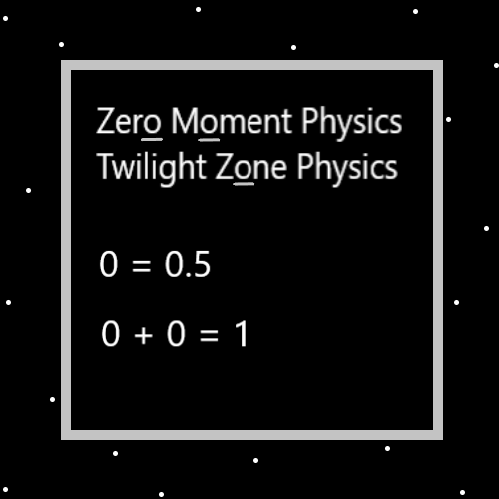
Principles: The Theory is that at One moment the Laws were 0 + 0 = 1. Then the Laws Changed, to 0 + 0 = 0.
Principles: In the above Map, “0 = 0.5” may be wrong.
Principles: There is tons of Wizardry tech that can be used. Especially with the Sorcery of such things as Wizard Bags, Shrines, and Smith Summons like Spells. However, such tech is not always needed and can be much more than is needed. As a Wizard, the Higher your Level gets the less important Gear is. Also, lots of Sorcery and Gear can be a Firey Path. Also, unlocking Expert Wizard does not require doing Sorcery or using Gear. It may be accurate to say the author here uses very little Sorcery tech, including not equipping a bunch of Gear.
Principles: Like training Martial Arts is good for a person’s Chi, so is Meditation like Smith Summons Spells. It’s not always needed though. Not everyone should train Martial Arts or do heavy amounts of Meditation.
Principles: A person can replace the Word “Wizard/Wizardry” with the Word “chess” most of the Time in PAAIL.org text.

