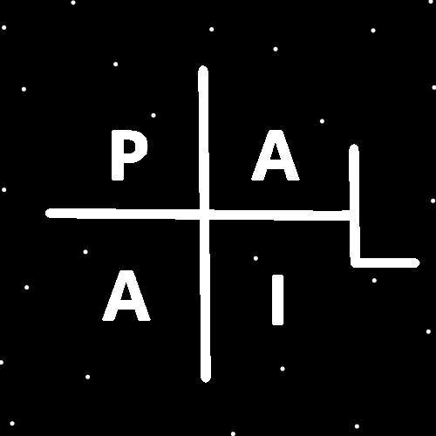
ObjectType: Room
ObjectNumber: 151
LocationName: PAAIL.org
LocationNumber:
Language: PAAIL 2.9

Maker: PAAIL.org
Model:
Name:
Rank:
SerialNumber:

Level: 7.191
Score:
Birth: 7-13-2026

Label: Room 151
Title: Smith Notes 58
Details: PAAIL.org Scripture…
Principle: Ultimate Scripture….
Agenda: Ultimate Scripture….
Action: Ultimate Scripture….
Information: Ultimate Scripture….
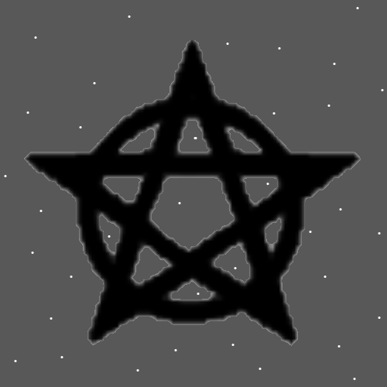
Item Group: Cosmic Laws
Principle: Here at the Beginning of Time Reality is very simplistic/simple.
Principle: A person can be a combination of massive Virtues and also massive Flaws.
Principles: These days because of modern technology, modern art and more…. People have gigantic intelligence Levels. Likely other gigantic Mind Levels as well. This leads to overconfidence.
Principles: Expensive/nice leather or silk bound, expensive paper…. These Wizard books are much better than the cheap Ones. It reminds me of Harry Potter how some families are more wealthy than others and have nicer things.
Principles: Massive amounts of high End, super Advanced art is profound for the Mind. It gives great intelligence for One. By 18 years old everyone has been exposed to this.
Principles: Likely most expensive Charms are more Powerful in some ways.
Principles: Level 4 Wizard is a gigantic thing. It’s not apprentice Wizard. It’s full Wizard. Such a person could take on apprentices.
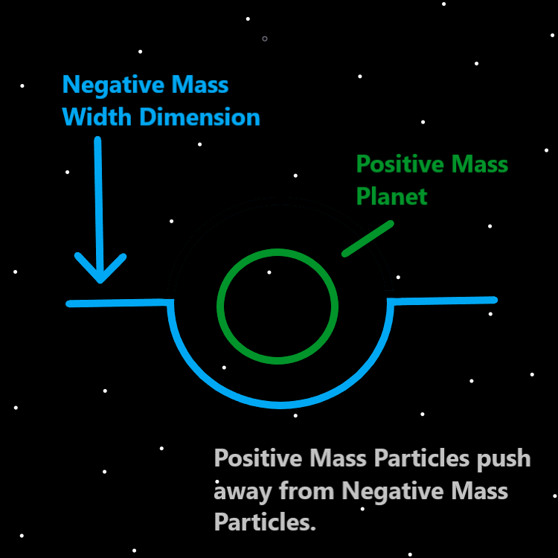
Principles: The secrets and more!
Principles: It all Makes you smarter, wiser and more graceful.
X2 Principles: It gives other Virtues also.
Principles: Sorcery Practice Makes you smarter, wiser and more graceful.
Principle: If there are men in black then they be Wizards.
Principles: “Sorcery Practice” is a newer term. There is Sorcery Laws and there is Sorcery Practice. Those are the Two Parts of Sorcery.
Principles: If a person were to learn Sorcery from Heaven, they likely could quickly get to Fire Balls and lightning bolts.
Principles: Some people are Light upon the Universe. Some people are Twilight upon the Universe, and some people are Darkness upon the Universe.
Principles: There are Three areas of Laws. Positive Laws, Negative Laws and Neutral Laws.
Principles: Wizardry may be Three categories. Cosmic Laws, Sorcery Laws and Sorcery Practice. Quantum Laws would be a subcategory of Cosmic Laws. Divination would be a subcategory of Sorcery Laws and Sorcery Practice. Numerology and Colorology are areas of Cosmic Law. If they have a Connection to the 3 Energies (Positive, Negative, Neutral) then Cosmic Laws would be Positive. Sorcery Laws would be Neutral and Sorcery Practice would be Negative. Cosmic Laws is Enlightenment, Sorcery Laws are more Twilight like and Sorcery Practice is Fire.
Principles: When you do Divination with the PAAIL logo (first picture of this room), Agendas are Water, Actions are Fire, Information is Earth and Principles are Air.
Principles: One of the biggest lessons of them all is that life is a constant dice roll. We constantly roll the dice, with everything we do.
Principles: In the Map to the left it says “Positive Mass Particles push away from Negative Mass Particles” …. Also, the Theory goes that Negative Particles push away from Positive Mass Particles. They push away from each other. Like the behavior of Magnets.
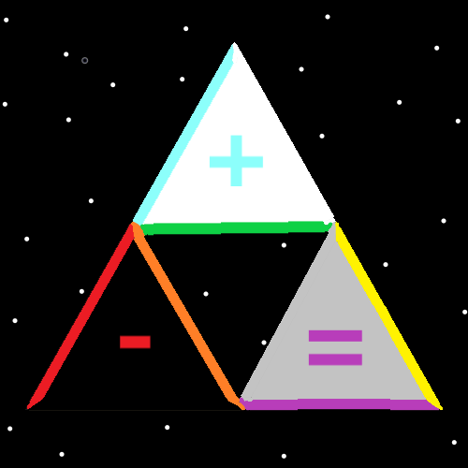
Principles: Because the likely Story is that Physics is 3 areas. I am reminded of the Tri Force Symbol. The “equals” Symbol above may have not been the right Symbol for the Map. There may be a better option. Perhaps the Dot.
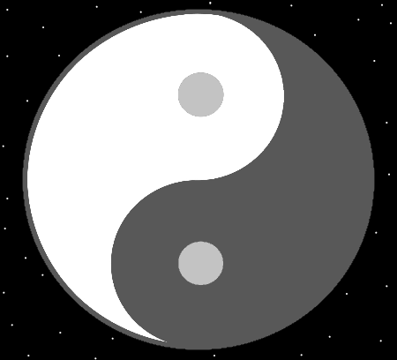
Principles: Looking at Maps is all Powerful for Mind development. Wizardry Maps especially so.
Principles: In the Map above, I think I would Make the White Side on the right and the Black on the left.
Principles: The disappointing truth is likely that rich Wizards can afford much better Charms. Also, better food, drink and more.
Principles: What animals do is survive. They take care of (Keep) themselves and sometimes others. What humans do is survive. They too sometimes take care of themselves (Keep) and help others. The Keyword here is “survive”. Survive is the Path of Light and glory. Animals often have shelters and always eat food. Humans need shelters and also food. The best way to get shelter and food is with money. Animals have to work for their food. Often humans must work for their food. Often humans Make money then use the money to buy food. Most humans that Make money do so by working a job. Often you have to work a job to get money. Usually to Keep yourself and others you need money.

Principles: One Part of survival is consuming Lifeforce of plants and animals. It is a terrible Body that demands consuming Lifeforce to live.
Action: Power to his Holiness Origin. Power to his Holiness Origin. Read this Item 2 times.
Principles: The Theory goes there are at least 6 Senses. One Theory goes that being able to predict obvious things might be its own Sense. Example knowing/Sensing when you add 2 + 2 On a calculator, its likely going to say 4. Or knowing/Sensing the sun will rise again the next day.
Principles: The Theory goes that there may be 7, 8, 9 or more Senses. If so, then training Wizardry will likely increase/improve them. It likely enhances the 6th Sense also.
Principles: Wizardry books should always have lots of Maps and/or decorative pictures. They should also always come Rune Enchanted or someone should personally Rune Enchant them.
Principles: Wizardry videos should always have lots of Maps and appropriate music/sound effects.
Principles: One of the biggest Details of Reality is the first Map. The Map that is completely Black with One Grey Dot at the center.
Principles: Wizardry is the Science of Moons and Stars. That Stars are the Angels and Moons are their Charms. That’s why Wizardry has a gigantic Connection to Moon and Star Symbols.
Principle: Wizardry can Make a person mighty.
Principles: As One would expect, the Physics of the Zero moment is less complex, with few major Laws and is easy to understand. Probably it would take only 30 to 60 minutes going over all the major Laws. Laws like…. A Zero amount of Time has passed, and Reality was Zero big.
Principles: One Law of the Zero moment is that there was no popcorn. Another was no TV’s. These are not major Laws though.
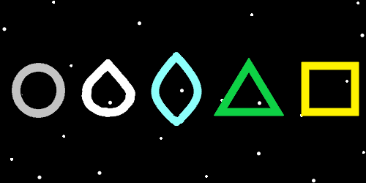
Principles: It seems noteworthy to state his Holiness Origin is the only One without a father. He is “the great I am”.
Principles: One possibility is that everything is a Particle and a Wave. That Protons are Particles and Waves. That Energy Bits are Particles and Waves.
Principles: Space is a Particle (and or a Wave) with at least 3 or 4 Sides.
Principles: The Theory goes that humans will be a 10,000 year long Story. 0 is the Birth of Adam and 7,000 is Resurrection Day. On Resurrection Day humans are given Bodies that are 10x faster. You don’t notice the difference, however you are going 10x faster. Then another 3000 years pass and its 10,000 Accension Day. The 7000 to 10,000 experience becomes a 30,000 year experience because of the increase in speed. Because of the speed increase a 2026 helicopter would seem like it goes very slow. For helicopter entertainment you will have to use something that simulates it. You would need something that goes 10x faster than the 2026 model.

