ObjectType: Article  
ObjectNumber: 100

LocationName: PAAIL.org

LocationNumber:

Language: PAAIL 2.8

Maker: PAAIL.org  
Model:   
  
Name:

Rank:

SerialNumber:

Level: 6.0

Score:   
Birth: 3-30-2025

Label: Room 100

Title: Smith Notes 16

Details: PAAIL.org Scripture…

Principle: Ultimate Scripture….

Agenda: Ultimate Scripture….

Action: Ultimate Scripture….

Information: Ultimate Scripture….

Item Group: Understanding The Multiverse 0

Principles: The easiest and quickest way to experience ESP is to listen to music.

Principles: Sometimes you can focus on a thing, and if you choose the right music you get a huge ESP experience on what you focus. A person could focus on a Charm or any other thing in the Multiverse. Force the Vision of Planet Earth spinning along with the right music and you will experience ESP. Since Planet Earth has many Sides, many songs work. There be Sense all Sides as a choice also.

Principles: Eventually we get what we deserved all along. To be raised by our God, his Holiness Origin.

Principles: If you use the Key “to” for some Divination. On this page you can get “Item. Group. Understanding. To.”.

X2 Principle: This comes from using the Word “to” Two Times.

Principle: Be safe.

Principles: Wrapping rope around the palms of your hands can be a good thing. Leaving them on too long is a danger. It does a compression therapy for one thing. This is another way to gear up. If you do tarot card readings or something similar this is another way to gear up. Sometimes this is not safe, it Makes using your hands more difficult.

Principles: Across Planet Earth gloves are very underestimated, very overlooked, nice pieces of gear that more people should use. I can’t say enough about gloves.

Principles: Level 3 Wizard is a gigantic thing because Wizardry Science is a gigantic thing. Level 3 is easy to achieve and takes only a small amount of Time. Level 3 is enlightenment.

Principles: The way Divination works is that it gives a person Visions of this or that. When you do Divination what comes into your Mind is a Vision.

Principles: Basic Information that is now only fully realized is that Divination sometimes gives a person Visions.

Principles: Music sometimes gives people Visions. It may be right to say that ESP experiences are Visions.

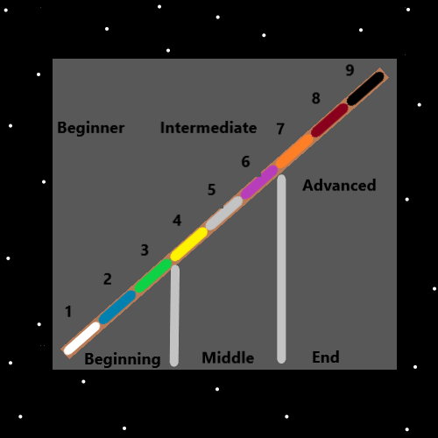

Item Group: Understanding The Multiverse 1

Principles: 5 is the Number of Balance and Chaos.

Principles: All Numbers have their Positive Side and their Negative Side. Their Positive version and their Negative version. (except maybe Zero). All Numbers have their Light Side and their Dark Side.

Principles: All Shrines should have an Energy Stone or Energy Rock. Sometimes they are called “pet rocks”.

Principles: An Energy Stone or Energy Rock can be a great thing to add to your pocket. Sometimes it’s called a “pet rock”.

Principles: It may be that Dividing a Number by 2 and then adding 11 is an Operation. It may be that “2 + 6 + 76.034 + 1.3” is an Operation.

Principles: All Wizards have a Connection to Dr. Strange from the movie “Dr. Strange”. All Wizards have a Connection to Merlin from the move “Excalibur”. Wizards have a Connection to the Jedi in Star Wars, because they are Wizard like people. All Wizards have a Connection to Harry Potter from the Harry Potter movies. All Wizards have a Connection to the music from Dr. Strange, Excalibur, Star Wars, and Harry Potter.

Principles: There is a game called “The Secret of Mana”. Its music is Level 6 and because the Word “Mana” is used in the game, Wizards have a Connection to its music.

Principles: I am pretty sure there is a book Titled “The Way of the Wizard”. Because the Word Wizard is used, it has a Connection to Wizardry, and Wizards have a Connection to it. By Connections we mean “huge” Connections.

Item Group: Understanding The Multiverse 2

Principles: Drugs and alcohol are the great destroyer of lives.

X2 Principle: Alcohol is a drug.

Principles: When you sit at a desk you “Dock” with it. When you sit in a Room, on the floor or ground you Dock with the Room and Building. When you stand in front of a punching bag you Dock with it. When you are outside and stop in place for a moment, you Dock with the area. When you visualize the Zero moment in front of you, you can visualize Docking with it and Dock with it. Chairs often live Docked with desks or tables. A chair can help a person Dock with a desk or table. A person also Undocks throughout their existence. Understanding Docking can Make a person more graceful. A Dock attempt can go bad. A Dock attempt can go great. When you sit in front of a video screen you Dock with it. You can Dock in a Room and it End up Docking with the little Shrine in the corner of the Room.

Principles: It is likely an all-powerful Spell to do 30 minutes of Breathing Exercise only. Where the only thing you do is Breathing for 30 minutes.

Principles: The best Meditation Practice is likely a Fusion of Fire and Water Meditation. It may be that Fire is great for training and Water once training has been completed.

Principles: PAAIL.org Wizardry teachings is that all people should prioritize getting to Level 3 Wizard. And that they should work often for getting to Level 4.

Principles: Wizardry Maps are good for the brain.

Principles: Using the 1 to 6 System, calling 4 Expert, 5 Master, and 6 Sage, would be a great design for a chess game website. Instead of something like beginner Rooms, intermediate Rooms, and advanced Rooms, you use 1 to 6. 1 Rooms would be for the worst players, and 6 Rooms for the best players. This is 1 application of the 1 to 6 Numerology System.

Principles: Lying on your back, on a hard surface can be a great Exercise.