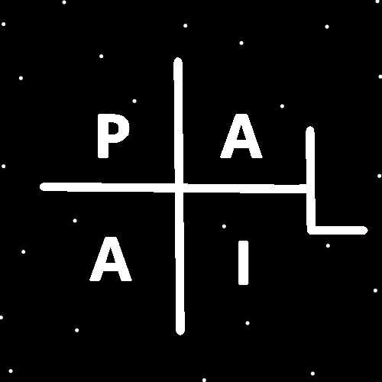
ObjectType: Room
ObjectNumber: 143
LocationName: PAAIL.org
LocationNumber:
Language: PAAIL 2.9

Maker: PAAIL.org
Model:
Name:
Rank:
SerialNumber:

Level: 7.105
Score:
Birth: 4-25-2026

Label: Room 143
Title: Smith Notes 50
Details: PAAIL.org Scripture…
Principle: Ultimate Scripture….
Agenda: Ultimate Scripture….
Action: Ultimate Scripture….
Information: Ultimate Scripture….
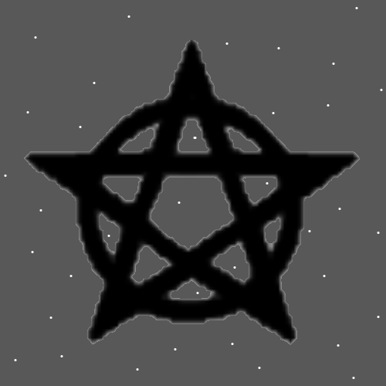
Item Group: More Knowledge
Principles: Becoming an Expert Wizard is a gigantic boost to a person’s Chi/Karma.
Principles: The Pentagram above has been used many Times. For this reason, it has a gigantic Connection to Wizardry. It is the Symbol of PAAIL.org Wizardry.
Principles: This is as small as his Holiness Origin could shrink the Darkness down to. Its as good as he could do. His Holiness Jesus’s sacrifice helped a lot. That shrunk the Darkness a great deal.
Principles: I was always taught there are the 4 states of periodic table Elements. It may be there are 8, not 4. It may be there are 16. It may be there are 32. As Reality Evolves their Numbers may Grow. Right now there may be only 4. In the future there may be more.
Principles: Writing evidence that supports Theories is not as nice as writing Theories. I often pass on writing evidence. At the End of Jesus’s Story, I think it says he rose up to Heaven. If so, this is evidence that there is a Heaven. Which is not very entertaining to read. Reading evidence can be not very entertaining.
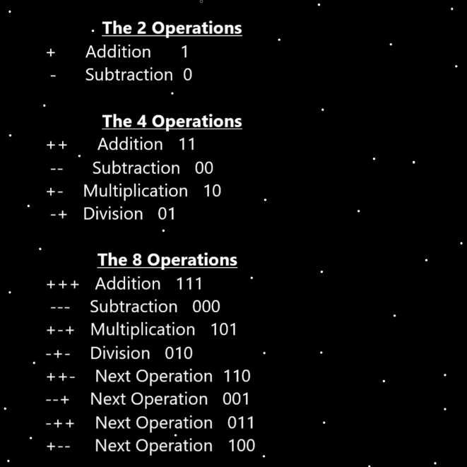
Principles: Writing evidence about Theories Makes for a lot more to read. For many reasons writing evidence can be wrong. It’s proper in some books, and not in others.
Principles: What’s good for the Body is often good for the Mind. What’s good for the Body is often good for the Spirit. What’s good for the Mind is often good for the Body. What’s good for the Mind is often good for the Spirit. What’s good for the Spirit is often good for the Body. What’s good for the Spirit is often good for the Mind.
Principles: If ever spaceships to other solar Systems technology is invented it may very much resemble when planes first broke the sound barrier.
Principles: It may be Gravity looks weak; however it is not. Likely the Height, Width, Depth Dimensions push back and reduce the amount of bend around a Planet or Star. Making Gravity look weaker. The final Strength of the Gravity field is the amount the Planet bends minus the push back from Height, Width and Depth. It may be Gravity amount equals Mass minus Dimensional push back. The whole process may resemble magnets. How certain Sides of the magnets will push away from each other.
Principles: The Theory is that Height, Width and Depth have Negative Mass and that Negative Mass Objects push away from Positive Mass Objects. They push away from each other.
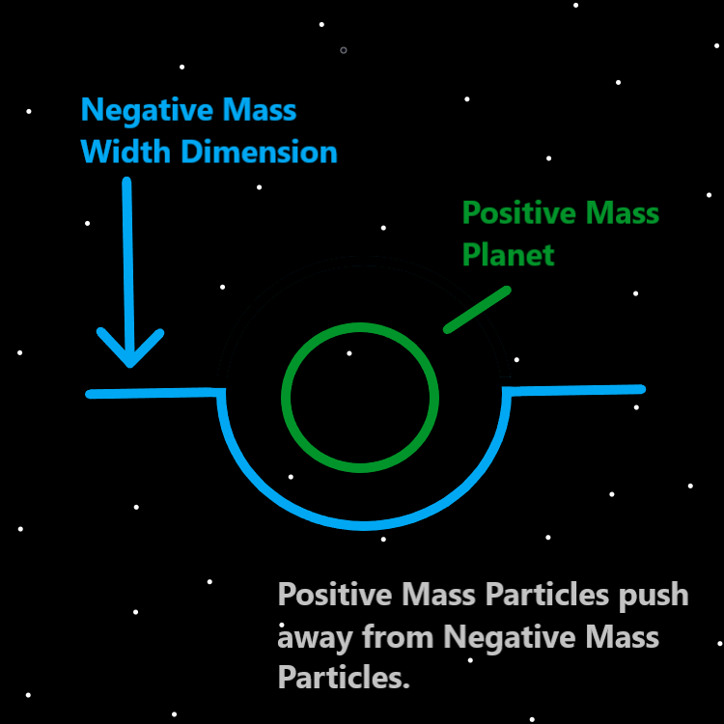
Principles: It may be that the Dimension Width can be described as a string. If it were Infinitely strong then Planets would not bend it.
Principles: That Mass and Gravity have a huge Connection is only One of many Theories. It may be wrong.
Principles: In the greatest of martial arts designs you would find the first strike is the “palm strike”. It is a weak strike and yet still right. One problem with it is that if you don’t do it just right it fails. There are other Negative things about it as well. However it is Making the Dot Symbol and is 100% perfect for the very beginning of martial arts. It also has a use as Part of movement patterns. You would mix it in once and awhile. Its not just for the Low Level, it is also for the High Level. It’s sometimes a great addition to the mix in training.

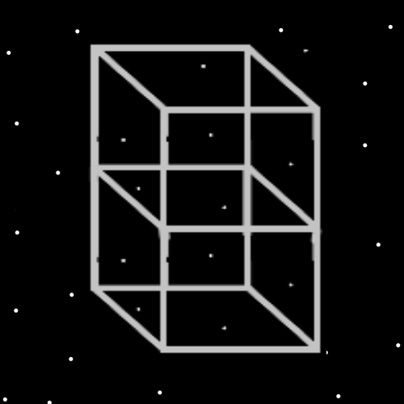
Principles: There is the core 10 Words (0 to 9). There is also the core 100 Words (0 to 99) and the core 1000 Words (0 to 999).
Principles: The Energy Bits layer of the Multiverse comes before the Math layer of the Multiverse. This is One reason why the Math of Energy Bits Makes no Sense.
Principles: At the End all things are Made of Energy Bits. Energy Bits that combined add up to Code and everything is Made of that Code.
Principles: The first Map is the Dot Map. A Black, empty background with a Grey Dot at the center. It likely has many Names, and One may be the “Origin Map”. It may have Infinite Names if you count the future. The Zero Map may also be One of its Names.
Principles: His Holiness One, in some ways, is the only One that is One with the Force.
Principles: Theres a lot of Water Level gain and Earth Level gain in rest. Theres a lot of Fire Level gain and Air Level gain in work.
Principles: There are Water Wizards, Fire Wizards, Earth Wizards and Air Wizards. Sometimes people Change as they Evolve.
Principles: It may be that Fire Wizards tend to be more Powerful. Air 2nd, Earth 3rd and Water 4th.
Principles: There are likely many good situations where a person should choose a Water Wizard Path. Healers are associated with the Water Force. It may be best for healers. One of its Colors is White.
Principles: On One Map there is only Fire Wizard or Water Wizard.
Principles: Choosing a Fire Path for a duration of Time and then switching to a Water Path can be like cooling a sword in Water. Switching from work to rest, work to rest, over and over can be a great Path.
Principles: We are all family of his Holiness Energy and his Holiness Origin. This Makes us all family of each other. Also, is some ways since we are all descendants of Adam and Eve most of us are cousins of each other.
Principles: Baseball caps and sunglasses have been/and are ultimate Charms of the Multiverse. Beware of using sunglasses when it will Make it hard to see. They don’t have as much use in Low Light settings. Baseball caps, even in Low Light environments reduce the amount of Objects in View. This reduces how much your eyes Drain on your brain and it also does more.
Principles: Why I must insist that Waves are Particles is because Particle means “chunk of Energy” and Waves are chunks of Energy. I believe Waves may be a Type of Particle.
Principles: It may be at the End of the road things look like squares in the game “Minecraft”. The squares may be 4 Dimensional and Made of an Infinity multiplied by 4 amount of Code.
Principles: It may be Math is Made of Energy Bits. And it may be Energy Bits are not Made of Math. At least these are some Theories.

