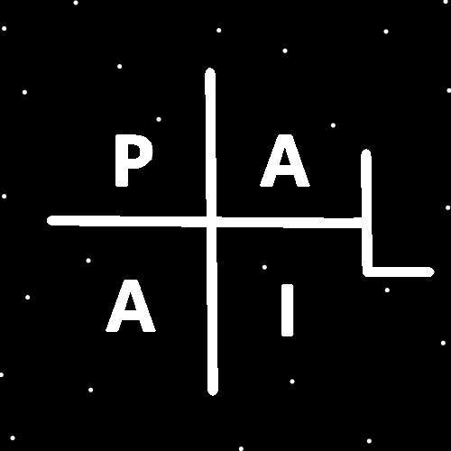
ObjectType: Room
ObjectNumber: 147
LocationName: PAAIL.org
LocationNumber:
Language: PAAIL 2.9

Maker: PAAIL.org
Model:
Name:
Rank:
SerialNumber:

Level: 7.14
Score:
Birth: 6-6-2026

Label: Room 147
Title: Smith Notes 54
Details: PAAIL.org Scripture…
Principle: Ultimate Scripture….
Agenda: Ultimate Scripture….
Action: Ultimate Scripture….
Information: Ultimate Scripture….
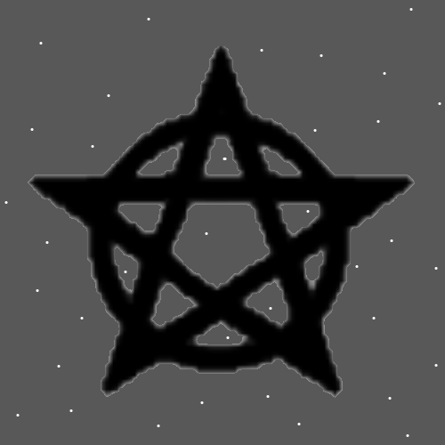
Item Group: Wizardry Laws 7+
Principles: It may be that Energy Bits have a Property that they are Infinite. Energy Bits may be Infinite in some ways.
Principles: Level 7 Wizard can be obtained. Once you get to Level 6 you just do the same training for another 20 hours a week for 4 years. It is not worth it at all. People should not do it at all. At most a Level 6 person should do 10 hours of exercise a week. Over 10 years that may be enough for Level 7 Wizard. Level 8 Wizard is likely not achievable.
Principles: Looking at a Object is a Connection to that Object. That Connection is a existing Energy and can have a influence on the Object. This may be the Story with 2D Wave Type Objects. If may be that you cannot observe a Particle or Wave without having a impact on it.
Principles: Energy Bits are likely 1 Dimensional. Or even 0 Dimensional.

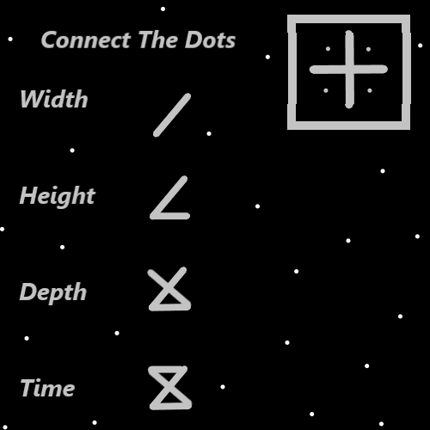
Principles: Its possible the 5th Operation is “+2”. The 6th then would be “-2”, the 7th would be “*2” and the 8th would be “/2”. This would Make Addition the “+1” Operation, Subtraction the “-1” Operation, Multiplication the “*1” Operation and Division the “/1” Operation.
Principles: In Energy Bits the 4 Forces are known as the ++ Force, the - - Force, the + - Force and the - + Force.
Principles: All people have a Chess Aura. A person’s Chess Level is Part of that Aura. There are other Parts as well.
Principles: All people have a Wizard Aura. A person’s Wizard Level is Part of that Aura. There are other Parts as well.
Principles: The Words “Parts” and “Dimensions” have a gigantic Connection.
Principles: It all Ends up the Go-Go education from the character in the cartoon “Tiny Toons”.

Principles: All things are Energies. Even Negative Energy is Energy. Even Darkness is a Energy. Often +1 is referred to as “Energy” and -1 is referred to as “Negative-Energy”. Addition has a gigantic Connection to +1. All Operations are a Type of Addition. Subtraction is a “Addition” to Reality. Subtraction is a Type of Energy. As for Multiplication and Division they are mixtures of Addition and Subtraction.
Principles: Charms Grow the Levels of their owners. When you’re an Expert at something they Grow that a lot. This can be sped up with Shrines and Temples Alchemy. Its harder to get High Level Charms without Alchemy. It takes a long Time to get a Charm to Level 4 at something without doing some Alchemy.
Principles: Charms Worship our God. Some Religious Charms End up Priests. Charms almost Worship their owner.
Principle: Grey and Transparent may be opposites.
Principles: In the movie Excalibur Merlin refers to sleeping many days. Sleeping may have a gigantic Connection to Mana Recharge.
Principles: In the computer games you always want to equip something in every open slot. In games this usually is the most Powered up decision. It turns out that Reality is the same. To Power up a bunch a person can equip tons of stuff. Most of the Time much Power will flow through a person that does. One of the big differences between Reality and the games is that in Reality there are more gear slots, more things that can be equipped. If you put 8 Rings on that’s 8 slots used. Having stuff in a bag is also huge.

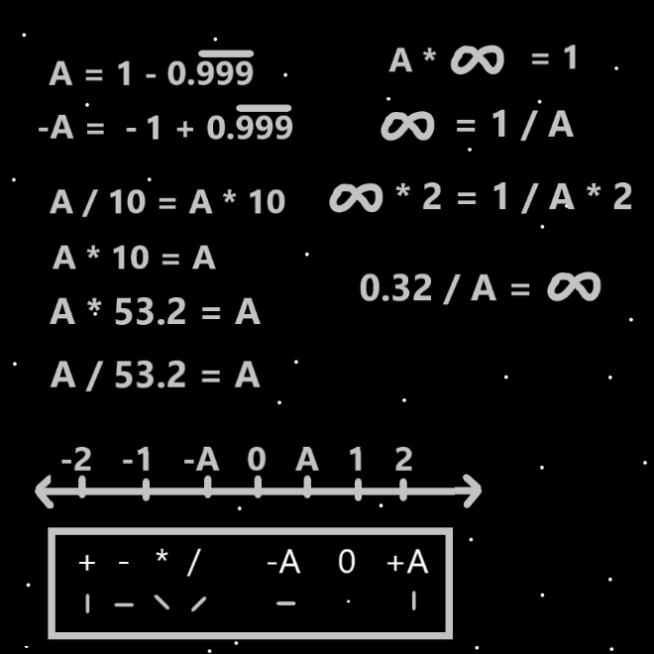
Principles: When doing Tarot card readings for others you likely want to have a lot of gear personally equipped. Note lots of gear can be dangerous. It’s a “Fire Rig” for you if you choose lots of gear. A “Water Rig” tends to be more peaceful and full of Recharge. Very little gear would be a “Water Rig” choice/Spell.
Principles: The dynamics of 2D Particles/Waves may be simpler than 3D Particles/Waves. This simpler Reality may Make them Connected to Negative a lot. All 2D Objects could be Negative Type Objects.
Principles: All the Charms around us are extremely Powerful. Much Power flows from them.
Principles: Human artifacts are Beginning of Time artifacts.
Principles: When a Charm sits in One place for a long Time and then is moved somewhere else, a residue is left behind. Like a ghost of the Charm. It might be right to call this “Spectral” Energy. The Energy field (ghost) decays over Time.
Principles: In Gods more Advanced Science being a Doctor at something Makes a person at least Level 6 at that thing.
Principles: Because Wizardry is the ultimate Science. As a Scientist, God above all is a Wizard. Its his biggest Science.
Principles: 1st through 12th grade in public schools is 12 years. In 12 years a person could easily learn all PAAIL.org Wizardry. 6 years would also be easy. 4 years would be easy.
Principles: The Map to the left has been updated from a previous version. The “0.3/A = Infinity” Part was added.
Principles: Understanding Energy Bits very likely has a gigantic Connection to understanding computers. One can figure out Energy Bits Science by understanding computer Science. The author here is Level 2 General computer Science. I know nothing about computer hardware. Nothing about circuitry and so forth. I am a Level 3 programmer, and you can see the secrets when you are a Level 3 programmer. You can see how everything is “true” and “false”. You can see how everything is “code”.
X2 Principles: “True” and “false” are major Vocabulary Words in computer programming.
Principles: A Doctor of Physics who is also a Level 4 Expert at computer Science could likely Fuse the Two and see secrets of Energy Bits. There may be priceless knowledge that can be gained from Fusing the Two.
Principles: Likely all Particles are Connected to all other Particles. All Energy Bits may be Connected to all other Energy Bits.
Principles: When you visualize a Energy Ball in front of you, you create a Energy Ball in front of you. This Energy Ball is likely Part Spectral Energy.
Principles: Once you hit Expert Wizard you should still stay current and read it all. It will likely lead to Level 5 Wizard over the years.

