ObjectType: Article  
ObjectNumber: 109

LocationName: PAAIL.org

LocationNumber:

Language: PAAIL 2.8

Maker: PAAIL.org  
Model:   
  
Name:

Rank:

SerialNumber:

Level: 6.1

Score:   
Birth: 8-15-2025

Label: Room 109

Title: Smith Notes 23

Details: PAAIL.org Scripture…

Principle: Ultimate Scripture….

Agenda: Ultimate Scripture….

Action: Ultimate Scripture….

Information: Ultimate Scripture….

Item Group: Understanding The Multiverse 0

Principles: If you die a good person, you slay a dragon for God.

Principles: No humans slay more than 3 dragons. All good humans slay at least 1.

Principles: Slaying a dragon is a monumental thing and gigantic achievement.

Principles: All good humans have a monumental and gigantic existence.

Principles: Music is super Advanced these days. It is a gigantic Force in the Multiverse.

Principle: Music can invoke Visions.

Principle: Often people guide other people.

Principles: People with High Levels in a thing can often instruct people with Low Levels in a thing.

Principles: People with Higher Meditation Levels likely have great power as Meditation guides.

Principles: High Levels of Meditation guidance is a thing. People who have spent much Time guiding the Meditation of others.

Principles: I believe that colleges have “guidance counselors”.

Principles: PAAIL.org is a guide, and a powerful One. However, it is messy, disorganized and unrefined.

Principles: The Bible is a guide. Scripture is at least sometimes guidance.

Principles: Theres a Part in the Bible that goes… (I think was about Moses) “….Moses is not like a prophet who I speak to in riddles. With Moses I speak plainly.”-The Holy Bible.

X2 Principles: This implies a few things. One: that God often(or always) speaks in riddles to the prophets. Two: On some Maps Moses was bigger than a prophet. As is known prophets are Level 8. Moses was likely the Level 9 and “a friend of God”.

Principles: In the 1 to 6 Numerology System 2 is not ok. 2 is not good, and 2 is not ok.

Principles: When you are Level 3 at something, like chess, your average dice roll is 3. Sometimes you roll a 2 with your strategy or Action. Sometimes you luck out and roll a 4. Roll a 1 can happen to. Life is full of dice rolls. With every Action a person rolls the dice.

Principles: All day long people output Spiritual Energy. Positive Spiritual Energy and Negative Spiritual Energy. When working, when sleeping, when playing a silly game.

Principles: Its really not about believing in God or Worshipping God. It’s all about being a good person, a being of Light.

Principles: When it comes to Multidimensional Numbers the person that owns the Number is likely the first Number. All Multidimensional Numbers that start with 0 belong to our God.

Principles: On many Maps 0 to 9 are the 10 Number categories. Likely the 2nd digit of a Number is its Number category. Exception to the single digit Numbers 0 to 9. So, 10 is a 0 Number, 100 is a 0 Number, 101 is a 0 Number and 10321 is a 0 Number. Because they all have the 0 as their 2nd digit. This means that 11 is a 1 Number and so is 113433. 1687 is a 6 Number and so on.

Principles: On some Maps the 0 to 9 Numbers are 0 category. They be the largest people of Reality.

Principles: Even though some Maps seem to contradict each other, it may be they all have their own unique Name. This can explain the contradictions.

Principles: It is a major Detail of physics that gravity is either the addition Force, the subtraction Force, the division Force or the multiplication Force. It is a major Detail that gravity is both a Pole and a Axis, with Positive and Negative gravity. This is valuable knowledge for all physics Experts.

Principles: The theory long has been that there is that electromagnetism is both a Pole and an Axis. With Positive and Negative electromagnetism. The Story is the same with the strong-nuclear Force and the weak-nuclear Force.

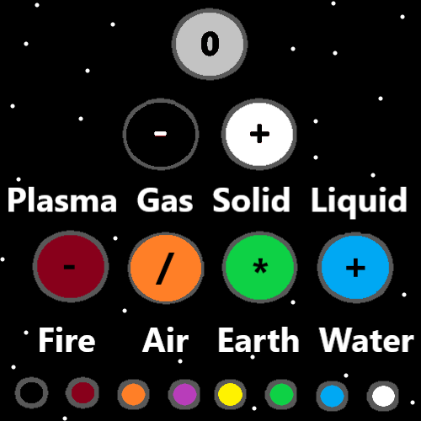

Principle: This writing be nuclear(new clear) secrets.

Principles: It is good to note things like how on a 2D graph the Origin is the 0,0 Location. And note that the 0,0 Location is known as the Origin.

Principles: The Zero moment is also known as the Zero-Dimensional moment. When Reality was not 4D, it was 0D.

Principles: Its possible that the Zero moment is also known as the 2D moment. When Reality was in some ways 2D.

Principles: The Zero moments has a gigantic Connection to 2 objects slamming into each other. Like in a particle accelerator (a machine that slams Particles into each other).

Principles: In the 1 to 6 Numerology rating System 2 is not 0k. 3 is 0k.

Principles: Some Actions come from our Virtues. Some Actions come from our Flaws. Virtues improve dice rolls. Flaws do not.

Principles: Mass is likely an Axis and a Pole. Since it’s a Pole there is an opposite to mass, a form of Energy that is the opposite of mass. Since its an Axis, there be Positive and Negative mass. The opposite of mass would also be an Axis with Positive and Negative to it.

Principle: Many many things are Axis’s and Poles.

Principles: Electrons may have Negative mass. All electrons could have a unique amount of mass.

Principles: It may be right to say his Holiness Jesus was born in a barn. The Bible says there was no Room at the inn so they used the stable.

Principles: If a proton is a Pole and an Axis. Then there is the opposite of a proton and there is also Positive and Negative protons. It may be that the electron is the opposite of a proton.

Principles: The Low Medium High Map is a monumental Map. On some Maps 1,2,3 are Low, 4,5,6 are Medium and 7,8,9 are High. With the 1 to 6 Numerology System, 1,2 are Low, 3,4 are Medium and 5,6 is High.

Principles: To get Off drugs you may have to Disconnect from certain people and places. If marijuana is legal it may help.