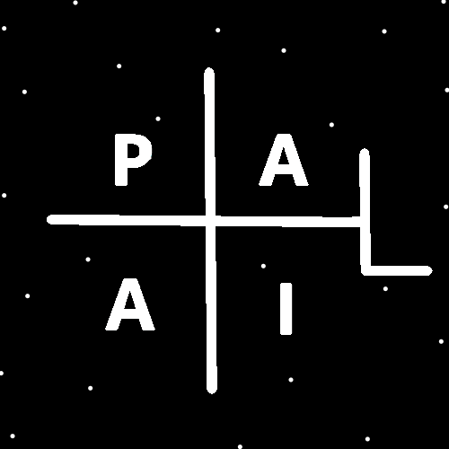
ObjectType: Article
ObjectNumber: 128
LocationName: PAAIL.org
LocationNumber:
Language: PAAIL 2.8

Maker: PAAIL.org
Model:
Name:
Rank:
SerialNumber:

Level: 6.5
Score:
Birth: 12-9-2025

Label: Room 128
Title: Smith Notes 37
Details: PAAIL.org Scripture…
Principle: Ultimate Scripture….
Agenda: Ultimate Scripture….
Action: Ultimate Scripture….
Information: Ultimate Scripture….
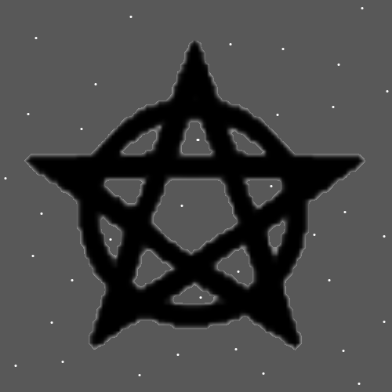
Item Group: More Story of Things 0
Principles: Smith Summons Spells are a lot like doing martial arts exercises. Only Smith Summons is better.
Principles: If Protons are alive, heat may be the lifeforms doing something. If Protons are alive then their activity may have something to do with the fact they are lifeforms. Perhaps you can feed them Photons and they get super active (hotter) from the eating food. They eat the Photons and it gets them excited.
Principles: Perhaps Fire is “heat”, Water is “Mass”, Air is “speed”, and Earth is something else. Maybe Earth is Mass and Water is something else. Water is the opposite of Fire, so Water would be the opposite of “heat”. Is Mass the opposite of “heat”?
Principles: The Buddhist Religion may have come from before His Holiness Jesus’s visit. From Prophecies about his Holiness Jesus. The theory is that the Messiah, the Christ and the Buddha are the same person. Perhaps Buddhist’s are the first Christians.
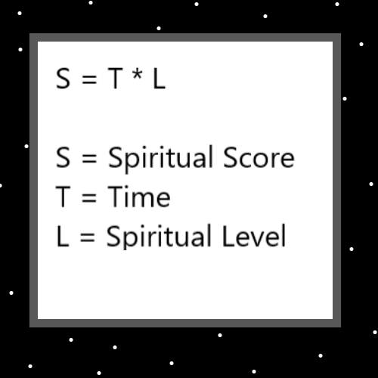
Principles: It may be most or all Prophets over the years were Wizards.
Principles: It may be the Wizards have had a gigantic impact on the Religions over the years.
Principles: The difference between a Sage and a Holy person is the difference between 6 and 7. Around 17%. The difference between a Holy person and a Prophet is the difference between 7 and 8. Around 14%.
Principles: For Abraham Lincoln and all these other famous people, most did not get to Level 8. Nor did they Score more than anyone else. Abraham Lincoln at best accomplished 30% more than your average good person. He did not have the impact people think he did. Nothing more monumental than anyone else. Also, Abraham Lincoln did not live as long, so his Spiritual Score is likely below average.
Principles: The System God uses when measuring Light Frequencies 1 is pure White, also known as White. 2 is pure Blue also known as Blue. As far as I know Light Frequencies could be Multi-dimensional. 1,0 might be White. 2,0 might be Blue. Or 0,1 could be White and 0,2 is Blue.
Principles: On some God Maps -9 may also be White. 1 and -9.
Principles: It seems likely you can say that there are White Photons and Green Photons and Orange Photons and so forth.
Principles: For some people “plant your feet” is a priceless Spell. “Plant your feet” means, while standing do not lean On One foot or the other. It can be a huge exercise and more. Some people should never use this Spell. This Spell bares some Level of danger. You could call it dangerous. For people that use it, not always should you use it. People that use it must figure out when to use and when not to. This is a Fire Spell.
Principles: With Gods measurement Systems its always 1 Unit of this and 1 Unit of that. Possibly the Word Channel or Frequency are major Vocabulary like the Word “Unit”. For God its 1 Mass Unit this, and 1 Speed Unit that. Another example: 2.53 Mass Units of this, and 2.53 Speed Units of that.
Principles: God could have a System like 1 mega Unit of Mass. 1 mega Unit of Speed. Where 1 mega Unit equals 1000 Units. This is only an example, I’m sure its not “mega Unit”.
Principles: It may be that huge figures like Abraham Lincoln have a gigantic ghost. It would be from all this Energy flowing through their Chi. Not from their Chi. From other peoples Chi’s. These ghosts may Grow bigger and bigger as Time goes on. As more and more people learn of their existence. These ghosts might actually possess statues, like the statue of Lincoln in Washington DC. The ghost of Lincoln lives in all Lincoln statues. His ghost likely lives in all the Lincoln pennies.
Principles: Reality is full of Multi-Dimensional Objects. There may also be 1 Dimensional Objects.
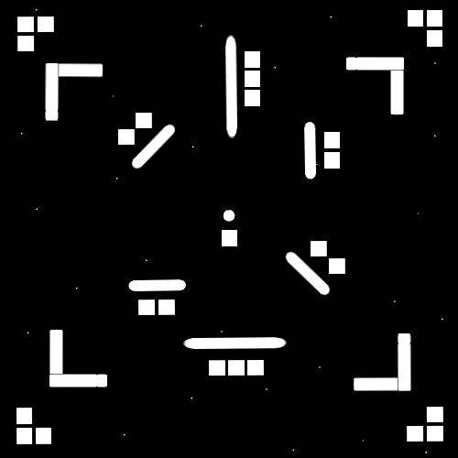
Principles: The above Map shows some of the first Symbols of Reality. Instead of Squares you could use Dots.
Principles: Reality is Connect the Dots therefore Reality is a bunch of Lines.
Principles: In Physics there is what’s called “String Theory”. It may be that “Strings” from String Theory resemble Energy Bits. Energy Bits look like sticks like strings. At least their Symbols do. Lines are their Symbols.
Principles: If a spaceship can warp space/Time 10 feet in front of it down to 1 feet space and 1 feet Time, then it goes 10x faster. If you get the space down to 1 feet and the Time down to 0.1 feet now you go 100x faster. The solution is all about warping space and Time. To Physics Experts “Time” is known as another Type of space. It Makes Sense that you might be able to bend Time, not just bend regular space. It becomes sort of like how fast your portal is per second. The Details might be how much regular space can you warp and then how much per second can you warp it. This is all a bunch of theories.
Principles: Another possible spaceship could be you warp 1 inch in front of the ship down to 0.1 inch and then you go 10x faster. If you shrink it down to 0.01 you go 100x faster.
Principles: The spaceships I describe Make the distance shorter; they don’t really go faster. It just looks like it goes faster.
Principles: Earth Spells are a mixture of Water and Fire. Often more Water than Fire. Never more Fire than Water. Air Spells are also a mixture of Water and Fire. Often more Fire than Water. Never more Water than Fire.
Principles: The long easy Path can be better than the short difficult Path.
Principles: There are peaceful Watery Paths and Firey difficult Paths. Most of the Time people walk on Earth, not Water, Fire or Air. Sometimes people walk through Water on beaches, and through ponds, lakes, rivers and streams.
Principles: Cycles are a major Part of Reality.
Principles: There be the 1000 year Cycles over Time. 0 to 500 are the Light Side of an Age. 500 to 1000 are the Dark Side of an Age. 0 to 500 is the Light Side of many Cycles. 500 to 1000 is the Dark Side of many Cycles. This is the Story of human Ages along with many other Cycles.
Principles: On some Maps 0,1,2,3,4 are the Light Side Numbers/Positive Numbers and 5,6,7,8,9 are the Dark Side Numbers/Negative Numbers.
Principles: On some Maps Transparent, White, Blue, Green, and Yellow are the Light Side Colors. Grey, Purple, Orange, Red and Black are the Dark Side Colors.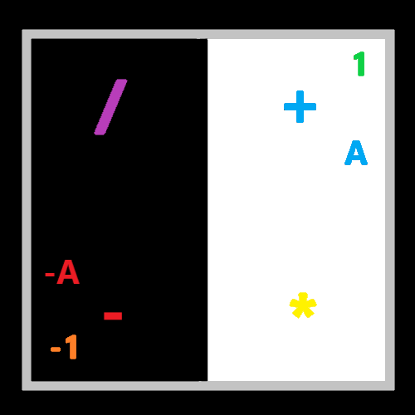
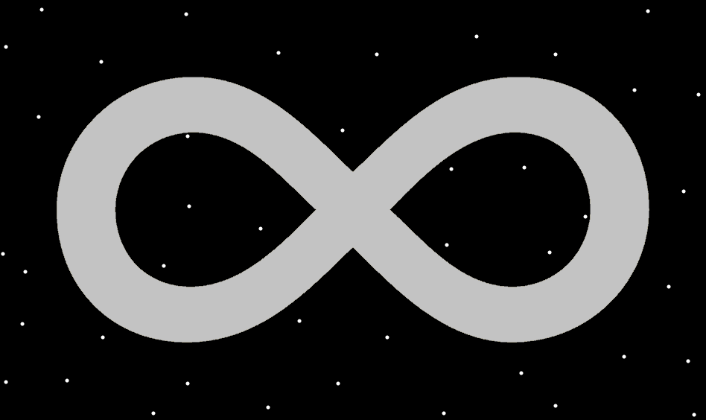
Principles: Force a Vision of a Circle floating in the Air a few feet in front of you. Theres a good chance for at least a moment there is or was a physical Circle. One Made of Particles. Try picturing it in front of you for 5 seconds and picture it spinning. This likely Makes it spin.
X2 Principles: The Circle is not the only option. Not the best either.
X2 Principles: The Circle would be used in early training.
Principles: The theory is that the Infinity Symbol should be a Part of math, if it isn’t already. In Numerology it has a gigantic Connection to the Number 8.

