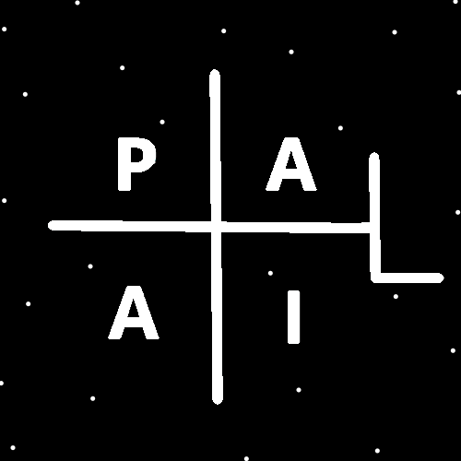
ObjectType: Article
ObjectNumber: 137
LocationName: PAAIL.org
LocationNumber:
Language: PAAIL 2.8

Maker: PAAIL.org
Model:
Name:
Rank:
SerialNumber:

Level: 7.01
Score:
Birth: 1-10-2026

Label: Room 137
Title: Smith Notes 44
Details: PAAIL.org Scripture…
Principle: Ultimate Scripture….
Agenda: Ultimate Scripture….
Action: Ultimate Scripture….
Information: Ultimate Scripture….
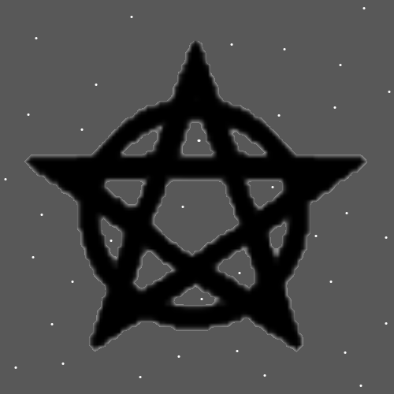
Item Group: More Levels of Understanding
Principles: The Symbol above has its own Name. It’s called a Pentagram. It has a gigantic Connection to “Witchcraft” and through that fact (Connect the Dots) it has a gigantic Connection to Wizardry. It may be the biggest of the Wizardry Symbols. It seems likely that it is at least One of the biggest.
Principles: Moons and Stars are also very Connected to Wizardry. Moon Symbols and Star Symbols. Moons and Stars are Cosmic Bodies.
Principles: It seems to Make Sense to increase/Add to the Level with every new Room. Thus, the Level on this Room is 7.01. The last Room was 7.0.
Principles: I have heard over and over about something called “Dark Matter”. Something about Energy that can’t be seen. Perhaps this Matter is Made of Particles that have something like 1/1,000,000,000,000,000,000th the Mass of Protons, Electrons or Photons. You wouldn’t be able to detect such Particles because they are too small.
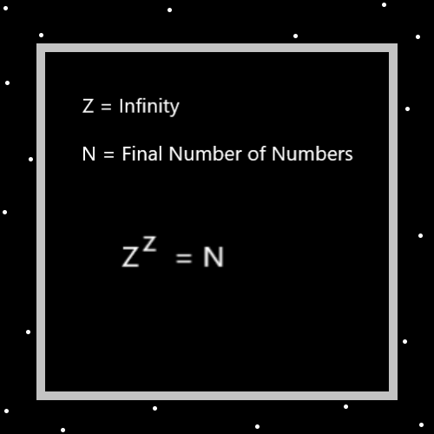
Principles: The Map above is only a Theory. If you had “Z to Power Z + 10” you would never get to the “+ 10” Part of the Operation.
Principles: It’s possible that empty space is not so empty. It’s possible that its full of Energy. However, the Particles are too small to detect.
Principles: If Photons have Mass and there are smaller/lower Mass Particles than Photons. Then possibly there are Particles moving faster than the speed of Light.
Principles: The latest refinement is to say there are the Spiritual Laws of the Spiritual Side. Spiritual Laws of the Spiritual Aura’s. The use of the Word Laws is a very good thing. In Numerology it is thought the Word Laws is very Connected to the Number Category 3. Since 3 is a super Low Number Laws are a major thing of Reality.
Principles: Achieving Cosmic Laws 5 is Enlightenment. Perhaps Cosmic Laws 4 or even 3. A person can be an Expert Wizard and only at Cosmic Laws Level 5. Perhaps Cosmic Laws 4. To get Cosmic Laws 7 you have to learn a lot of Wizardry Physics.

Principles: If “-A” Particles have Mass, you would think it might be Negative Mass. If they have Negative Mass, you would think there may be other Particles that have Negative Mass.
Principles: The only Philosophy that I ever Named is what I call the “Big Brother Philosophy”. The Name partially comes from people complaining and saying things like “big brother this!!!” and “big brother that!!!”. Something to do with government Operations they don’t believe in. The Philosophy is that if you have a big brother then your business is their business because they are family. This further extends to all family. If you’re family, then your business is my business. If it’s a family member, then their business is your business and your business is their business. This further extends to all life. The bugs, the beasts, the trees, God and all of Heaven. Since it’s all family their business is our business. I believe in big brother this and big brother that.
Principles: “The journey is the reward.”-Unknown. “Sometimes the journey is the reward.” is 100% Accurate. Sometimes the journey is not the reward.
Principles: “Accurate” and “Accuracy” are major Vocabulary Words.
Principles: A person can probably get from Level 6 to Level 7 Wizard in 2 to 4 years doing 40 hours a week training. It’s not worth the Time, you wouldn’t even notice the difference. Also, a person could spend that Time doing much better things. It may be that when a person hits Level 6, 10 to 20 years later they will just arrive at Level 7. Level 7 may require No specialized training. Level 8 may be impossible and it could require specialized training.

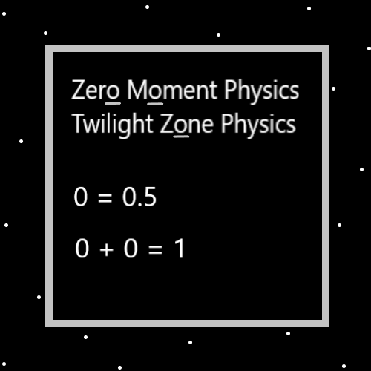
Principles: A person could Make a 2-to-6-hour series of videos that would be Nuclear. New clear. It would be full of Maps and animations. Someone would narrate as we go through animations and Maps. Many of the Maps would not be PAAIL.org Maps. PAAIL.org Maps wouldn’t necessarily be right at all. They would be at least a great inspiration for the videos project.
X2 Principles: When Making weapons grade uranium you spin the material round and round until you get the heavy stuff On One Side. Then do that again with the heavy stuff. This is how you get refined uranium.
X2 Principles: The process of Making nuclear weapons is a great inspiration for Making the videos. It is a blueprint for doing so. There are also nuclear Power plants. I don’t know much about them.
X2 Principles: The Words “new clear” are major inspiration. You want it to be new Information, and you want it to be clear Information. The biggest Information is also the best choice.

Principles: Also, there is nuclear Power plants. I think you get Power plant uranium the same way you get weapons uranium.
Principles: Understanding “education Levels” is understanding Levels and education Science. Understanding Levels in a great/Cosmic way is Wizardry. There is the Fusion of Wizardry and education.
Principles: The Numbers 8888, 22222, 33 and 444 are a Type of Number. The “it repeats Type”. This Principle has been taught before. It should be noted that One important Detail is that there are Endless Number Types. This is just One Type.
Principles: To truly understand the 4 Forces, Water, Fire, Earth and Air you have to understand a bunch of Physics. To be a Doctor of Wizardry you must understand a lot of Wizardry Physics.
Principles: New tech has bugs. It’s new for people to have a super compact, ultra-Powerful, mini phone, internet thing. It’s bugged. The internet is bugged.
Principles: There is the Light Side of the Darkside and the Darkside of the Light Side. When you Zoom in On a Axis it is Made of Two Poles. When you Zoom in On those Poles, they each are Made of Two Poles. This results in 4 Poles. There is the Light Side of the Light Side. The Light Side of the Darkside. The Darkside of the Darkside and the Darkside of the Light Side. 4 Poles.
Principles: All things that exist are Ons. All things that do not exist are Offs.
Principles: Many people have heard of the Theoretical Energy “Anti-matter”. It would Make Sense that if exists then it might have Negative Mass. There may be no such thing as Negative Mass.

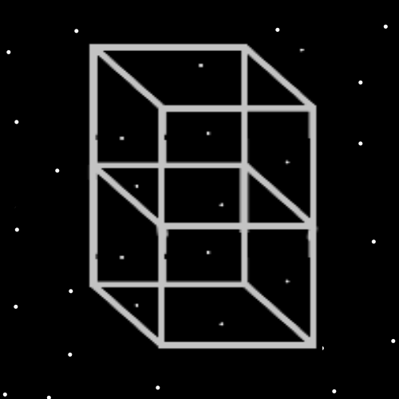
Principles: If Protons generate a Positive Gravity field, then Positive Gravity Objects like Earth gravitate towards each other when they get close. It may be that when a Positive Gravity Object comes near a Negative Gravity Object they push away from each other.
Principles: When a Particle travels through Space (like a Photon) it may be moving through tons of Energy. Like when a fish swims in the Ocean.
Principles: It would Make Sense that when Anti-matter collides with Matter it might cause an explosion. It maybe never happens though because they push away from each other. Perhaps the closer they get the more extreme the push.
Principles: All this Physics may be extremely similar to “Magnets”. If you bring Magnets close together in the right way they push away from each other. If you bring them together in the right way they pull together. One Side of the Magnet is the Positive Side and One is the Negative Side is how I think it goes.
Principles: When a person sits, they “Dock” with the environment. You “Undock” when you get up.
Principles: You would think that if there is such thing as Negative Mass that Electrons might have Negative Mass. You would think that they might also generate a Negative Gravity field. They may be bend in Particles.

