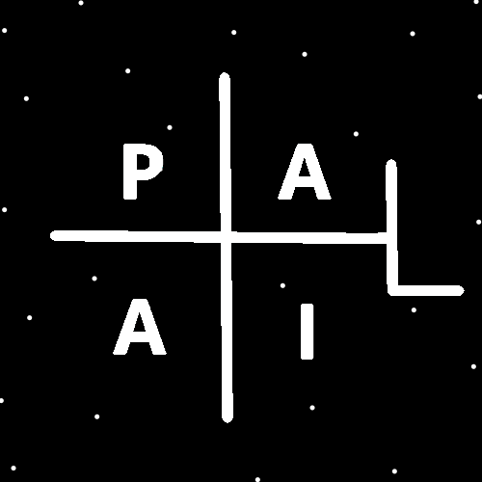
ObjectType: Article
ObjectNumber: 129
LocationName: PAAIL.org
LocationNumber:
Language: PAAIL 2.8

Maker: PAAIL.org
Model:
Name:
Rank:
SerialNumber:

Level: 6.5
Score:
Birth: 12-14-2025

Label: Room 129
Title: Smith Notes 38
Details: PAAIL.org Scripture…
Principle: Ultimate Scripture….
Agenda: Ultimate Scripture….
Action: Ultimate Scripture….
Information: Ultimate Scripture….
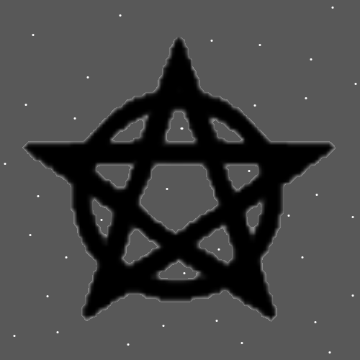
Item Group: More Enlightenment About The Story
Principles: There is for sure Enlightenment and for sure “Knowledge Enlightenment”. Knowledge Enlightenment is knowing the ultimate Cosmic knowledge. It’s unclear whether a person can be just “Enlightened” and not be a nice person.
Principles: God is something like 100s of trillions of years old. He calls it 99.
X2 Principles: 100s of trillions is likely extremely inaccurate. It’s the best I can do.
Principles: Getting to Level 4 Divination Makes your Divination more Powerful. Your luck while doing it will go up and instead of 30-60 minute sessions, you can do 5-30 minute sessions.
Principles: When things are trained up you don’t need the Spell Part Time as much. You accomplish more in a shorter Time.
Principles: Thinking a Keyword for 5 seconds can be a Powerful Spell. Especially for someone who is fully trained. It’s Meditation so you want Meditation Levels for One thing.
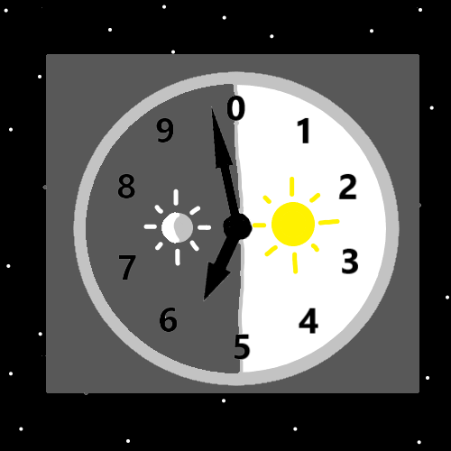
Principles: Maps are an Information Item. Not a Principle, Agenda or Action. Though Maps do teach Principles/ represent Principles.
Principles: When a person has High Levels at something it takes less Time to cast Spells/Actions related to that something.
Principles: It only recently occurred to me that I could have drawn up a million more Maps. So far, they mostly only get written about, not drawn up.
Principles: The Map above is set to 5980. The guess is that we are somewhere around the 5800s to the 5900’s. Since the Birth of Adam.
Principles: Divination is commune with the Four Winds. Divination is commune with the Force. Divination is listening to the Four Winds.
Principles: Divination is a brain exercise, like puzzle games.
Principles: Fire is extremely dangerous. Which is more accurate than “Fire is dangerous”.

Principles: The statement “Philosophy bakes no bread” is wrong. I read the statement once “Philosophy bakes no bread”-Unknown. Philosophy bakes more peace and order along with other stuff, which bakes more bread.
Principles: When a person dies, they go onto the game over Scoreboards. Likely all people have a non-living ghost that continues after them.
Principles: When visualizing a White Circle in front of you. You want to Make it rotate. Make it rotate like a coin would so you can see both Sides. Instead of a Circle you can use many things, like a coin shape. Rotate it so you can see both Sides.
X2 Principles: “What does this Circle do?” It is Made of Particles, it is a Charm. It lives; it Breathes. It’s like all the other Charms around it. It has a Positive Aura. It can be Enchanted, Aged and more.
Principles: “I was around at the Beginning of Time. I was an ant.”-Some person in the future.
Principles: “I was around at the Beginning of Time. I was a beaver.”-Some person in the future.
Principles: There is no guarantee a persons Positive Energy flows through their work. Most of the Time it does. Sometimes it doesn’t. When it does not flow through your work it flows through other things in your life.
Principles: “Tome of the Yellow Wizard”. Its Negative/bad Divination to say “Tome of the Cowardly Wizard”. Because the Word “cowardly” is so Negative. It is more acceptable to say “Tome of the Scared Wizard”.

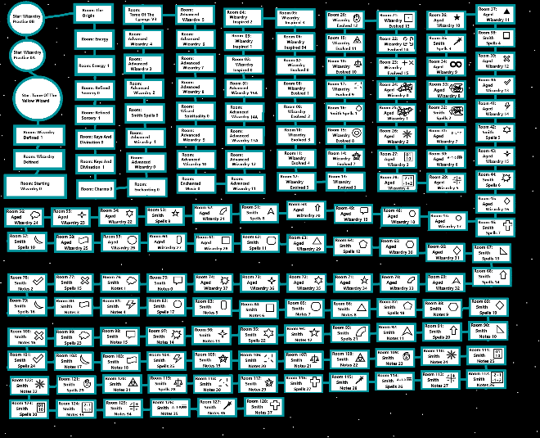
Principles: Looking at the above PAAIL.org Wizardry Map can help a person Sense their Wizardry progress. A Map regarding Math can help a person Sense their Math Levels. A Map regarding chess does the same. This is Sorcery.
Principles: Looking at the above Map can help a person Sense the gigantic size that Wizardry has Grown to. A person can also Sense how “Tome of the Yellow Wizard” is just the tiny Beginning of it all. Tome of the Yellow Wizard is something like 4 years old and super out of date.
Principles: Some PAAIL.org Principles are wrong. That is Part of why I call it all Theories.
Principles: Some PAAIL.org Principles are inaccurate. PAAIL.org is a collection of Theories.
Principles: People speak of God having a plan. God has a plan. This is all Part of Gods plan. Not everything that happens is Gods will or Gods choice. Sometimes it is the Darkness behind an event. God lost a battle with the Darkness. Also, God does not control us directly. We are ships and captains of the ship. God owns the ship; however, the captain gets the ship from here to there. God helps captains in indirect ways. Clergy often help captains. Clergy often read Scripture. The likely Story is that God is quite Disconnected from our existence. People say things like “It’s God’s will.”. If its Light then it is Gods will, if it is Darkness then it is not. And it is only Gods will because it’s what he desires, not because he Made it happen.
Principles: It may be that Agendas are Water, Actions are Fire, Information is Earth and Principles are Air.
Principles: On some Maps 1111, 22, 22222, 8888 are all a certain Type of Number. The “it repeats” Type.
Principles: 1 is the Number for Energy. 0 is so close to 1 that 0 has a gigantic Connection to the Word Energy.
Principles: Its Paranormal knowing the secrets of the Multiverse. It’s Supernatural knowing the secrets of the Multiverse. It’s Mystical knowing the secrets of the Multiverse.
Principles: You just spin it around and around until you get the heaviest stuff On the End. Then you take that and spin it around and around until you get the heaviest of that On One End.
Principles: The Word “Medicinal” is a major Vocabulary Word. Many things are Medicinal and such things can be Powerful Water Actions/Spells/Sorcery. A Water Wizard would be a person of Medicinal things. The Word Medicinal has a gigantic Connection to Water.
Principles: People contribute their Positive Aura 5 minutes at a Time. You usually can’t accomplish anything in 5 minutes, however it Adds Up over One’s life. Even when you see a moment where you accomplish more its usually only 10 Times more at most, 50 minutes. 50 minutes is still not much.

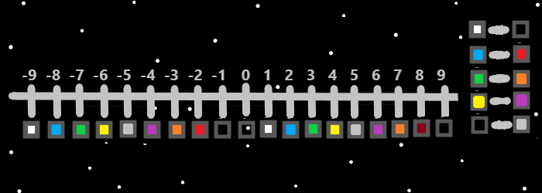
Principles: Many have heard “pressure Makes diamonds”. Diamonds take something like 100s of millions to years to form. Humans live only a short while, and pressure is Fire, which is dangerous, plus you don’t want too much pressure and so forth. Thus, the statement “pressure Makes diamonds” is not always a great statement. In life you want the right amount of pressure. The Right Balance of pressure. Never have too much pressure.
Principles: When you bring 10 coins together, they glow. This is because Part of their existence Vibrates on the same Frequency. The Frequency is amplified because of them being close together.
X2 Principles: By “glow” I mean they emit Particles. Perhaps Photons, perhaps not. Perhaps many different Types.
Principles: Because a coin collection glows when the coins are near each other it would seem sometimes the whole does equal more than the sum of its Parts. It seems likely sometimes the whole does equal the sum of its Parts.
Principles: Charm collecting is a major Part of Wizardry. It is Alchemy/Sorcery and more.
Principles: Charm collecting has been gone over. I’m choosing not to do so again. Except to say that using a Wizard Bag is super awesome and you can collect a lot of cheap stuff in them. Books to generate weight/Mass.
X2 Principles: A “Wizard Bag” is a bag that has a Level 4 or better “Wizard Bag Enchantment”.
Principles: Ageing a Wizard Bag takes no Time at all. It gets to Level 4 fast. It belongs to One of the ancients from the Beginning of Time, its Personally Equipped a lot, there’s all this stuff in it and much more. It seems like Alchemy/Enchanting has been covered enough that I need not say more.
Actions: Sense all the things you own. Picture/think about all the things you own in your Mind. Do this for 10 seconds, and then you do not need to do it ever again if you don’t want. Its possible this is a really nice Spell, and it could be used more.
Principles: On some Maps 0.2 is not 2%, it’s 20% of a Level. On some Maps 3.2 is 20% closer to Level 4 than Level 3.0. On some Maps 0.2 is a lot.
Principles: It may be decent Divination to use the Keywords “1, One, Energy, I, Won, Substance, Beginning”, and other 1 Words. Replace them with your Keyword. Such as chess or football. This is only for some situations.
Principles: Some people are strong with the chess Side of the Force. The author is like 3.1, maybe 3.2.
