ObjectType: Article  
ObjectNumber: 88

LocationName: PAAIL.org

LocationNumber:

Language: PAAIL 2.8

Maker: PAAIL.org  
Model:   
  
Name:

Rank:

SerialNumber:

Level: 5.5

Score:   
Birth: 11-29-2024

Label: Room 88

Title: Smith Notes 9

Details: PAAIL.org Scripture…

Principle: Ultimate Scripture….

Agenda: Ultimate Scripture….

Action: Ultimate Scripture….

Information: Ultimate Scripture….

Item Group: Understanding The Multiverse 0

Principles: I once heard a psychologist speaking with a patient. They reasoned with the person. This is guiding their thought. This counts as a guided Meditation Spell. When a person advises a person it can be guided Meditation. It may be that it is always guided Meditation when a person advises another person. It may be right to say we guide the thoughts of others when we speak or when people read things we have written.

Principles: Good people are glorious. The Word “glory” is a major Word of the Multiverse.

Principles: When you split a Energy Bit you get more Energy Bits.

Principles: When Sensing Auras a person can get so used to the Aura that they stop Sensing it. This happens with the Sense of smell, a person can get so used to a smell that they stop being able to smell it.

Principles: ESP Sense mechanics are like normal Sense’s mechanics.

Principles: Sometimes when doing Divination a person might experience ESP moments. The ESP mixes with the Divination.

Principles: One of the most common ESP experiences is Sensing the massive Chi of a thing. All the Charms and people around us have massive Chi’s. All the Charms are artifacts from the beginning of Time. They are huge.

Principles: When Sensing multiple things at the same Time you get a mixture of Auras and it Ends up its own unique final flavor. It may be that most of the Time people Sense multiple Auras at once.

Principles: As for the ESP experience, it can be a ride, each person has a unique ride and often you can’t get old ESP experiences to come back after you have had them. If you chase the dragon, you may never catch it. One ESP moment flows into the next. It’s a ride.

Principles: For his Holiness, our grandfather, our lives are Scripture.

Principles: Everyone has ESP. Though some more than others. You likely can increase ESP Levels from many things, such as Meditation, Body exercise, and Divination. Understanding the Four Forces likely increases ESP Levels, and Energy Bits too. Greater knowledge about the Multiverse increases ESP Levels.

Principles: Sometimes massive Positive Energy flows through a person and it Makes them seem like they have much greater meaning to their lives, even though they don’t. This can also happen with Charms, Locations and other things.

Principles: On a 1-dimensional Number line, when Two Numbers are close to each other, they are similar to each other. The closer they are, the more similarity. Numbers 1 and 2 are very close together. 1 and 999 are also rather close together.

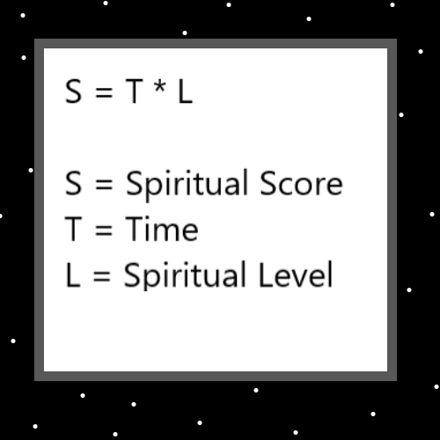

Principles: Energy Bits have Names in Numbers. +A and -A. They are so close together on a Number line that they are very similar to each other. It may be that they are “virtually” the same or almost the same.

Principles: Human/Earth Reality may be the Quantum realm. The Quantum Scale. Like in the movie “Tron”.

Principles: Over the next 100 years these many theories could be tested.

Principles: Some Religions are more 100% than others.

Principles: 2 + 2 =4. This is a 100% Law. Not all Laws are 100%.

Principles: There be the Path of Light and the Path of Darkness.

Item Group: Understanding The Multiverse 1

Principle: Maps like the One above are good on the Mind.

Principles: The first century of Time has a huge Connection to the Word “Genesis”, the first book of the Holy Bible. The last book of the Bible “Revelation” has a huge Connection to something like the 66th century of Time, when his Holiness Origin will be around 6600 Cosmic years old.

Principles: “In the beginning God made the Heavens and the Earth”.

The Holy Bible - Genesis 1:1

X2 Principle: There is a God.

X2 Principle: There is a Beginning.

X2 Principle: There is Making things.

X2 Principle: There is a Heaven.

X2 Principle: There is a Earth.

X2 Principle: God Made Heaven.

X2 Principle: God Made Earth.

X2 Principle: God Made Heaven in the Beginning.

X2 Principle: God Made Earth in the Beginning.

X2 Principle: There is such thing as “Words”.

X2 Principle: There are facts of Reality.

X3 Principle: If some of these things are true it seems fair to say there are facts or Laws about Reality.

X2 Principle: God may have existed before the Heavens and the Earth. Educated guess is that he did.

X3 Principle: As a theory it Makes Sense since he Made Heaven and Earth.

X4 Principle: Some Science is theoretical. It is not proven.

X2 Principle: There are Objects.

X3 Principle: It seems fair to say God is a Object, and Earth is a Object, and Making things is an Object. Perhaps fair to say a beginning is a Object.

X2 Principle: There are statements in books.

Principles: “…and there was war in Heaven…”- The Holy Bible.

X2 Principle: Parables, metaphors and analogies….There was never a real war in Heaven. All angels are Holy people. There has never been physical fights, unless it’s a sport, and no One ever gets angry at someone. It’s a Holy environment. “and there was war in Heaven” means other things. It’s a parable, metaphor or an analogy… I don’t know which. Lots of Scripture is this way.

Principle: Likely everyone doesn’t always agree in Heaven. Perhaps sometimes, his Holiness Origin is unsure, and everybody else takes One Side or another.

Principles: I often think there was no real talking snake in the Garden of Eden. It’s a parable, metaphor or analogy. Maybe a snake jumped at some mouse, bird, lizard or something and its fangs got stuck in a piece of fruit for a moment….Maybe there was no tree or fruit or snake at all…..maybe its all parables/metaphors/analogies about some other, Real event that happened.

Principle: Lots of Scripture is parables/metaphors/analogies.

Item Group: New Spells

Spell: Make Scripture 0

Write Scripture, Make Scripture videos or Make Scripture in some other way.

X2 Principle: When you Make videos that are Stories from the Bible, you Make Scripture videos.

X2 Principle: Every human Story is either Light Side or Dark Side Scripture. If you do a painting or video of your life, it is Scripture.

Spell: Plant Feet 0

Plant your feet. Do not lean on One foot or the other.

X2 Principles: Some people should never use this Spell. You must figure out the right amount and when you should use it. Zero is an amount. Often through the day there are moments this Spell can be used. Moments when you typically lean on One foot.

Spell: Lock Knees 0

Lock your knees. Lock your legs.

X2 Principles: Some people should never use this Spell. You must figure out the right amount and when you should use it. Zero is an amount.

Spell: Arms Back 0

Put your arms behind your lower back. Put your hands behind your lower back. A person could also put only One hand/arm behind their lower back.

X2 Principles: Some people should never use this Spell. You must figure out the right amount and when you should use it. Zero is an amount.

X2 Principles: This should be considered a Meditation Spell Part. It may also be useful during some Meditation.

Principles: A person can do all 3 Spells, Plant Feet 0, Lock Knees 0 and Arms Back 0 at the same Time. That is not mandatory. A person can also do mixtures of the 3, such as only using 2 of them.