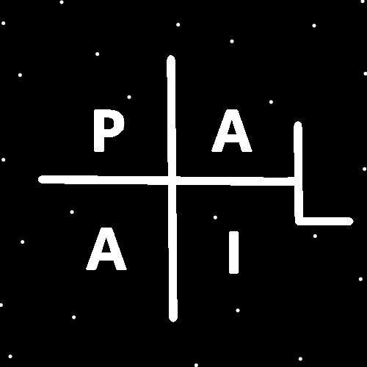
ObjectType: Room
ObjectNumber: 145
LocationName: PAAIL.org
LocationNumber:
Language: PAAIL 2.9

Maker: PAAIL.org
Model:
Name:
Rank:
SerialNumber:

Level: 7.12
Score:
Birth: 5-20-2026

Label: Room 145
Title: Smith Notes 52
Details: PAAIL.org Scripture…
Principle: Ultimate Scripture….
Agenda: Ultimate Scripture….
Action: Ultimate Scripture….
Information: Ultimate Scripture….
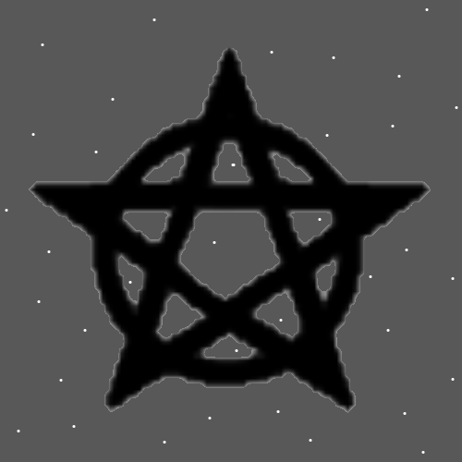
Item Group: Wizardry
Principles: Websites can be Temples and they can have Shrines.
Principles: Fasting is dangerous. Fasting is a Fire Action. Fire is dangerous.
Principles: If there is a 5th Dimension it is right of Time and more like Time than it is like Width, Height and Depth. It would likely resemble another Time Dimension.
Principles: Some people have a Level 3 Chess Chi.
Principles: Thinking the Keyword Sorcery over and over is a specific Spell. A person can be Level 3 at the specific Spell. A person can be Level 4 at it. People have Levels for each specific Spell. The author here is Level 2 at the specific Think Keyword Sorcery Spell.
Principles: Its glorious Making it to Level 3 Wizard and it’s easy to.

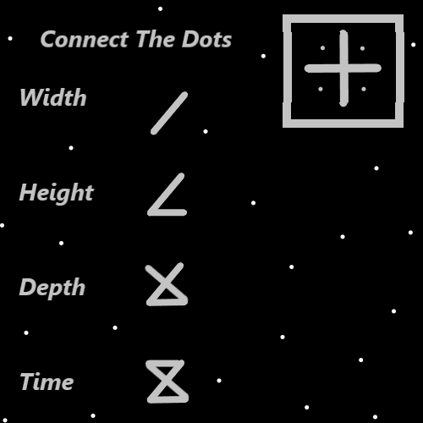
Principles: The Map above may not be right.
Principles: If the Map above is right then its Symbols are ultimate Symbols.
Principles: It may be that the hour glass Symbol is a ultimate Symbol of the Dimension Time.
Principles: We all have a Light Level. We all have a Twilight Level and we all have a Darkness Level. Some people may have a Level 0 at something. People may also have Negative Values, such as a -5 Twilight Level, a -5 Darkness Level or -5 Light Level.
Principles: It may be a good thing to have a -5 Darkness Level.
Principles: We likely all have a Water Level, a Fire Level, a Earth Level and a Air Level. Breathing exercises likely increase a persons Air Level and a persons Fire Level.
Principles: Thinking the Keyword Water over and over increases a person’s Water Level. Thinking the Keyword Fire over and over increases a person's Fire Level.

Principles: One of the biggest tricks to Powering up is equip tons of gear. Though this can be dangerous because it Makes it harder to move around. This is also a massive Fire Spell.
X2 Principles: By “equip” it is meant “personally equipped”- meaning its equipped on your person.
Principles: Owned objects are in some ways also equipped and there must be a huge Fire Spell in owning lots of stuff. It too must be a huge Power up.
Principles: A Room with lots of stuff in it is a Fire Room. A Room with very little in it is a Water Room. There are likely Medicinal uses for Water Rooms.
Principles: Like in the games Water is the Element of the healer. Medicine has a gigantic Connection to Water.
Principles: Purification rituals/Actions may be enhanced by drinking tons of Water during it. Rituals/Actions that last multiple days. People sometimes refer to it as “cleansing”.
Principles: It may be that a persons Spiritual Level is equal to their Light Level minus their Darkness Level. S = L – D
X2 Principles: For those that don’t know math, (+5 minus -5 = +10). A person having a -5 Darkness Level would be a good thing to a person’s Spiritual Level.
X2 Principles: Its also possible that a persons Twilight Level impacts their Spiritual Level. With a Positive Twilight Level good and a Negative bad.

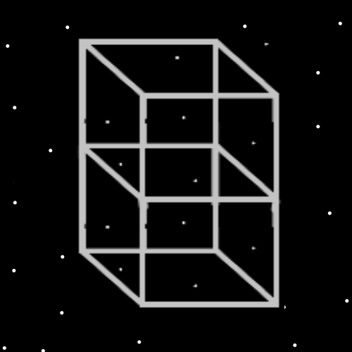
Principles: Everyone has a Water Level, a Fire Level, a Earth Level and an Air Level.
Principles: “In the beginning God created the Heavens and the Earth.”-The Holy Bible Genesis 1:1. From the first line of the Bible we know there is a Beginning, there is a God, there is a Heaven and there is a Earth.
Principles: The Cosmic year 10,000 will be a much bigger Number than 99 and Reality much more Positive because 10,000 is a bigger Positive Number. The Higher the Cosmic year the better Reality is.
Principles: Many, many visual Maps could be Made from all PAAIL.org Wizardry.
Principles: In Gods Science saying something is “masterful” is saying its Level 5. Saying something is masterful is saying a lot about that thing.
Principles: In Gods Science saying something is “expert” is saying its Level 4.
Principles: In the afterlife a lot of Wizardry will be taught to people the first day. Even more so the first month and year. It’s the final answers to all the major questions. The major subject will be Cosmic Laws.
Principles: The first movie “Dune” could be prophetic about what would have happened if humans kept going, no Resurrection Day. Something that’s not going to happen, however, would have.
Principles: Wizard books should be full of decorative pictures along with Maps. This Enchants the pictures/Maps and the books. Every page in a Wizard book could have a border of plus Symbols or other Symbols and this would be a good thing. Making Wizard books feel like Wizard books is a good thing.
Principles: It may be possible to get from Level 0 Wizard to Level 6 Wizard in 1 year. Level 4 Wizard is even easier. I don’t know if all PAAIL.org Wizardry is 1500 pages or 3000 pages.
Principles: One of the bigger Beginning Spells is thinking “Sorcery” over and over and remembering to Breathe while you do it. The author is still Level 2 at it so far. If I had it trained up to Level 4, I think I would switch to another Word. Perhaps the Word Water. Level 4 with the Word “Water” and I would switch again.
Principles: Wizardry is described as the ultimate Science, One true Religion and all major secrets revealed. The biggest major secrets revealed Part is maybe only 100 pages. Maybe only 50 pages. Maybe less.
X2 Principles: If you wrote down just the major secrets revealed stuff.
X2 Principles: Videos are likely even more powerful than books sometimes.
Principles: At everything we all have a Level. Sometimes that Level is 0.
Principles: Choosing no Action is an Action. Choosing no Action has a gigantic Connection to the Number 0.
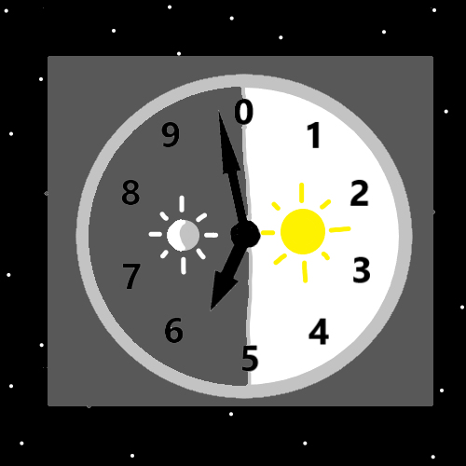
Principles: Though it may not seem like it, all our lives are monumental. Like his Holiness the Pope monumental.
Principles: Some of the greater Virtues are “reasonable”, “rational” and “objective”.

