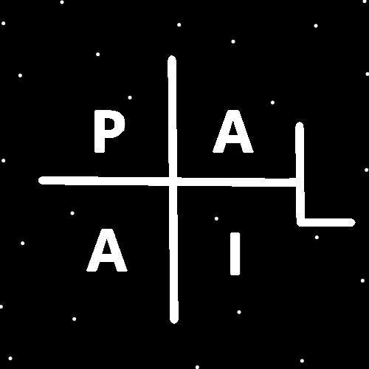
ObjectType: Room
ObjectNumber: 144
LocationName: PAAIL.org
LocationNumber:
Language: PAAIL 2.9

Maker: PAAIL.org
Model:
Name:
Rank:
SerialNumber:

Level: 7.11
Score:
Birth: 5-10-2026

Label: Room 144
Title: Smith Notes 51
Details: PAAIL.org Scripture…
Principle: Ultimate Scripture….
Agenda: Ultimate Scripture….
Action: Ultimate Scripture….
Information: Ultimate Scripture….
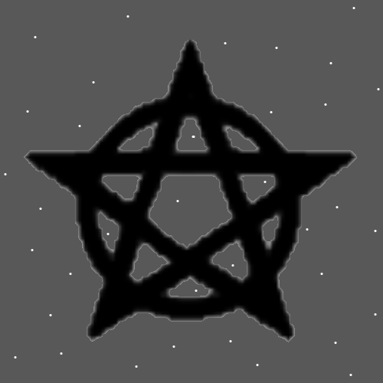
Item Group: Pentagram
Actions: Stare upon the Pentagram above. Let it flow through your Mind.
Principles: “Pentagram”….. pen tag ram. Divination. Suddenly the picture above Makes me think of a ram animal.
Principles: By adding the picture above to all these Rooms I have Enchanted it. This is Alchemy. It has High Enchantment Levels to it because it was added to all these Rooms. It is a Level 5 Wizard at least. Perhaps Higher. Staring upon it does more because it is super Enchanted.
Principles: Sometimes the only options are Fire or Water. No Earth, no Air. On some Maps all Actions/Spells are Fire or Water.
Principles: On the Water and Fire Map Breathing exercises are Fire.
Principles: A person can do Keyword think Sorcery, Sorcery, Sorcery 10 plus Times (don’t count how many, just do a lot of them) think the Word over and over, and try to remember to Breathe while you do it. The author here is Level 2 at it, and is training it. I am Level 3 at think Keyword “Breathe”. I do some of it as well. Sorcery Word more.
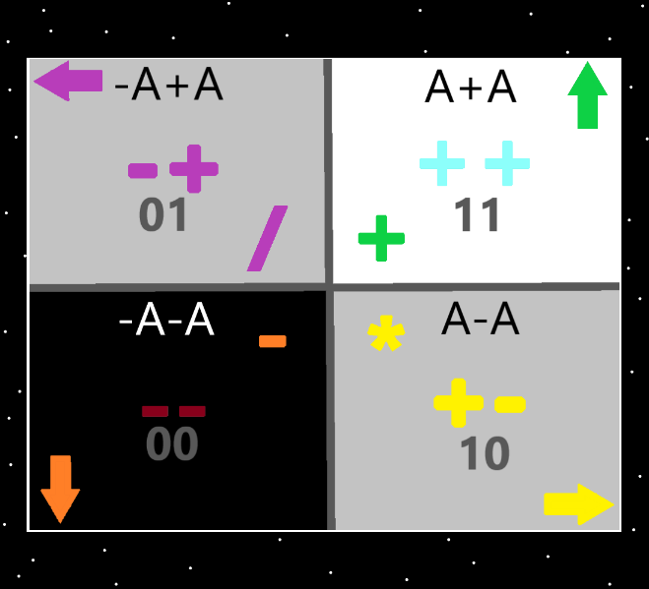
Actions: Sorcery, Sorcery, Sorcery, Sorcery, Sorcery, Sorcery, Sorcery. Breathe, Breathe, Breathe, Breathe. Sorcery, Sorcery, Sorcery, Sorcery, Sorcery, Sorcery, Sorcery. Breathe, Breathe, Breathe, Breathe.
X2 Principles: Remember to Breathe while you read this Action. Reading this Action is a Spell. It is a Powerful Spell. Read it a few Times.
X2 Principles: Reading this Action is a Meditation.
Principles: In the Bible, in the book of Revelation, there is something about the 4 living creatures. This more than likely has a Connection to the 4 Forces.
Principles: Reading repetitive Words and so forth is a Powerful Spell. Reading Words can be a Meditation. There are many reading Words patterns that can be designed. From Positive, motivational Words to simple repeating Words.
Actions: Positive, Positive, Positive, is my existence eternal. Positive, Positive, Positive is their great meaning in my life.

Principles: In Science I have heard that there are “Particles” and “Waves” and they are not the same thing. They would still both be Bodies of Energy. I believe in the Theory we should call Waves Particles. That they are a Type of Particle. And all Bodies of Energy are Particles.
Principles: Sometimes “semantics” matters.
Principles: Its seeming likely that the Height, Width and Depth Dimensions are Wave Type Particles. Possibly the Time Dimension as well. It also seems likely that they are 1 Dimensional Objects.
Principles: All Locations are represented by a Multi-Dimensional Number. 1 Number for each Dimension of the Location.
Principles: A PAAIL.org based Wizard book comes with a Level 3 Wizard Enchantment before it leaves the printer Building. When a person buys such a book, because all people have gigantic Chi’s it Grows to Level 4 in 3 months. Aged 4 years and it is for sure at least Level 5. Aged 10 years Level 6. This is without Alchemy. If you use Alchemy, you can speed all this up a lot. With a Shrine and a person who is Level 4 Wizard, you can get Level 5 on the Wizard book in 1 year. Level 6 in 2 years. A Level 6 Wizard person can get a book to Level 6 Wizard in 1 year. Some Shrines are older and more Enchanted than others, this also is a major Part of the process. The more Enchanted the Shrine the better.
Principles: Putting a Shrine in a Building can lead to the Building becoming a Temple. Using Temples to Enchant things is a Powerful way to Enchant things. Even bigger than the Shrine. Though a Shrine is mandatory for a Temple. If the Temple is Going to be used for Enchanting.
X2 Actions: Read capitalized Words. 1 line at a Time. “Going Enchanting”.
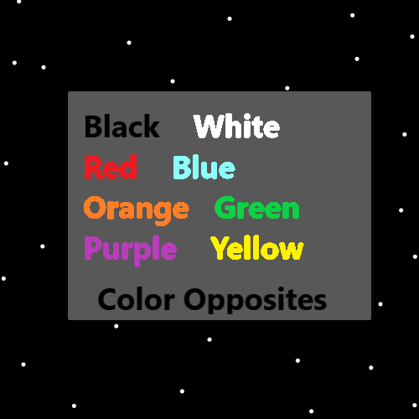
Principles: Some Temples have Higher Levels than others. When doing Alchemy and Enchanting having a Higher Level Temple helps a lot. Growing Higher Level Temples is also Alchemy/Enchanting.
Principles: When humans Make a good Shrine, it goes in the Multiverse book of Shrines. On a Cosmic scale every Shrine has a small Number.
Principles: On a Cosmic scale any Number a human can write in 60 seconds is a tiny Number.
Principles: Every Object Made by a living being has a Serial Number. Various Serial Numbers even. Once upon a Time there was the first sword. It would be quite valuable if you could prove it’s the first.
Principles: Colors may be Multi-Dimensional Numbers. Pure Blue could be 2,0, or 2,0,0 or 2,0,0,0.
Principles: All Objects have a Number. All things have a Number. Sometimes the Number is Multi-dimensional.
Principles: Why does 2 * A = A? Because you still have an Infinitely small amount of Energy.
Principles: Math is Made from Energy Bit Code. It takes an Infinite amount of Energy Bit Code to get beyond the Physics of Energy Bits. Math is Made of at least an Infinite amount of Energy Bit Code. Perhaps Infinity * 2 or 3 or something.
Principles: It is worth noting again that all Shrines should have at least 1 Religious Charm. As tribute to God and out of worship of God. This gives the Shrine a Religious Enchantment.
Principles: Its possible his Holiness Jesus lives at the center of this Universe/Heaven. He may be a giant Ball, like the size of a Galaxy or something.
Principles: It may be Wave Type Particles are Negative Type Particles.
Principles: PAAIL.org the website is a online Temple. The Enchantments on it are gigantic.

