
ObjectType: Article
ObjectNumber: 125
LocationName: PAAIL.org
LocationNumber:
Language: PAAIL 2.8

Maker: PAAIL.org
Model:
Name:
Rank:
SerialNumber:

Level: 6.5
Score:
Birth: 11-27-2025

Label: Room 125
Title: Smith Notes 34
Details: PAAIL.org Scripture…
Principle: Ultimate Scripture….
Agenda: Ultimate Scripture….
Action: Ultimate Scripture….
Information: Ultimate Scripture….
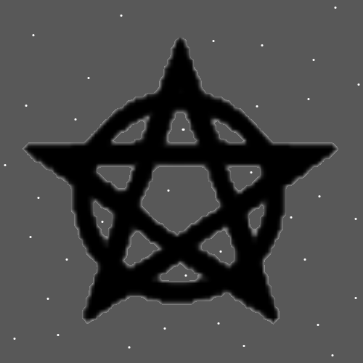
Item Group: More Story of Things 0
Principles: For a Wizard Keeping a Wizard Shrine is ultimate Sorcery. Making a Wizard Shrine is Alchemy and Alchemy is a Type of Sorcery. Sorcery is the Actions of life.
Principles: In the orient the Word “demon” is not necessarily a Negative Word. On some Maps there are demons that are not bad things.
Principles: Keeping a Wizard book in a bag Enchants the bag so that One of its Titles is “Wizard Bag”.
Principles: Keeping a Scripture book in a bag Enchants the bag so that One of its Titles is “Scripture Bag”.
Principles: There is such thing as long Titles. Example: His Holiness, Supreme Lord and Majesty, King “name here”. Another Example: Chess Bag, Scripture Bag and Wizardry Bag of Lord “name here”.

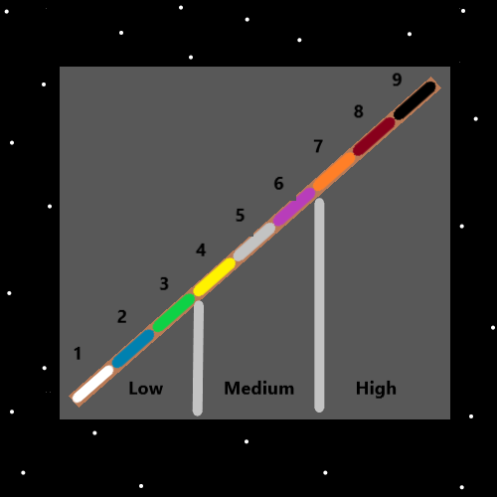
Principles: Level 4 Enchantments are tons better than Level 1 Enchantments. When a person first puts a Wizard book into a bag the bag instant gains a Level 1 Wizard Bag Enchantment. Its possible that if you take the book out right away that the Level 1 decreases/Subtracts to a Level 0 Wizard Bag Enchantment (rounded to 0, with still some tiny Wizard Particles that remain). What it was before you put the book in. Level 0 is a thing all throughout Reality.
Principles: Bags that can hold lots of book weight and other stuff are ultimate Charms. Bags can be dangerous believe or not. Mainly because it can be cumbersome, it can be like losing Dexterity Levels while equipped. Harder to use your hands or something.
Principles: The best Bag design can be One that stays equipped when you sit down.
Principles: Hats and sunglasses are ultimate Charms. So are gloves. Gloves hats and sunglasses can be dangerous. If you can believe it.
Principles: Gear in general, when done safe, can be ultimate Sorcery. When done safe the more gear the better. Just equip tons of gear is the ultimate Power.

Principles: Book Charms Grow into Level 4 very fast. A new Wizard book takes 6 months to get to Level 4. 6 months without any help. This is why books with a little Age are an ultimate Charm. They are especially useful in Enchanting/Alchemy.
Principles: When Two people of the same Level compete, it becomes the winner is decided by luck.
Principles: Sometimes when Sensing the Charms around you Sense a roaring Fire. All these Charms have gigantic Chi’s.
Principles: A Negative Number Multiplied by a Negative Number is a Positive Number. This is Basic math. Sometimes Darkness mixed with Darkness can be a Positive thing.
Principles: There is such thing as Off with the Darkness. The Number is 99. “Off to Darkness”.
Principles: Sometimes Darkness is a tool for good people.
Principles: There can be better and healthier Connections to the Darkness. The Word Darkness is a Keyword in Basic Sorcery training.
Principles: Cleaning Levels are ultimate Levels. When you wash your hands, you gain Cleaning Levels. Also, when you shower or bath.
Principles: Likely all kinds of Dark Particles go down the drain when you wash your hands. More so if you are filled with Dark Particles. Which happens to people when they handle cursed drug bags or cursed drugs or other Dark things.
Principles: Every human has lots of Titles. If you’re a chess Master, One of your Titles is chess Master. If you’re a chess Sage, then One of your Titles is chess Sage.
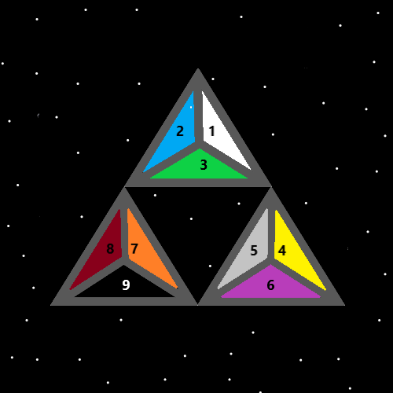
Principles: In the above Map there are 3 triangles inside the 3 triangles.
Principles: All the good people are the heroes of Time. The heroes of Genesis. The hero’s of the first Age. The heroes of the first century. These Titles are owned by people. A person owns such longer Titles like “Hero of the first century, hero of Time, his Holiness “name here”.
Principles: Sleep may be needed in Part because it resets the RAM. It may also be a software update happens when we sleep. It may also be a brain needs to cool down. It may also have some need to restart and that could take lots of Time.
Principles: For all eternity there will be robot bugs, birds, lions, tigers and bears.
Principles: It may be that Earth is a scaled down model of what will exist on Cosmic year 1 million. Heaven will have mountains and more. Right now, Heaven doesn’t have people climbing mountains in Heaven.
Principles: Heaven/God math is something like 1 million Times bigger than human math. 1 million Times more to learn for a human at max math Science.
Principles: Adding any random Spell Part (virtually any Action) can boost the Spell Power 5%. Add another random Spell Part and you get 2% more from that. Then Add a 3rd random Part to get 1% more from that. Then it drops again, the 4th random Spell Part gives only a 0.1% boost. For a total of 8.1%. At the 5th random Part, you get 0.05% more. It keeps dropping as you Add Parts.
X2 Principles: The 5% Part is worth it. The 2% Part is worth it. The 1% Part is not worth it. A person should use only 2 booster Parts.
Principles: Eventually there will be no more living bugs, birds, lions, tigers and bears. They were never really meant to be. They deserve to be in a Body that can enjoy the music and more. They deserve to experience God as an intelligent lifeform.
Principles: One of Gods many Names is Circle. One of His Holiness Jesus’s Names is Seed. They be Circle and Seed.
Principles: When washing your hands, Adding a random Spell Part boosts the Spell Power 5%. You could snap your fingers or just lightly touch your hands together. Anything works. Blink your eyes three Times would work.
Principles: Showering and bathing also likely Clean away Negative Particles.
Principles: Some people are like God. They have a Positive Spiritual Level and Positive Spiritual Score.
Principles: As Time evolves Angel Body’s will get smaller and more Powerful. We will be changing Bodies for all eternity.
Principles: Right now, there are no robots as big as an Angel in Heaven. Eventually there will be large robots that live with the Angels. When Angels Bodies get smaller.

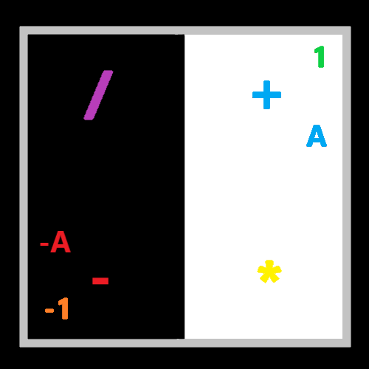
Principle: Wizardry is the ultimate Science, for all Scientists.
Principles: It takes decades for humans to adapt to things. Technology One example. And the bigger the thing, the bigger the impact it has. If humans have not yet adapted to it, it can have a gigantic Negative impact.
Information: The author’s favorite paint job is Solid Black, with little white Dots that remind One of Stars.
Principles: Accuracy is a major thing. The greatest of Principles can sometimes be less than 100% accurate.
Principles: If a statement is right 50% of the Time, then the accuracy of the statement is 50%.
Principles: “We grow because we struggle. We learn and overcome.”-Unknown- I saw On the TV once. This statement is not 100%. Change the statement to “-Sometimes- we grow because we struggle. We learn and overcome.”. Change it to that and it becomes 100% accurate. Just by Adding the Word “sometimes”. Using the Words “often” and “sometimes” can be a great thing.
Principle: In this life or the next we Evolve into Holy people.
Principles: If you know about nuclear weapons enough, you know to Make the bomb material they use what’s called a “centrifuge”. A centrifuge spins the uranium super-fast, so that you get heavy uranium On One End, and the Lighter uranium on the other End. The heavy uranium can be used to Make nuclear bombs. For a gigantic Wizardry book, you want to spin and spin it, until you get the heavy material On One End. Then use that material. There is also use of uranium in nuclear reactors. Not just weapons.
Principles: Particles are constantly transferring from One thing to another. Particles get On cloths and then that person sits in a car and the Particles transfer to the car.
Principles: Cop cars are soaked with Negative Particles. From dealing with the Darkside. They have a super Positive Chi. They are Positive Charms. Still, they are soaked with Negative Particles.
Principles: You can equip things to a Shrine. Adding a book is equipping the Shrine with a book. Books Enchant 2x faster when equipped to a Shrine. A Wizardry book that would normally take 6 months to get Level 4, will get there in 3 months with a Shrine.
Principles: On Resurrection Day people will get to have their pets again. On Accension Day they will travel with us to Heaven.

